Half-term Test 1 Pupil Book 2 (Chapters 1, 2, 3)
SECTION A: You must not use a calculator for these questions
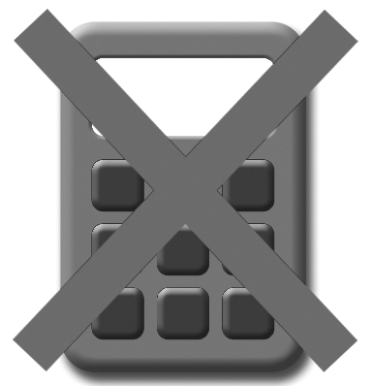
- Fill in the missing numbers:
4

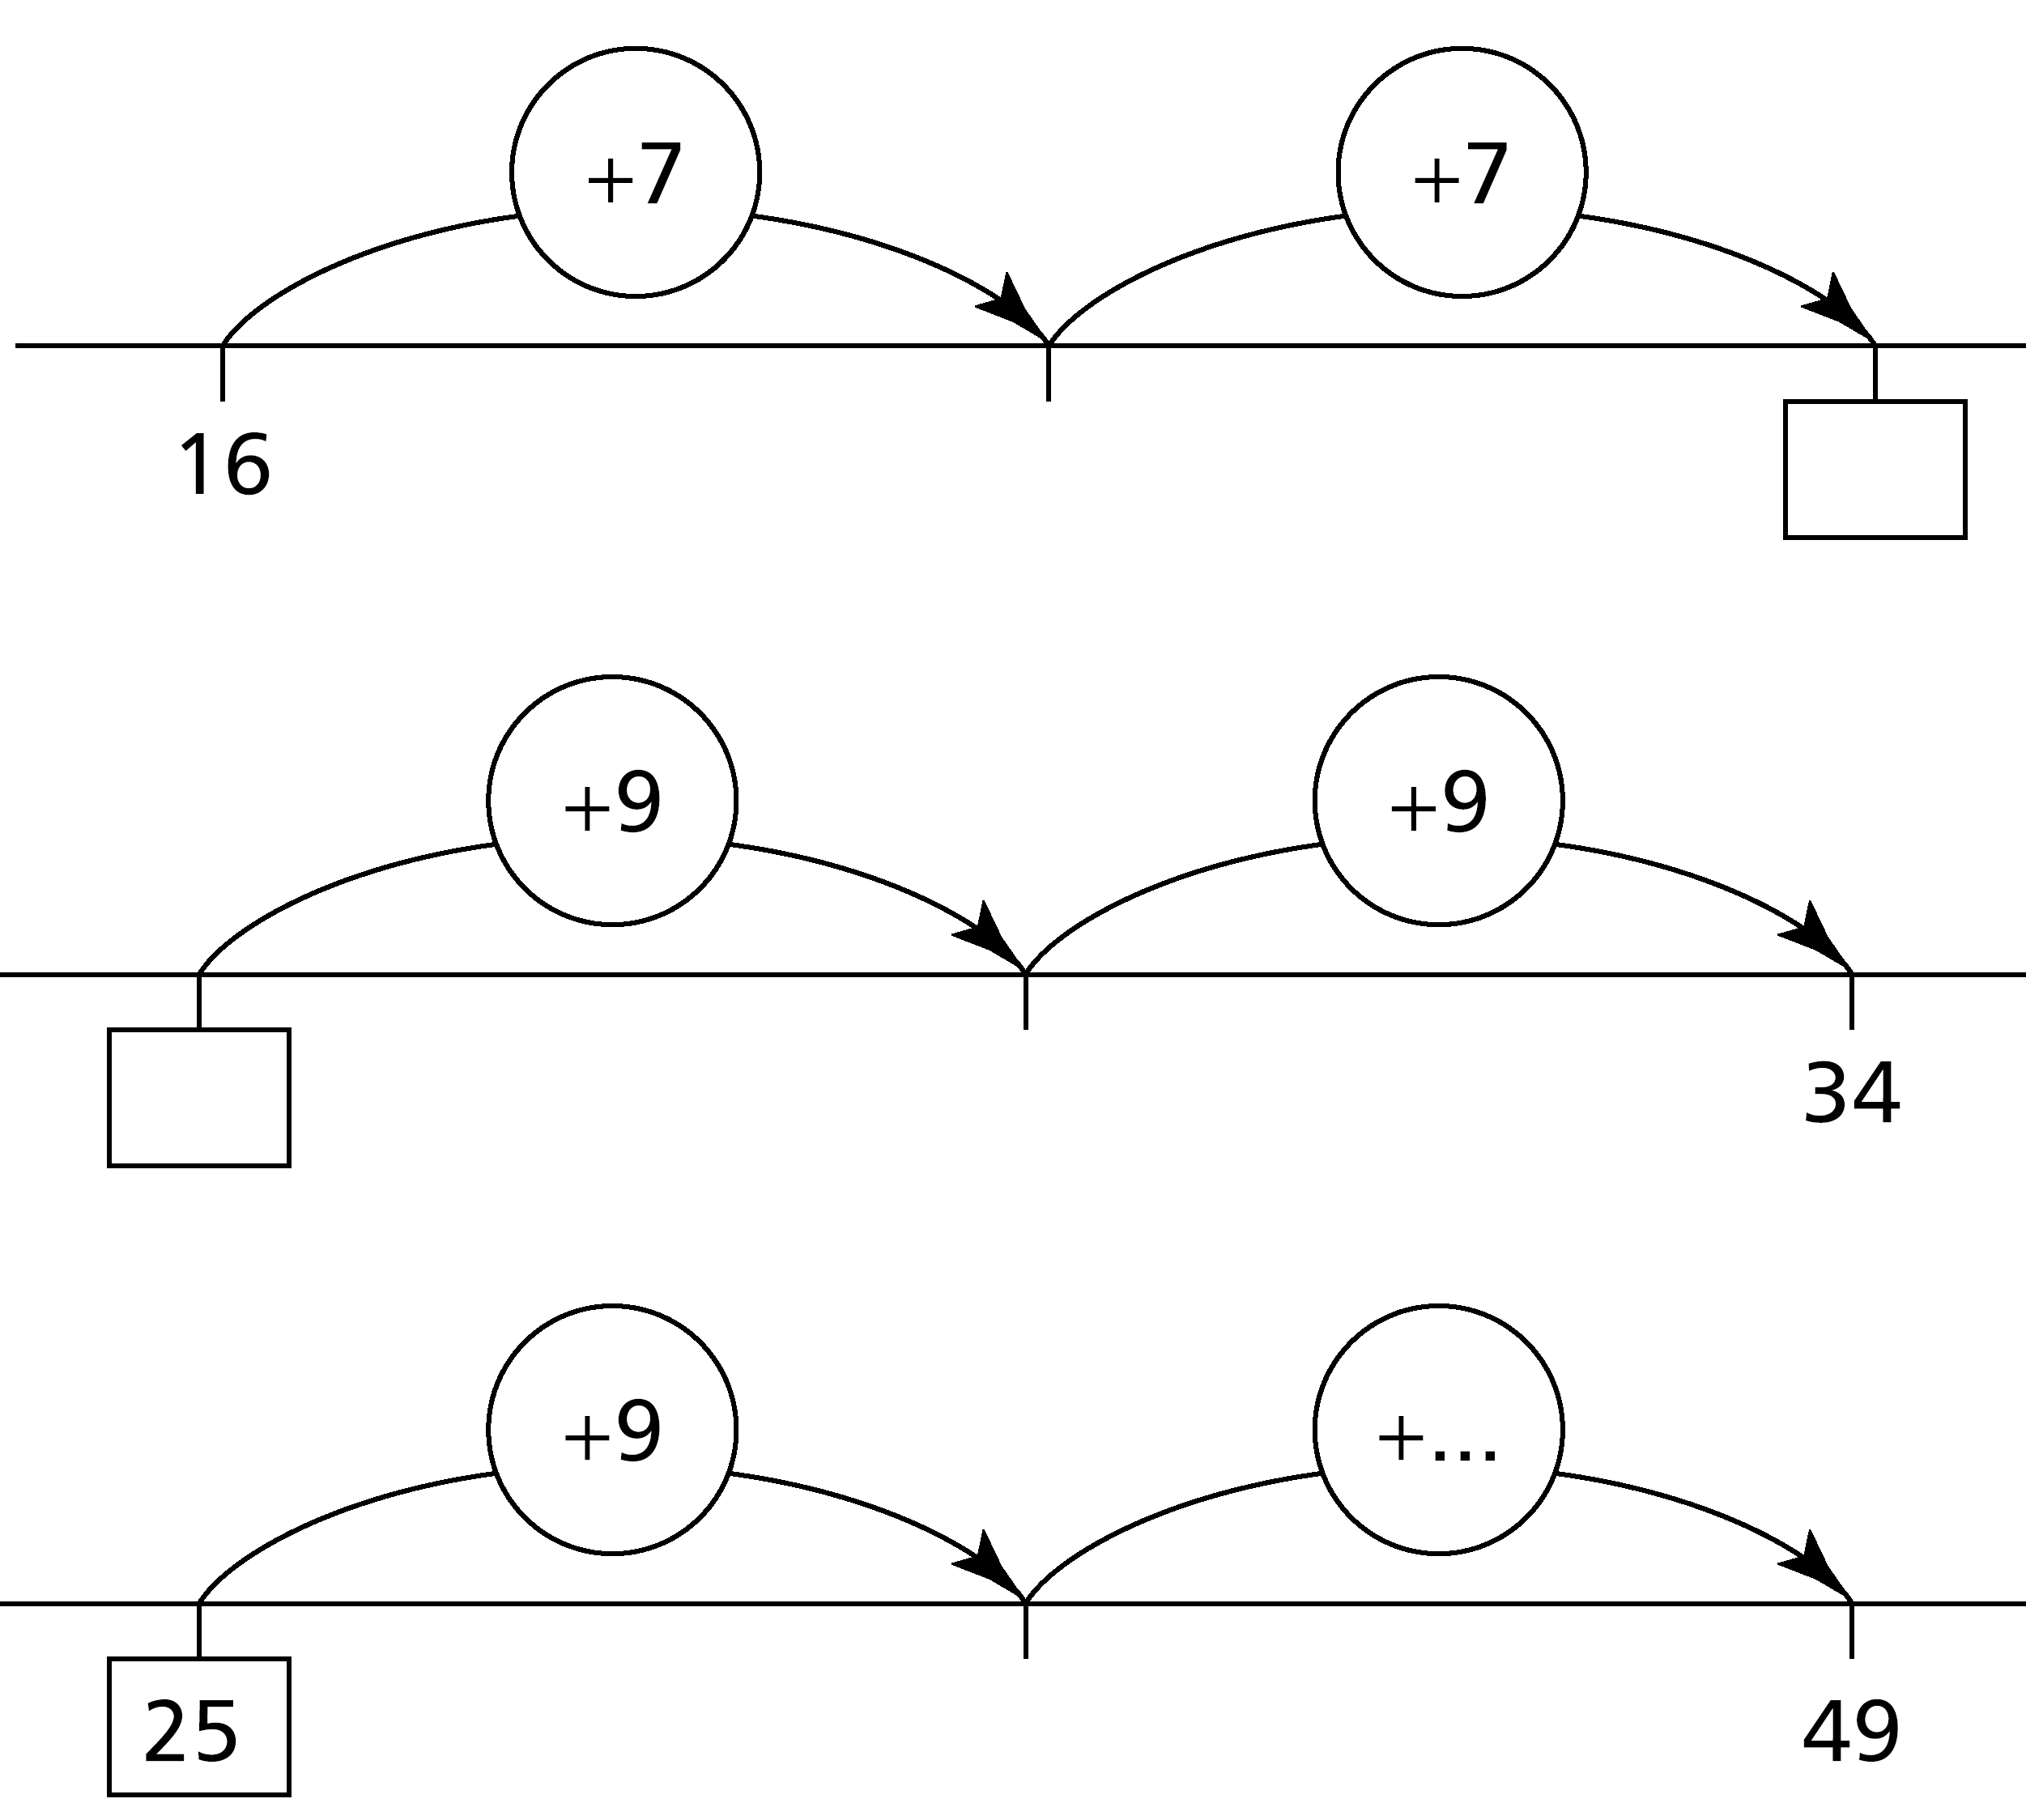
(a)

(b)

(c)

……………………………………………………………………………… [3 marks]
- Put the following amounts of money in order from smallest to largest:
£3.12 67p 145p £0.08
....…………………………………………………………………………… [1 mark]
- (a) Fill in the missing output for this function machine.
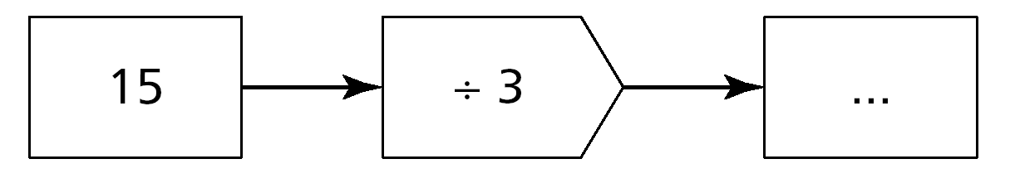

[1 mark]
- Fill in the missing input for this function machine.
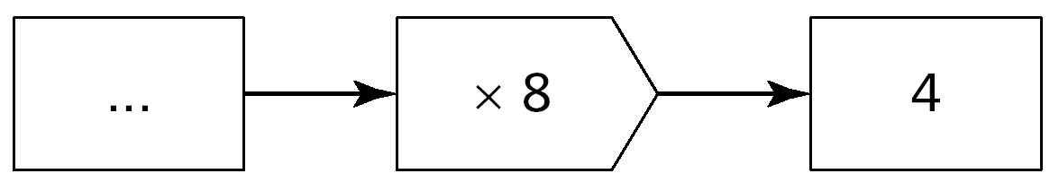

[1 mark]
- Fill in the missing numbers so that the answer is always 65.
4

One example is done to help you.

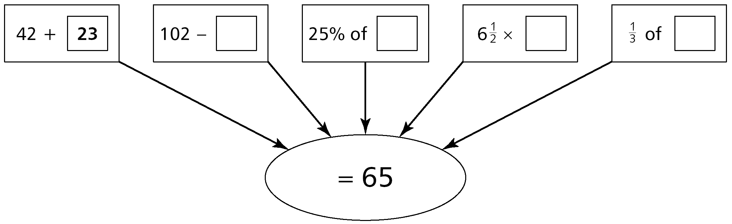

[4 marks]

5 Write either > or < to make each statement correct.

–5 ......... 5

0 ......... –1

–3 ......... –2 [3 marks]

6 Complete these calculations:

4 × 100 = ................... [1 mark]

................... × 10 = 3000 [1 mark]

60 ÷ ................... = 0.6 [1 mark]

7 Here is a shape drawn on a centimetre squared grid:

Work out the perimeter and the area of the shape. Give the units in your answers.
5

Perimeter = ................... [1 mark]

Area = ................... [1 mark]

8 Work out the surface area of the cube.

7 cm
7 cm
7 cm

................................... cm² [2 marks]

9 Circle the calculation that should be used to estimate the answer to
48.3 × 13.9.

48 × 13 40 × 10 50 × 14 50 × 10 [1 mark]

10 Fill in the table showing the faces, edges and vertices of the two 3-D shapes shown.

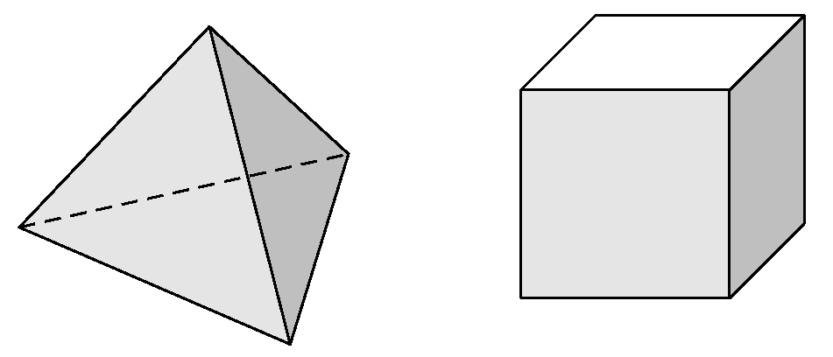
Shape | Faces | Edges | Vertices
A
B
A B

[2 marks]
11 Look at these cards.
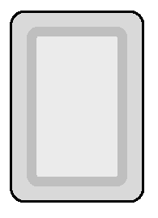
–2
0
+6
+9
–4
–7
+2
5

+
= –1
+

(a) Choose three cards that give the answer –1.

= 0
+

(b) Choose two cards that give the answer to

=
+
–4

(c) Choose a card that gives the highest possible answer to

=
+
–4

(d) Choose a card that gives the lowest possible answer to

[4 marks]
12 Given that 49 × 132 = 6468, work out:

- 49 × 13.2 =................... [1 mark]
- 490 × 1320 =................... [1 mark]
- 4.9 × 1.32 =................... [1 mark]

13 This is a mapping diagram for a function:
2 → 6

3 → 7

6 → 10

The rule for the function is x → x + 4.
- Here is a mapping diagram for a different function.
2 → 0

5 → 3

10 → 8
5

Complete the rule for this function. x → ................... [1 mark]
A further function has the rule x → 3x.
- Complete the mapping diagram for this function.
2 → ......

5 → ......

...... → 27

[2 marks]

14 Tom is making patterns with matches:
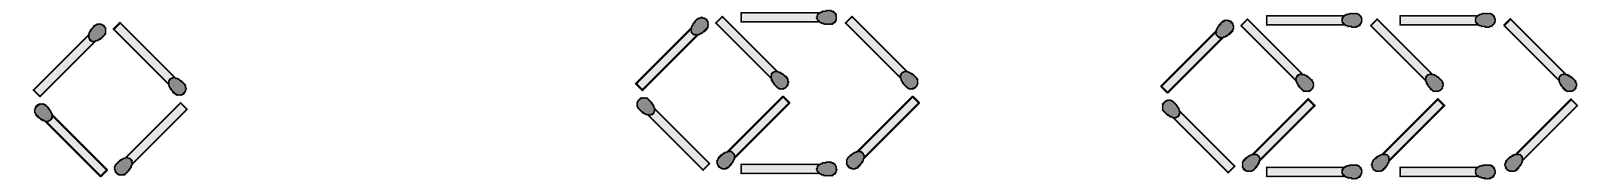

Pattern 1 Pattern 2 Pattern 3

- How many more matches will Tom need to make pattern 4?
...................................... [1 mark]
- How many matches altogether will Tom need to make pattern 5?
...................................... [1 mark]
- How many matches will Tom need to make pattern 12?
...................................... [1 mark]
- Tom has a box containing 99 matches. What is the largest pattern number he can make?
...................................... [2 marks]
SECTION B: You may use a calculator for these questions
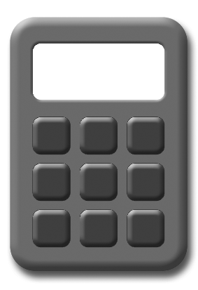
4

15 Here is a number sequence:

5 9 13 ......... .........

Write the next two numbers in the sequence. [1 mark]

Write the rule for the sequence. ...................................... [1 mark]

Here is another sequence.

......... 5 2 ......... –4

Write the two missing numbers in the sequence. [1 mark]

5

16 Arrange the following lengths in order, smallest to largest:

3.4 m 0.036 km 350 cm 3700 mm

.............................................................................................................. [2 marks]

17 Some people use stones to measure weight.
The diagram shows one way to change stones to kilograms.

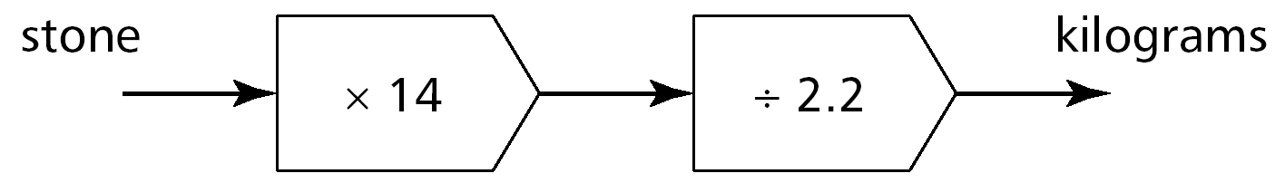
stones
kilograms

- Change 5 stones to kilograms. ............................... kg [1 mark]

- Change 25 kilograms to stones. ............................... stones [2 marks]

18 The area of the rectangle is 36 cm².
4 cm

- What is the length of the rectangle? ............................... cm [1 mark]
- A different rectangle also has an area of 36 cm². It is not a square.
Write what the length and the width of this rectangle could be.
5

Length = ....................... cm Width = ....................... cm [1 mark]

19 A roll of wallpaper has a length of 10.05 m.
Louise cuts three 2.6 m lengths from the roll.

What length of wallpaper is left? ............................... m [2 marks]

Total Marks 50

Investigation
Here are four consecutive digits:

1 2 3 4

Use the digits to make two 2-digit numbers that add together to give the biggest total.
+
=

Now use the digits again to make two 2-digit numbers that add together to give the smallest total.
+
=

Find the difference between the two answers.

Try this again for the digits 2, 3, 4 and 5. What do you notice?

Does this work for any four consecutive digits? Investigate.

Extension

Try this investigation using six consecutive digits.

