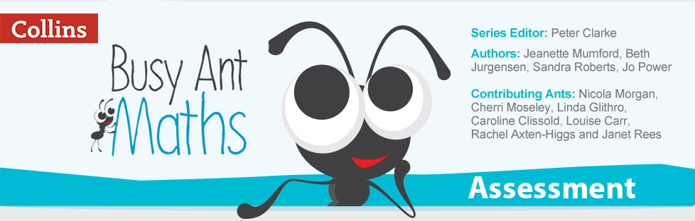
Busy Ant Maths has assessment at the heart and from the start – with integrated and effective
diagnostic, formative and summative assessment which will help to inform your planning and teaching.

Formative assessment
Shared Success Criteria are provided in each lesson to assist pupils in identifying the steps required to achieve the learning objective. 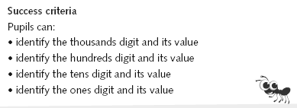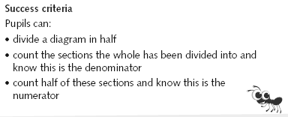
Progress Check Questions are a feature of every Busy Ant Maths lesson and are linked to specific learning objectives.
They are designed to provide immediate feedback to pupils and to gauge pupil progress in order to adapt teaching.
Busy Ant Maths Assessment Guides (one for each year) contain ‘Assessment Tasks’ and ‘Assessment Exercises’.
They can be used to review and record the progress of both individual pupils and the class as a whole, in relation to the National Curriculum Attainment Targets.
The formative Assessment Tasks and Exercises provide individual and/or group opportunities to identify those pupils who are not yet reaching, or who are exceeding, national expectations. They can also be used to set individual targets for pupils.
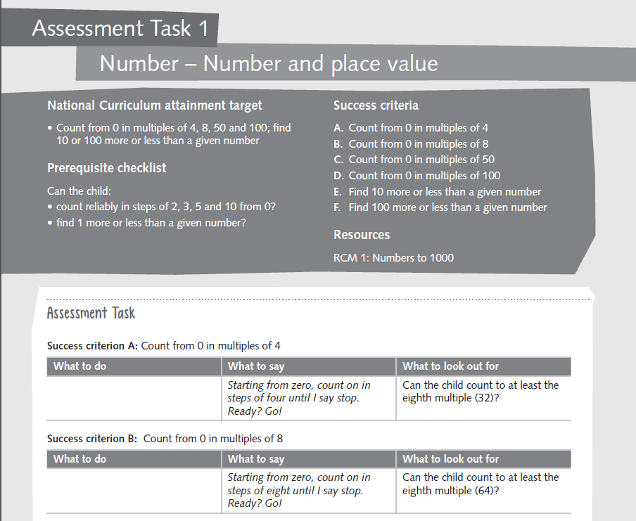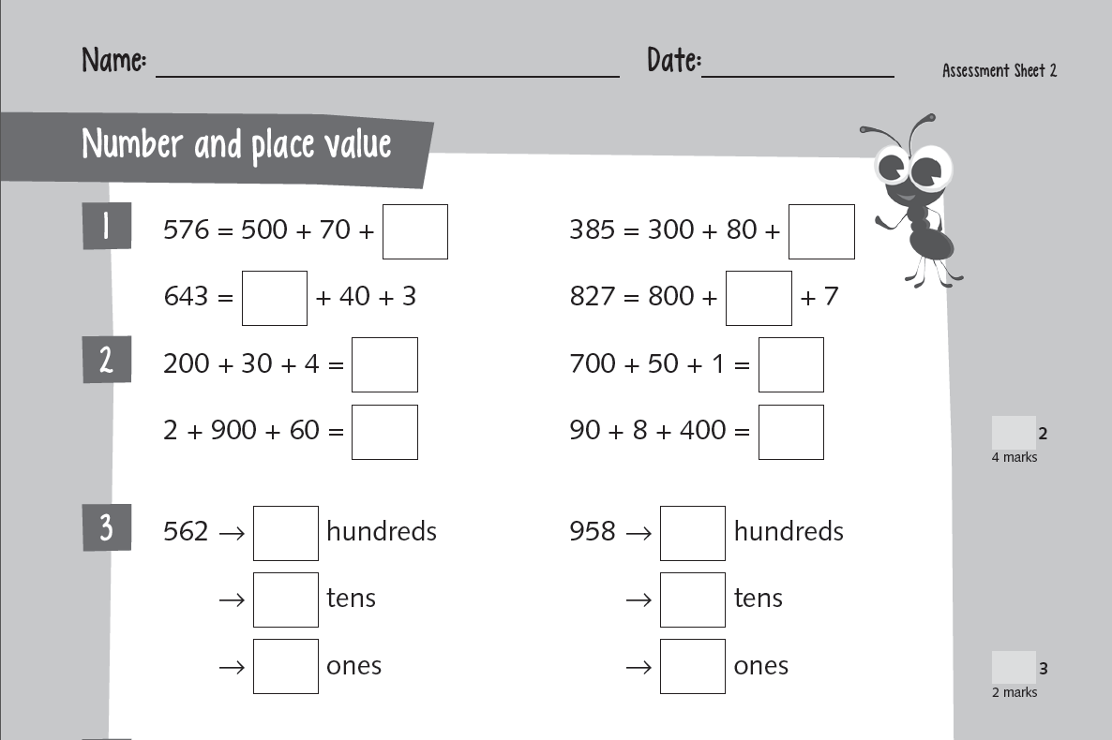

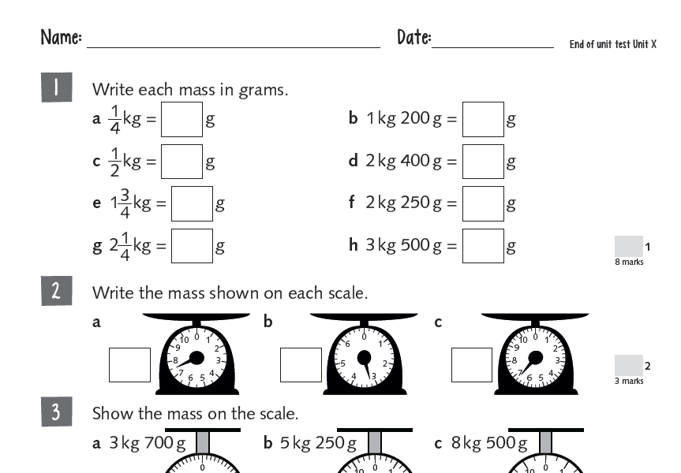
In-school summative assessment
An End-of-unit Test is provided within the Busy Ant Maths Assessment Guides for each of the 12 Busy Ant Maths units.
Each test is designed to assess the mathematics covered during the three-week unit.
End-of-Year Tests are designed to show individual pupils’ level of mastery against national standards at the end of each year. (Available from February 2016).

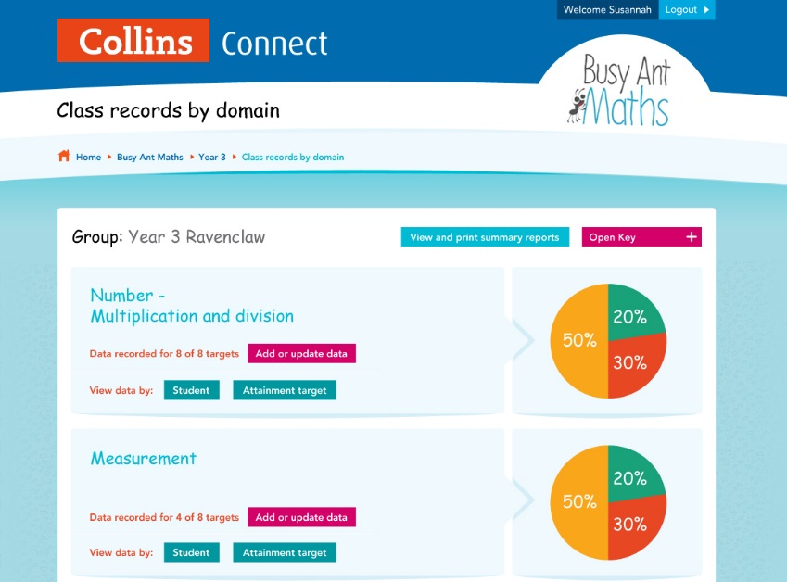

Record-keeping
The various record-keeping formats found in the Assessment Guides and on Collins Connect are designed to show individual pupils’ level of mastery against national standards.
They draw on the data gathered throughout the year, including results from Assessment Tasks, Exercises and Tests, performance in whole-class discussions, participation in group work, written evidence and any other supplementary notes.
It is these documents that form the basis for reporting to parents and guardians and informing the next year’s teacher.
Importantly, they also help to identify whether pupils are on track to meet end of key stage expectations.

