AQA A-Level Chemistry Year 1 and AS

Student Book Answers

Chapter 1: Atomic structure
  - assignment 1
A1. a. (9.109 ×10−31) + (1.672 × 10−27) = 1.673 × 10−27 kg
b. 1.673 × 10−27 × 1000 × 2 = 3.346 × 10−24 g
c. (1.674 × 10−27) ÷ (9.109 × 10−31) = 1838
A2. a. 1.674 × 10−27 × 103 = 1.674 × 10−24 g
b. (9.109 × 10−31) × (200 × 10⁶) = 1.822 × 10−22 kg = 1.822 × 10−19 g
c. 0.311 × 103 = 311 = 3.11 × 102 g
A3. 1.538 × 10−²⁵ kg
A4. Mass of nucleus = (1.672 × 10−²⁷ × 2) + (1.674 × 10−²⁷); mass of electrons = 9.109 × 10−³¹; number of times heavier = [(1.672 × 10−²⁷) + (1.674 × 10−²⁷)] ÷ 9.109 × 10−³¹ = 3673 times
  - Assignment 2
A1. a. Carbon's isotopes are: carbon-12 with atomic number 6, mass number 12; carbon-13 with atomic number 6, mass number 13; carbon-14, atomic number 6, mass number 14.
b. Hydrogen's isotopes are: hydrogen-1 with atomic number 1, mass number 1; hydrogen-2 with atomic number 1, mass number 2; hydrogen-3 with atomic number 1, mass number 3.
A2. The percentage abundance (1 × 10−¹⁰) is so small that it is negligible.
A3. 1
A4. 1
A5. ¹²CH₄ because carbon-12 and hydrogen-1 are the commonest isotopes of the two elements.
A6. ¹⁴CD₄
A7. They are assuming the natural abundances of carbon and hydrogen isotopes on Mars will be the same or very similar to those on Earth.
  - Assignment 3
A1. ⁸⁷Sr: 38 protons, 49 neutrons, 38 electrons; ⁸⁸Sr: 38 protons, 50 neutrons, 38 electrons
A2. a.
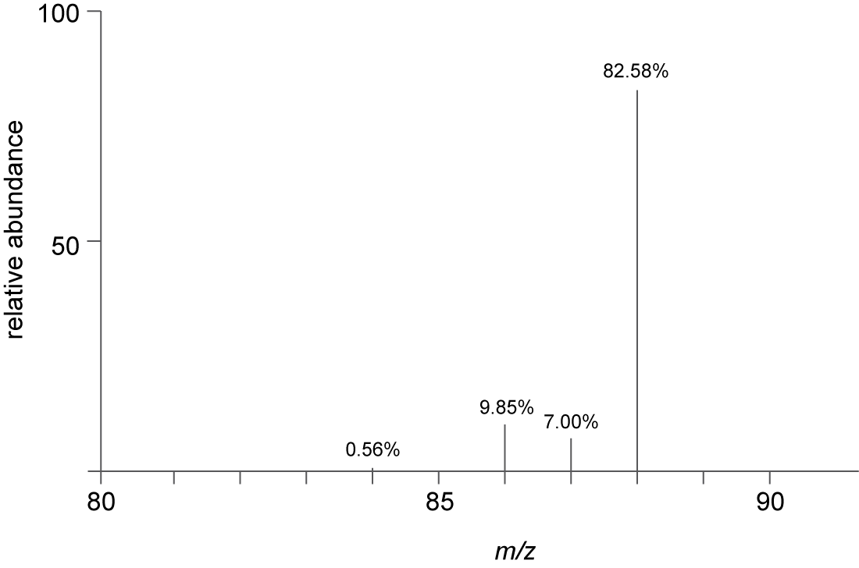

b. relative atomic mass = [(84 × 0.56) + (86 × 9.86) + (87 × 7.00) + (88 × 82.58)] ÷ 100 = 87.7
A3. Local isotope abundances (isotope signatures) for the specific locations being investigated.
  - Assignment 4
A1.
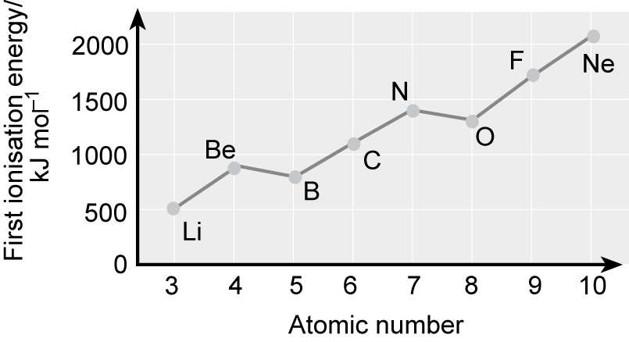
A2. Increasing nuclear charge, electrons added to the same energy level.
A3. Increased nuclear charge.
A4. Al: The outer electron is the first in the p sub-shell. S: First electron pair in a p sub-shell orbital. Electrons in the same orbital repel each other and are easier to remove.
A5. a. Electrons are being added, one to each p orbital, but the nuclear charge is increasing, so it becomes more difficult to remove an electron.
b. Electrons are being paired up in p orbitals, but the nuclear charge is increasing and it becomes more difficult to remove an electron.
A6. All electrons were in a similar environment.
A7. a. There is a drop in the first ionisation energy at the beginning of each period.
b. There are step-like increases across each period.
A8. It is low; not much energy needed to remove it.
A9. Its first ionisation energy is relatively high, so it is difficult to remove an electron and this is one of the factors that contributes.
  - Practice questions
1. a. 37; 48
b. i. Electron gun / high speed / high energy electrons knock out electron(s).
ii. Rb(g) → Rb⁺(g) + e⁽⁻⁾
OR
Rb(g) + e⁽⁻⁾ → Rb⁺(g) + 2e⁽⁻⁾
OR
Rb(g) – e⁽⁻⁾ → Rb⁺(g)
c. Rb is a bigger (atom) / e further from nucleus / electron lost from a higher energy level / more shielding in Rb / less attraction of nucleus in Rb for outer electron / more shells.
d. i. s / block s / group s
ii. 1s² 2s² 2p⁶ 3s² 3p⁶ 4s² 3d¹⁰ 4p⁶ 5s¹
e.
$$\frac{\left(\text{85 × 2.5}\right)\text{ + 87 × 1}}{\text{3.5}}\text{ OR }\frac{\left(\text{85 × 5}\right)\text{ + 87 × 2}}{\text{7}}\text{ = 85.6}$$
f. Detector current / digital pulses / electrical signal related to abundance.
2. a. N⁻³
b. F⁻ / fluoride
c. Li₃N
3. a. i. Different number of neutrons.
ii. Same electron configuration / same number of electrons (in the outer shell).
b.
$$\frac{\text{Average mass of 1 atom (of an element)}}{\frac{\text{1}}{\text{12}}\text{ mass atom of }{}_{}^{\text{12}}{\text{C}}}$$
c. i.
$$\frac{\left(\text{64 ×} \text{12}\right) \text{+} \left(\text{66 ×} \text{8}\right) \text{+} \left(\text{67 ×} \text{1}\right) \text{+} \text{(68 ×} \text{6)}}{\text{27}} \text{= }\frac{\text{1771}}{\text{27}} \text{=} \text{65.6}$$
ii. ⁶⁴Zn⁺
d. Ions hit detector and cause current / ions to accept electrons / cause electron flow / electric pulse
caused bigger current = more of that isotope / current proportional to abundance.
4. a. 4d¹⁰ 5s² 5p¹
b. i. Using an electron gun / (beam of) high energy / fast moving electrons.
ii. In(g) + e⁻ → In⁺(g) + 2e⁻
OR
In(g) → In⁺(g) + e⁻
In(g) – e⁻ → In⁺(g)
iii. So no more than one electron is knocked out / so only one electron is knocked out / prevent further ionisation.
iv. Any two processes from: Accelerate; Deflect; Detect
c. i.
$$\frac{\text{Average mass of 1 atom (of an element)}}{\frac{\text{1}}{\text{12}}\text{ mass atom of }{}_{}^{\text{12}}{\text{C}}}$$

ii.
$$\frac{\text{113}\text{x} \text{+} \text{115}\text{y}}{\text{x} \text{+} \text{y}} \text{=} \text{114.5}$$

Ratio (113:115) = 1:3 or 25:75 or 0.5:1.5
d. None; Same number of electrons (in the outer shell) / same electron configuration.
5. a.
 | Relative mass | Relative charge
Proton | 1 | +1
Electron | 5.45 × 10⁻⁴ | −1

b. ³⁸Ar
c. i. 1s² 2s²2p⁶
ii. Al³⁺ has more protons than Na⁺, greater nucleur charge; attracts electrons more strongly.
d. i. Decreases down Group 2
ii. Electron shells shield the outer electron from the nucleur charge; increasing numbers of electron shells make it easier to remove the outer electron.
e. i. Overall increase; increases from Na to Mg, Al to P, S to Ar; falls between Mg and Al, and between P and S.
ii. Graph of first IE against atomic number shows ‘kinks’ in overall increase; first ionisation energy for Al is lower than that for Mg because electron enters p sub-shell at slightly higher energy than s sub-shell and is easier to remove; first ionisation energy of S is lower than that of P because of electrons pairing in p sub-shell / repulsion of pair electrons in p sub-shell makes it easier to remove an electron.
6. a.
 | Relative mass | Relative charge
Proton | 1 | +1
Electron | 5.45 x 10⁻⁴ | −1

b. i. 13
ii. ²⁸₁₄Si
c.
$$\frac{\text{Average mass of 1 atom (of an element)}}{\frac{\text{1}}{\text{12}}\text{ mass atom of }{}_{}^{\text{12}}{\text{C}}}$$
d.
$$\frac{\left(\text{24 ×} \text{73.5}\right) \text{+} \left(\text{25 ×} \text{10.1}\right) \text{+} \text{(26 ×} \text{16.4) }}{\text{100}} \text{=} \text{24.4}$$
e. From its molecular ion peak
7. a. i. The same number of protons but different numbers of neutrons OR the same atomic number
but different mass numbers.
ii. Fe(g) → Fe⁺(g) + e⁻
iii. Mass charge.
iv. Both have the same mass/charge (m/z) ratio.
b. i.
$$\frac{\text{Average mass of 1 atom (of an element)}}{\frac{\text{1}}{\text{12}}\text{ mass atom of }{}_{}^{\text{12}}{\text{C}}}$$
ii.
$$\frac{\left(\text{54 × 5.8}\right)\text{ + }\left(\text{56 × 91.6}\right)\text{ + (57 × 2.6) }}{\text{100}}\text{ = 55.9}$$
8. a. i. Elements that form an ion with a partially filled d orbital.
ii. 1s² 2s² 2p⁶ 3s² 3p⁶ 3d² 4s²
b. i. Different numbers of neutrons/mass numbers; any two from: same number of protons, same number of electrons, same chemical properties.
ii. Chemical reactions involve rearranging electrons; isotopes have same number of electrons.
c. They have the same mass/charge (m/z) ratio.
9. a. 1s² 2s² 2p⁶ 3s² 3p⁶ 3d² 4s²
3d¹ 4s²
b. i. 1s² 2s² 2p⁶ 3s² 3p⁶
ii. Two electrons are lost from the s sub-shell only
c. 1s² 2s² 2p⁶ 3s² 3p⁶ 3d¹⁰
d. 1s² 2s² 2p⁶ 3s² 3p⁶ 3d⁵
10. Bromine
11. 14
12. 8.59 × 10⁻³
13. m/z ratio

Chapter 2: Amount of substance
  - assignment 1
A1. Mass of iron = 0.35 × 5.98 × 10²⁷ = 2.09 × 10²⁷ g
A2. Number of moles of iron = $\frac{\text{2.09} \text{×} {\text{10}}^{\text{27}}}{\text{55.8}}\text{=} \text{3.75} \text{×} {\text{10}}^{\text{25}}$
A3. 3.75 × 10²⁵ × 6.023 × 10²³ = 2.26 × 10⁴⁹
A4. 1.33 × 10⁵⁰
  - assignment 2
A1. 82%
A2. 37%
A3. 100%
A4. It has a higher atom economy (100%) and there is no waste. This cuts cost and all the products have a market.
A5. If the manufacture of phenol using propene has a low percentage yield, then the reaction might not be cost effective.
  - Required practical 1 (PART 1)
P1. The diameter of the neck of the flask is narrower than the cylinder. Therefore, a difference of 0.1 cm between the bottom of the meniscus and the gradation mark makes to a greater difference in the volume in the flask than in the cylinder.
P2. The neck is the narrowest part of the flask, so if the meniscus of the liquid is just below or just above the graduation mark, it produces the smallest error (same argument as answer to question).
P3. Liquids expand when heated. The volumetric flask is calibrated by using the stated volume of water at the temperature shown on the flask.
  - Required practical 1 (PART 2)
P1. A 20 cm³ pipette, because its graduation mark is on a narrower piece of glassware than the graduation marks on a 50 cm³ burette.
P2. It is easy to go a little past the end point, so a rough titration helps to know when the end point is getting near and, therefore, when to add the volumetric solution from the burette more slowly.
P3. Two titrations can be carried out without the need to refill the burette, yet the error is still only ±0.05 cm³ and for a 20 cm³ titre this is 0.25%.
  - Assignment 3
A1. a. 0.12%
b. 0.24%
c. 0.21%
d. 0.89%
e. 0.09%
f. 0.89%
g. The smaller balance reading.
A2. 0.89 + 0.24 = 1.13%
  - Assignment 4
A1. 14.70 cm³
A2. $\frac{\text{14.70}}{\text{100}}\text{ ×} \text{0.1 =} \text{0.00147 }\text{mol}$
A3. 1
A4. 0.00147 mol
A5. 180.2
A6. 180.2 × 0.00147 = 0.26 g
A7. Percentage error on burette = (1 × 100) ÷ 14.7 = 6.8% (this is the only apparatus error, so 6.8% is the overall error)
  - Practice questions
1. a. Mol Pb = 8.14 ÷ 207(.2) = 0.0393 mol, mol HNO₃ = (0.0393 × 8)/3 = 0.105 mol, vol HNO₃ = 0.105 ÷ 2 = 0.0524 dm³ (3 sig figs required)
b. 101 000 Pa and 638 × 10⁻⁶ m³; n = pV ÷ RT = (101 000 × 638 × 10⁻⁶) ÷ (8.31 × 298) = 0.026(0) mol (2 sig figs or more)
c. i. 2Pb(NO₃)₂(s) → 2 PbO(s) + 4NO₂(g) + O₂(g) (allow multiples, allow fractions)
ii. Decomposition not complete / side reactions / by-products / some NO₂ escapes / not all reacts / impure Pb(NO₃)₂.
iii. Difficult to separate O₂ from NO₂ / difficult to separate the two gases (allow mixture of gases).
2. a. i. 0.0212 or 2.12 × 10⁻² (need 3 sig figs)
ii. 0.0106
iii. M_{r} = 100.1, therefore 1.06 g (3 sig figs required)
iv. Neutralisation or acid / base reaction (allow acid / alkali reaction).
b. i. T = 304 K and P = 100 000 Pa, (100 000 × 3.50 × 10³) ÷ (8.31 × 304) = 0.139 mol
ii. 0.0278 mol (allow 0.028)
c. 4.20 g Ca(NO₃)₂, Ca(NO₃)₂ 4.20 ÷ 164 = 0.0256; H₂O = 1.84 ÷ 18 = 0.102, ratio 0.0256:0.102 = 1:3.98, therefore x = 4
3. a. i. 4.98 × 10⁻³
ii. 2.49 × 10⁻³ (2 or more sig figs)
iii. 2.49 × 10⁻² (2 or more sig figs)
iv. 138
v. (138 – 60)/2 = 39, therefore the metal is potassium (K)
b. PV = nRT or rearranged, T = (0.022 × 100 000) ÷ (0.658 × 8.31) = 402(.3) K (or 129 °C)
c. Pressure build-up from gas / may explode / stopper fly out / glass shatters or breaks.
d. i. M_{r} = 84.3, 6.27/84.3 = 0.0744 (2 or more sig figs)
ii. M_{r} MgSO₄ = 120.4, expected mass MgSO₄ = 0.0744 × 120.4 = 8.96 g, 95% yield = (8.96 × 95) ÷ 100 = 8.51 g
4. a. i. M_{r} MgO = 40.3, 0.741 ÷ 40.3 = 0.0184
ii. 0.0184 × 5 ÷ 2 = 0.0460
b. pV=nRT, V = (0.402 × 8.31 × 333) ÷ 100 000 = 0.0111 m³ = 11.1 dm³
c. i. 0.0152 × 2 = 0.0304
ii. 0.938 mol dm⁻³
5. a. i. (40 × 0.150 × 21.70)/1000 = 0.130 mol
ii. 0.130 ÷ 2 = 0.065 mol
iii. M_{r} = 1.92/0.065 = 29.5
b. i. The simplest ratio of the of the elements present in a compound
ii. Empirical formula = C₃H₅O₂, molecular formula = C₆H₁₀O₄
c. i. pV = nRT, n = pV/RT = 0.142 mol
ii. 84.0 × 0.142 = 11.9 g
6. a. i. Contains 6.023 particles (molecules)
ii. 0.350/32 = 0.0109 mol, total moles of gas produced = 0.0109 × 29 = 0.316 mol
iii. 0.0109 × 4 = 0.0436 mol, M_{r} = 227, mass of nitroglycerine = 227 × 0.0436 = 9.90 g
b. pV = nRT, p = nRT/V = 7.98 × 10⁻⁶ Pa
7. a. 9.5 g
b. 66%
c. Incomplete reaction / other reactions / product lost in apparatus.
d. (95 × 100) ÷ 157 = 60%
e. Less waste produced.
8. a. Add a few drops of phenolphthalein to the sodium hydroxide / rinse burette with acid solution / fill with acid solution using small funnel and record volume / remove funnel / add acid 1 cm³ at a time until near end point (pink colour only just persisting) / add acid a drop at a time until end point is reached / record final volume.
b. Connect pH probe to data logger / place pH probe in the conical flask / add acid as before, but monitor pH / end point is reached when contents of conical flask are neutral.
c. Titration 1: 24.00 cm³, titration 2: 22.50 cm³, titration 3: 22.60 cm³, titration 4: 22.40 cm³, average titre = 22.50 cm³
d. i. 0.0025 mol
ii. 0.0025 mol
iii. 0.111 mol dm⁻³
e. ±0.10 cm³
9. Sodium chloride.
10. 6.023 × 1023
11. pV = nRT
12. CH₂O
13. a. 25 cm³
b. i. Ethanoic acid, sodium ethanoate, water.
ii. Sodium ethanoate, water, sodium hydroxide.
c. Initial excess of ethanoic acid gives pH values between 1 and 6, excess of sodium hydroxide after end point gives pH between 8 and 14.
d. Curve to be same shape as initial curve, but displaced to the left so that vertical section of curve is 15 cm³ sodium hydroxide, to be labelled second curve ‘Vinegar X’.

Chapter 3: Bonding
  - Assignment 1
A1. The distance of the burette tip to the beaker; the distance of the charged rod to the stream of liquid; the time the rod was rubbed to charge it.
A2. Neither have a permanent dipole.
A3. Water has hydrogen bonds; hydrogen bonds are the strongest intermolecular force.
A4. Tetrachloromethane does not have a permanent dipole because it is a symmetrical molecule. Chloromethane has a permanent dipole because the molecule is not symmetrical.
A5. Both contain oxygen and hydrogen atoms and have some hydrogen bonds, but because of their composition, a lower proportion than water.
A6. Polar molecules in the stream of liquid will rotate so that the parts of the molecules with the δ⁺ charge are closest to the negatively charged rod. The stream liquid is attracted to the charged rod and is deflected.
A7. Ethanol, tetrachloromethane, chloromethane, hexane and propanone are toxic/flammable. The experiment needs to be carried out in a fume cupboard, with no naked flames.
  - Assignment 2
A1. a. 2
b. 131
A2. Diagram could show uneven electron distribution with charges labelled.
A3. Charges should be shown.
A4. van der Waals forces, intermolecular forces, induced dipole–dipole.
A5. Energy will be needed to overcome the intermolecular forces, so that xenon atoms can move apart.
A6. Helium has fewer electrons, so the instantaneous dipoles will be weaker. Thus less energy will be needed to overcome them.
  - Assignment 3
A1. Hydrogen atoms and a very electronegative atom such as a fluorine, oxygen or nitrogen atom.
A2. Hydrogen bonds are broken when hair is wet and reform when heat is applied from the straighteners in the desired style.
A3. Water breaks the hydrogen bonds and hair reverts back to its natural shape.
  - Assignment 4
A1. Longer alkane chains have higher boiling points.
A2. Covalent
A3. No – there is only a small difference in electronegativity values.
A4. Instantaneous dipole–induced dipole, van der Waals forces.
A5. More van der Waals forces would operate along the length of the alkane chain.
A6. Longer alkanes have more van der Waals forces. More energy is needed to overcome them so the boiling point is higher.
A7. Longer alkane chains.
A8. Shorter alkane chains.
A9. For example, known volumes/masses of liquid alkanes placed in glass container (on digital balance) in a fume cupboard; left for a set time; final volume/mass recorded. Controlled variables: size of glass container, temperature, air flow, mass or volume of sample.
  - Practice questions
1. a. i. The power of an atom or nucleus to withdraw or attract electrons OR electron density OR a
pair of electrons in a covalent bond.
ii. More protons / bigger nuclear charge; Same or similar shielding / electrons in the same shell or principal energy level / atoms get smaller.
b. Ionic; Strong or many or lots of electrostatic attractions between ions.
c. Small electronegativity difference / difference = 0.5
d. i. (simple) molecular
ii. OF₂ + H₂O → O₂ + 2HF
iii.
 | oxygen | fluorine
Number of moles | $$\frac{\text{45.7}}{\text{16}}\text{= 2.85}$$ | $$\frac{\text{54.3}}{\text{19}}\text{=} \text{2.85}$$
Ratio | 1 | 1

Empirical formula = OF or FO
Molecular formula = O₂F₂ or F₂O₂
2. a.
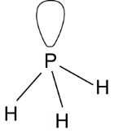
b. Coordinate / dative; Pair of electrons on P(H₃ ) donated to H⁺.
c. 109.5° / 109½ / 109° 28′
d. Difference in electronegativity between P and H is too small.
3. a. Covalent; Shared pair(s) of electrons / one electron from Br and one electron from F.
b. i.
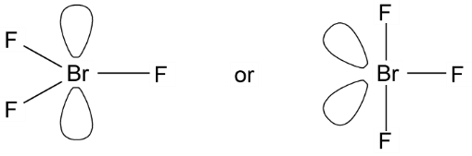
BrF₃ if trigonal planar shown = 120° or if T shape shown 84–90°
ii.
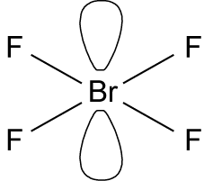
BrF₄– 90°
c. Ionic or (forces of) attraction between ions / bonds between ions; Strong (electrostatic) attraction / strong bonds / lots of energy needed to break bonds; Between K⁺ and BrF₄– ions/oppositely charged ions / + and – ions.
d. i. Hydrogen bonds / hydrogen bonding / H bonds / H bonding
ii.
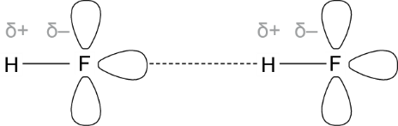
e. van der Waals forces between molecules; IMF are weak / need little energy to break IMF / easy to overcome IMF.
4. a. Al + 1.5Cl₂ → AlCl₃
b. Coordinate / dative (covalent); Electron pair on Cl – donated to Al(Cl₃).
c. Al₂Cl₆ or AlBr₃
d. SiCl₄ / silicon tetrachloride.
e.
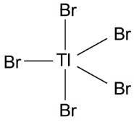
Trigonal bipyramid(al)
f. i. Cl–Tl–Cl
ii. (Two) bonds (pairs of electrons) repel equally / (electrons in) the bonds repel to be as far apart as possible.
g. Second
5. a. The ability of a nucleus to attract a bonding pair of electrons.
b. i. (in order) induced dipole–dipole / van der Waals, permanent dipole–dipole, hydrogen bonding.
ii. Large difference in electronegativity between hydrogen and fluorine produces strong polar bond in HF lone pair electrons on F attract positive H of another HF molecule.
c. i. Intermolecular forces are a combination of induced dipole–dipole and permanent dipole–dipole. Size of halogen atoms increases down Group 17 and induced dipole–dipole intermolecular forces have larger effect; more energy is needed to overcome the induced dipole–dipole forces and boiling point is higher.
ii. HF has hydrogen bonding
6. a. i. The bonding pair of electrons is closer to the more electronegative element in the molecule.
ii. Hydrogen: non-polar, both H attract bonding pair of electrons equally; Water: polar oxygen is more electronegative than hydrogen.
b. i.
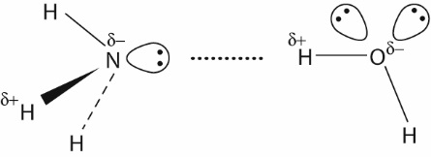
ii. 107°; water molecules have two lone pairs of electrons, ammonia has one; two lone pairs of electrons have greater repulsion than one, and bonding pairs are squeezed together more.
c. Dative/coordinate bond – both electrons in bonding pair originate from the same atom.
7. a. Similarity: covalent bonds; difference: iodine has a giant molecular structure, diamond has a macromolecular/giant covalent structure; Molecules in a molecular structure have weak intermolecular forces; easily broken; lower boiling points; Atoms in a giant covalent structure have strong covalent bonds; not easily broken and high melting points.
b. Carbon atoms in graphite have three covalent bonds; the fourth outer electron is delocalised and can carry an electric charge. Carbon atoms in diamond have four covalent bonds; no electrons free to carry an electric charge
c. i. Magnesium has metallic bonding with delocalised electrons to carry an electric charge; magnesium chloride has ionic bonding; there are no ions or electrons free to move.
ii. Liquid magnesium chloride.
8. a. i. Covalent bond
ii. Dative/coordinate bond
iii. Shows origin of bonding electron pair.
iv. Four bonding pairs of electrons give a tetrahedral shape; electron pairs repel each other to give angle of 109° 28′.
b. The ability of an atom to attract the bonding pair of electrons.
c. i. A small amount of positive charge on H.
ii. Nitrogen is more electronegative than hydrogen.
9. a. Na has one electron in outer shell; donates to OH group; Al has three electrons in outer shell; donates one to each of three OH groups.
b.
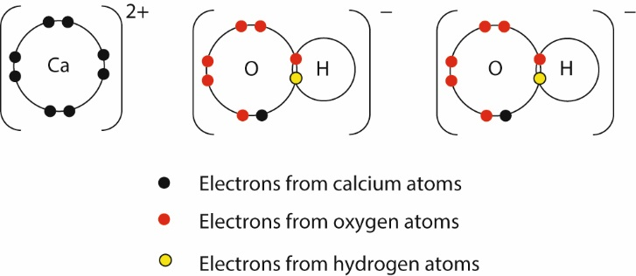
c. Electrons are transferred in ionic bonds, shared in a dative covalent bond.
d. i.
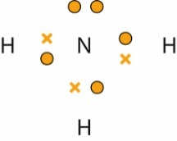
ii.
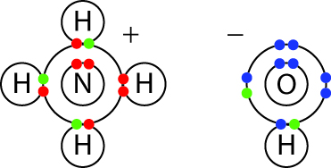

10. a. Hydrogen bonds; induced dipole–dipole / van der Waals.
b. i.
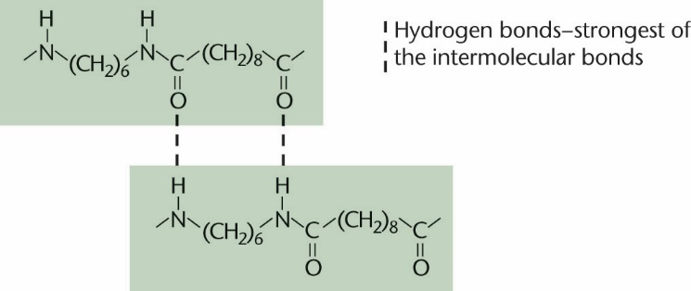
ii. O^{δ+} is attracted to H^{δ−}
c. i. 109° 28′
ii. 120°; Trigonal planar
11. C
12. A
13. D
14. C

Chapter 4: The Periodic Table
  - Assignment 1
A1. Gallium
A2. The discovery of elements whose properties matched the predicted properties of Mendeleev’s gaps in his periodic table.
A3. Filling the spaces across the transition metals and Groups 3 to 7 puts element 117 in Group 7, a halogen.
A4. Group 0, the noble gases.
A5. Mendeleev and chemists today have both added elements to the periodic table. Mendeleev filled gaps as new elements were discovered; Today, elements are made artificially and added to the end of the Periodic Table.
A6. Newland’s table only partially worked for the first 18 elements. Transition elements did not fit the pattern.
  - Assignment 2
A1. p block
A2. 5s2 5p5
A3. a. ~7 g cm−3
b. ~200 °C
c. ~900 kJ mol−1
A4. a. NaAt
b. Hat
A5. Physical properties such as density, melting points and ionisation energies show trends down a group. All elements in the same group have the same number of electrons in their outer shell. The formulae of their compounds will have similar formulae.
A6. Bismuth has 83 protons, helium ions have two protons. Adding these together gives an atom with 85 protons, which is astatine.
  - Assignment 3
A1. Li+, Na+, Mg2+, F−, O2−
A2. Sodium atom has one more electron shell than the lithium atom.
A3. Magnesium has one extra proton and a larger nuclear charge. Both have outer electrons in the 3s sub-level, but they are attracted more strongly in magnesium because of the larger nuclear charge.
A4. A lithium ion has the electron configuration of He, one fewer electron shell than a lithium atom. It also has the nuclear charge of a lithium atom, so its remaining electrons are attracted more strongly.
A5. a. 1s2, 2s2, 2p6
b. 1s2, 2s2, 2p6
A6. Both have the same electron configuration, but Mg2+ has a larger nuclear charge.
A7. a. 1s2, 2s2, 2p6
b. 1s2, 2s2, 2p6
A8. An increased number of electrons is being attracted to the same nuclear charge as in their respective atoms.
A9. a. In cations, the ionic radius is less than the atomic radius.
b. In anions, the ionic radius is greater than the atomic radius.
A10. a. Na = 1.91 × 10⁻¹⁰, Mg = 1.60 × 10⁻¹⁰, Al = 1.43 × 10⁻¹⁰, Si = 1.18 × 10⁻¹⁰, P = 1.10 × 10⁻¹⁰, S = 1.02 × 10⁻¹⁰, Cl = 9.9 × 10^{–11}
b. and c. Nuclear charge increases across the period, pulling electron shells closer to their nucleus.

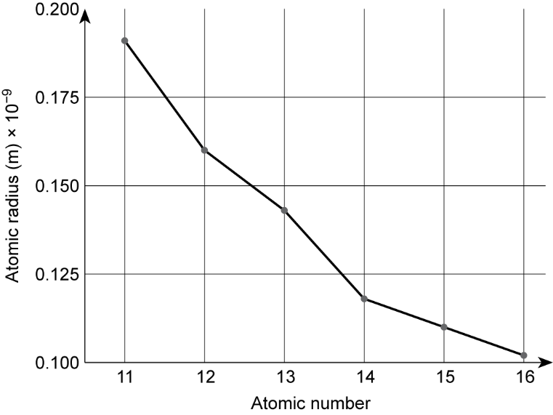
  - Practice questions
1. a. Carbon / Fewest protons / smallest nuclear charge / least attraction between protons (in the nucleus) and electrons / weakest nuclear attraction to electrons / Similar shielding.
b. Increase oxygen / Paired electrons in a (2)p orbital / Paired electrons in a p (orbital) repel.
c. C(g) → C⁺ (g) + e⁽⁻⁾
d. (More energy to) remove an electron from a (more) positive ion / cation.
e. Lithium
2. a. i. Higher than P 1
ii. 1s² 2s²2p⁶3s¹
iii. Al⁺(g) + e ⁽⁻⁾ Al²⁺(g) + 2e⁽⁻⁾
iv. Electron in Si (removed from) (3)p orbital / electron (removed) from higher energy orbital or sub-shell / electron in silicon is more shielded.
b. Sodium / Na / Electron (removed) from the 2nd shell / 2p (orbital).
c. Silicon / Si
d. Heat or energy needed to overcome the attraction between the (negative) electron and the (positive) nucleus or protons / electron promoted to higher energy level (infinity) so energy must be supplied.
3. a. Li(g) → Li⁺(g) + e⁻(g)
Li(g) − e⁻ → Li⁺(g)
Li(g) + e⁻(g) → Li⁺(g) + 2e⁻
b. Increases / Increasing nuclear charge / Increasing no of protons / Same or similar shielding / Same no of shells / Electron (taken) from same (sub)shell / Electron closer to the nucleus / Smaller atomic radius.
c. Lower / Paired electrons in a (4) p orbital / (Paired electrons) repel.
d. Kr is a bigger atom / has more shells / more shielding in Kr / electron removed further from nucleus / electron removed from a higher (principal or main) energy level.
e. 2
f. Arsenic
4. a. Energy required to remove one mole of outmost electrons from one mole of atoms of an element in the gaseous state.
b. 1s²2s²2p⁶
c. s block
d. Mg⁺(g) → Mg²⁺(g) + e⁻
e. Larger nuclear charge in Mg²⁺ attracts outer electron more strongly / Mg²⁺ is smaller than Ne; outer electrons attracted more strongly in Mg²⁺.
f. i. Overall, first IE increases with atomic number.
ii. Electron is paired in p orbital, repulsion, more easily removed.
5. a. Diagram needs to show Si (1687 K) higher than Al; Cl (171.5 K) lower than S, and Ar (83.6 K) lower than Cl.
b. Silicon has a giant covalent structure / strong bonds need a lot of energy to break.
c. S molecule is larger than P molecule / stronger intermolecular forces, so more energy needed to break them.
6. a.
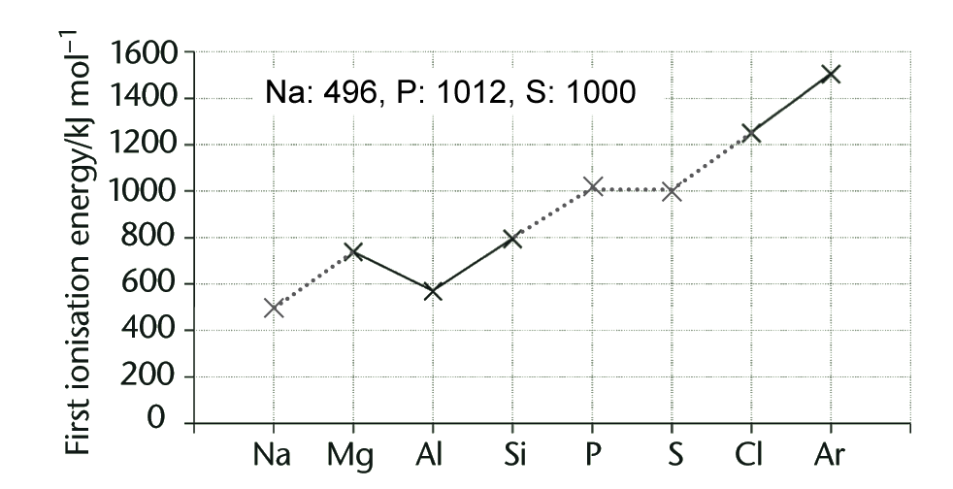
b. Increasing number of protons / nuclear charge across the period / electrons are attracted more strongly to the nucleus / more energy is needed to remove electrons.
c. Al has two electrons in 3s orbital and one in 3p orbital; p orbital electrons are in slightly higher energy level than s electrons and easier to remove / S has a pair of electrons in a p orbital; these repel each other and it is easier to remove one.
7. a. Section of periodic table containing Groups 1 and 2 / outer electrons are in s orbitals.
b. Higher nuclear charge / number of protons in magnesium atoms draws electron shells closer to the nucleus.
c. Magnesium has one more proton / higher nuclear charge than sodium attracts outer electrons more strongly and more energy is needed to remove an electron.
d. Solid magnesium contains Mg²⁺ ions and two delocalised electrons per ion. Compare with sodium. Stronger attraction between ions and delocalised electrons in magnesium. More energy needed to break metallic bonds.
e. i. Melting point of Al is higher than Mg melting point.
ii. Al forms Al³⁺ ions; stronger attraction between Al ions and electrons.
8. a. The energy needed to remove a mole of outermost electrons from a mole of atoms of an element in the gaseous state.
b. Na(g) → Na⁺(g) + e⁻
c. Overall increase across period 3 due to increasing number of protons/nuclear charge across period and more energy needed to remove an electron.
d. i. Al, S
ii. Al: electron enters p orbital at slightly higher energy level, less energy needed to remove it; S paired electron in p orbital; repulsion, easier to remove.
e. i. Trends or repeating patterns in the periodic table.
ii. Neon / highest nuclear charge, more energy needed to remove an electron.
f. Mg⁺(g) → Mg²⁺(g) + e⁻
g. Second ionisation energy is too high because electron is being removed from an inner shell.

9. a. i. Increasing charge on metal ion and number of delocalised electrons – more energy needed to
break metallic bonds
ii. Strong covalent bonds need to be broken.
b. P: molecular, P₄; S: molecular, S₈; Cl: molecular, Cl₂; Ar: atomic
c. i. S has larger molecules; stronger intermolecular forces; more energy needed to break them.
ii. Intermolecular forces decrease as molecules/atoms get smaller.
10. a. The ability of a nucleus to attract the bonding pair of electrons.
b. Chemically unreactive.
c. Decreases as number of protons/nuclear charge increases, drawing electron shells closer to the nucleus.
d. Increasing nuclear charge, decreasing size of atoms.
e. Similar values; neither S nor Cl has ability to withdraw the bonding pair of electrons to form an ionic bond / bonding electrons are shared.
11. B
12. D
13. A
14. D

Chapter 5: Introduction to organic chemistry
  - Assignment 1
A1. Bonds between carbon atoms, and between carbon atoms and functional groups.
A2. Double bonds.
A3. The atoms that make up the functional group are named.
A4. IUPAC
A5. The manufacturers of medicines containing ibuprofen.
A6. It ensures that ibuprofen is the same chemical, regardless of product name.
A7.
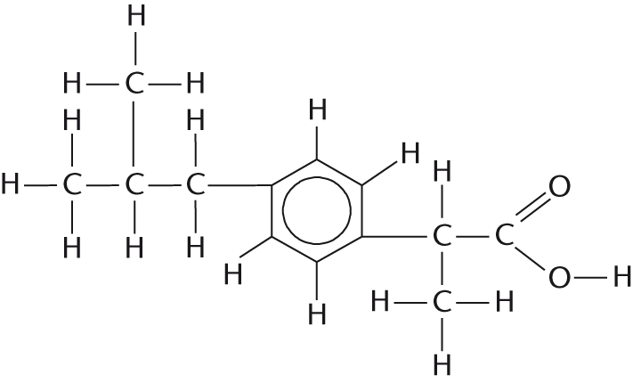
A8. –COOH; carboxylic acid group.
  - Assignment 2
A1. Platin has a flat structure.
A2.
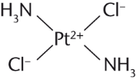
A3. The pair of electrons that make the covalent bond originated from the same atom.
A4.
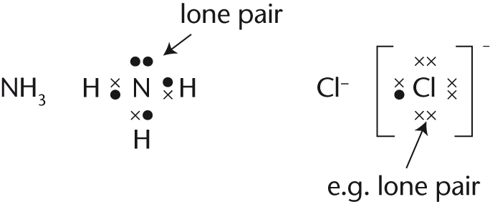
  - Assignment 3
A1. C–C single bonds
A2. Double bond is shorter, stronger and not free to rotate.
A3. Unsaturated fats possess a double bond in their long carbon chains which holds that section of the chain in a rigid position.
A4. Controlling variable such as different genetic make-ups, different environments, different diets, different appetites.
A5.
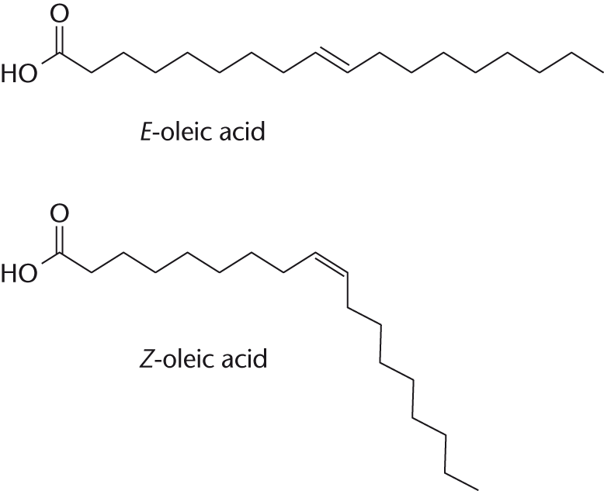
A6.
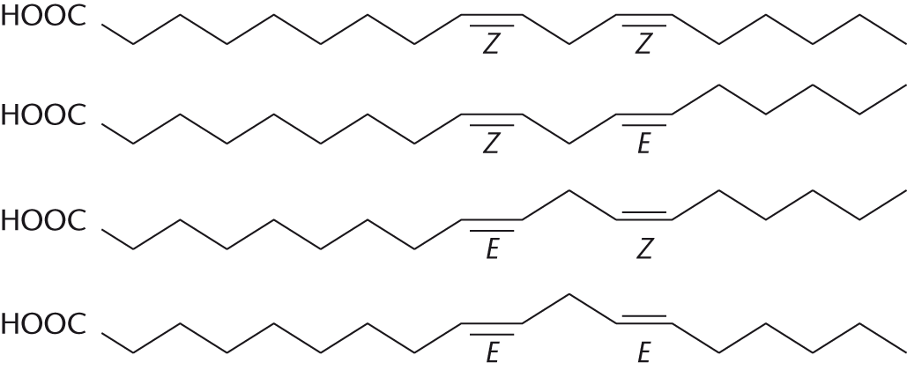

  - Practice questions
1. a. i. (Compounds with the) same molecular formula but different structural formula / different
displayed formula / different structures / different skeletal formula.
ii. But-2-ene
iii. (2)-methylprop-(1)-ene
iv.
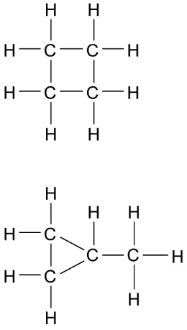
2. a. i. 2-bromo-2,3-dimethylbutane
ii. C_{n}H_{2n+1} Br or C_{n}H_{2n+1}X or C_{x}H_{2x+1}Br
iii. Stronger van der Waals forces between molecules of 1-bromohexane.

b.
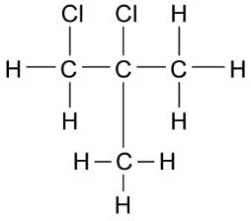C₂H₄Cl
3. a. i. C_{n}H_{2n}
ii. Fractional distillation / gas liquid chromatography.
b. i. But-1-ene
ii. A structure of cyclobutane or methyl-cyclopropane.
4. a. Same general formula / allow a named homologous series with its general formula. Chemically similar/same chemical reactions. Same functional group. Trend in physical properties (such as increasing boiling point as M_{r} increases). Molecules increase by CH₂/M_{r} = 14.
b. Fractional distillation / fractionation / chromatography.
c. i. (Molecules/compounds/substances) with the same molecular formula / same number and type of atoms but different structural formula / different displayed formula / different arrangement of atoms / different structures.
ii. 2,4-dimethylhexane, C₄H₉
d. Less surface contact / less polarisable molecule so fewer/weaker/less van der Waals forces.
5. a. but-1-ene; methylpropene
b. Isomer 2
6. a. i. Have the same molecular formula; atoms bonded together in a different order.
ii. Pentane and 2-methyl butane, hexane and 2-methylpropane, heptanes and 2-methylhexane.
iii. Chain isomerism.
b. i. C₅H₁₂
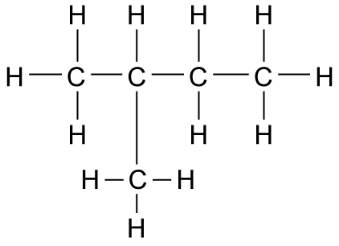
ii. Covalent
iii. Induced dipole–dipole/van der Waals.
iv. Straight chain structure molecules can get closer together; more induced dipole–dipole intermolecular forces; more energy needed to break them.
7. a. OH
b.
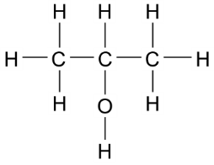
c. Positional isomer.
d. Propan-1-ol molecules lie closer together; more induced dipole/dipole intermolecular forces; more energy needed to break them.
e. Does not evaporate so easily / higher boiling point.
8. a. i. Alkenes
ii. C_{n}H_{2n}
b. i. CH₂

ii.
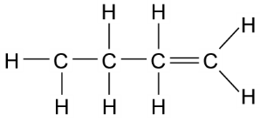
c. 2
d. i. e.g. but-1-ene, but-2-ene, 2-methlpropene
ii. Displayed formula to follow through from i.
iii. Types to follow through from i. and ii.
e. The double bond is always attached to the first carbon.
9. a. 1-chlorobutane;
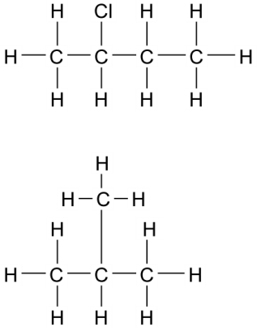
b. Halogenoalkanes
c. Same molecular formula, atoms bonded together in different order.
d.
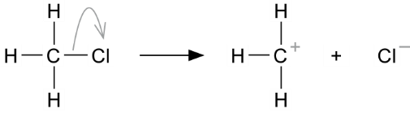
e. i
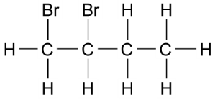
ii.
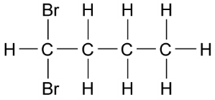
f. C₄H₈Br₂
g. C₂H₄Br
h.
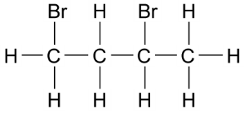 1,3-dibromobutane (or other correct isomer)

10. a.
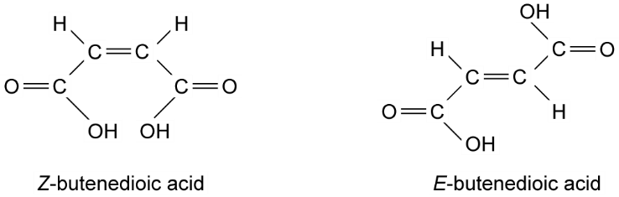
b.

c. C=C bond not free to rotate / planar; attached groups in fixed position.
d. H on the COOH groups.
11. A
12. D
13. C
14. A

Chapter 6: The alkanes
  - Assignment 1
A1. a. C_{n}H_{2n+2}
b. C₃H₈; C₁₀H₂₂
c. Propane
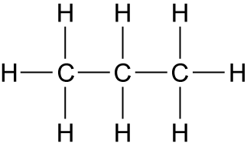
Decane
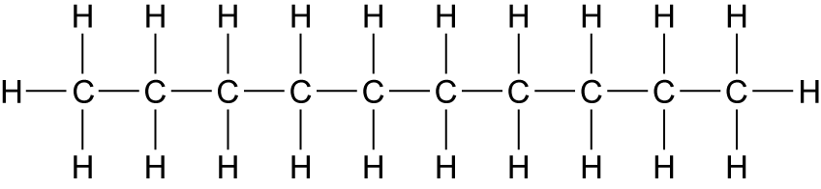
d. i.
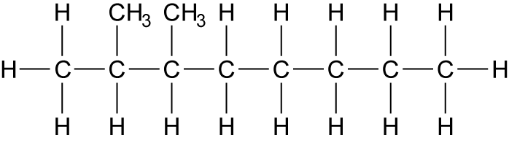
ii.
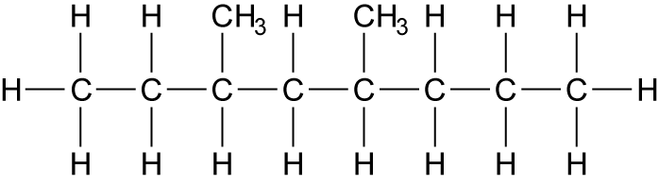

e.
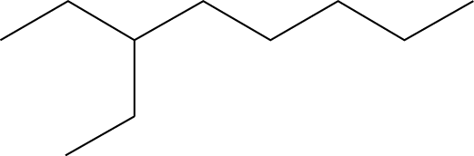
f. Chain isomers.
A2. a. No; the values are similar.
b. van der Waals.
c. The intermolecular forces, van der Waals forces are broken.
d. Propane has shorter carbon chains than decane and the van der Waals forces are less. Less energy is needed to break them and propane has a lower boiling point than decane.
A3. a. 1 to 12 carbons; 5 to 11 carbons; 11 to 15 carbons; 13–17 carbons.
b. LPG and petrol; naptha; kerosene; kerosine and gas oil/diesel.
  - Assignment 2
A1. CH4(g) + 2O2(g) → CO2(g) + 2H2O(g)
C8H18(g) + 121/2O2(g) → 8CO2(g) + 9H2O(g)
C12H26(g) + 181/2O2(g) → 12CO2(g) + 13H2O(g)
A2. CH4 = −890.3 kJ mol−1, C8H18 = −683.8 kJ mol−1, C12H26 = −673.9 kJ mol−1
A3. The longer the alkane chain, the less energy per mole of CO2 produced.
A4. Petrol: 5.63 × 107 tonnes.
A5. Refinery gases: 2.05 × 107 tonnes; Aviation fuel: 3.91 × 107 tonnes.
A6. Total = 1.16 × 108 tonnes
  - Assignment 3
A1.
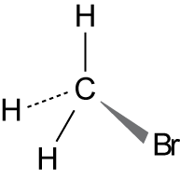
A2. CH₃Br → CH₃. + Br
A3. Bromine radicals have an unpaired electron which makes them very reactive.
A4. The ozone destroyed by naturally produced bromomethane was in balance with the ozone made in the upper atmosphere. Manufacturing extra bromomethane upset this balance.
A5. a. Br₂ → Br$\text{•}$ + Br$\text{•}$
b. CH₃Br + Br$\text{•}$ → CH₂Br$\text{•}$ + HBr
c. CH₂Br$\text{•}$ + Br₂ → CH₂Br₂ + Br
A6. Br$\text{•}$ + Br$\text{•}$ → Br₂, CH₂Br$\text{•}$ + Br$\text{•}$ → CH₂Br₂
A7. CH₃Br + 3Br₂ → CBr₄ + 3HBr
  - Practice questions
1. a. i. C₄H₈ + 2O₂ → 4C + 4H₂O
ii. Exacerbates asthma / breathing problems / damages lungs / smog / smoke / global dimming.
b. i. C₁₆H₃₄
ii. Jet fuel / diesel / motor fuel / lubricant / petrochemicals / kerosene / paraffin / central heating
fuel / fuel oil.
c. i. C₈H₁₈ + 25NO → 8CO₂ + 12.5 N₂ + 9H₂O
ii. Ir / iridium OR Pt / platinum OR Pd / palladium.

2. a. Fractional distillation / fractionation / GLC / gas liquid chromatography.
b. C₄H₁₀; It has a higher bp / has stronger IMF / larger molecules / longer chain / larger surface (area).
c. C₄H₁₀ + 6½ O₂ → 4CO₂ + 5H₂O
d. CO₂ or H₂O evolved is a greenhouse gas / CO₂ or H₂O evolved contribute to global warming / the products are greenhouse gases.
e. CH₃CH₂CH₂CH₃ + 3.5O₂ → C₂H₂(CO)₂O + 4H₂O
f. i. C₂H₅SH + 4.5O₂ → 2CO₂ + 3H₂O + SO₂
ii. Calcium oxide / calcium carbonate; Neutralises the SO₂ / acid base reaction / it is a base.
iii. Ethanol contains hydrogen bonding, which is stronger than IMF / dipole–dipole forces in ethanol / H bonding is the strongest IMF.
3. a. i. CH₄ + 2O₂ → CO₂ + 2H₂O
ii. Not enough oxygen / air.
iii. CMM / methane is a greenhouse gas / contributes to global warming.
b. i. CH₃SH + 3O₂ → CO₂ + 2H₂O + SO₂
ii. Calcium oxide is basic (and SO₂ is acidic) / CaO neutralises SO₂ / CaO reacts with SO₂ to form gypsum / salt / solid / CaSO₄ / CaSO₃; Allow CaO + SO₂ → CaSO₃
iii. Acid rain.
4. a. Initiation: Cl₂ → 2Cl•
b. First propagation: Cl• + CH₃Cl •CH₂Cl + HCl
c. Second propagation: Cl₂ + •CH₂Cl → CH₂Cl₂ + Cl•
d. Termination (making 1,2-dichloroethane): 2 •CH₂Cl → CH₂ClCH₂Cl
5. a. i. Any two from: Same functional group / similar chemical reactions / trends in physical
properties/ chemically similar or react in the same way have the same functional group 2.
ii. Fractional distillation or fractionation.
iii. All carbon–carbon bonds are single covalent bonds (or has no double bonds).
b. i. The molecular formula gives the actual number of atoms of each element/type in a molecule/hydrocarbon/compound/formula 1).
ii. C₁₄H₃₀ only 1
iii. C₁₀H₂₂ +5½O₂ → 10C + 11H₂O (or double this equation)
c. i. ½N₂ + ½O₂ → NO 1 (or double this equation)
ii. Platinum / rhodium 1 / palladium.
iii. 2NO + 2CO → 2CO₂ + N₂ or 2NO → N₂ + O₂ or
C + 2NO → CO₂ + N₂ (or half of each of these equations)
C₈H1₈ + 25NO → 8CO₂ + 12½N₂ + 9H₂O (or double this equation)
6. a. i. C₅H₁₂ + 8O₂ → 5CO₂ + 6H₂O
ii. Carbon
iii. Sulfur impurity in fuel combusts to form sulfur dioxide.
iv. Produces acid rain.
b. i. Calcium oxide
ii. SO₂ + CaCO₃ → CaSO₃ + CO₂
iii. To make CaSO₄ / plaster / plasterboard.
7. a. C₂₁H₄₄ → 3C₂H₄ + 2C₃H₆ + C₉H₂₀
b. i. Many fractions used as fuels; sulfur combusts to produce sulfur dioxide; causes acid rain.
ii. High temperature in petrol engine exceeds activation energy for O₂ and N₂ in air to react.
iii. Catalytic converter where 2NO + 2CO → 2CO₂ + N₂
CO is poisonous; NO contributes to acid rain / forms toxic NO₂.
8. a. Cl₂ → Cl• + Cl•
b. i. C₂H₆ + Cl• → C₂H₅• + HCl; C₂H₅• + Cl₂ → C₂H₅Cl + Cl•
ii. Chloroethane
iii. A chlorine radical is produced.
c. i. C₂H₅• + C₂H₅• → C₄H₁₀
ii. 1,1-dichloroethane, 1,2-dichloroethane
9. a.
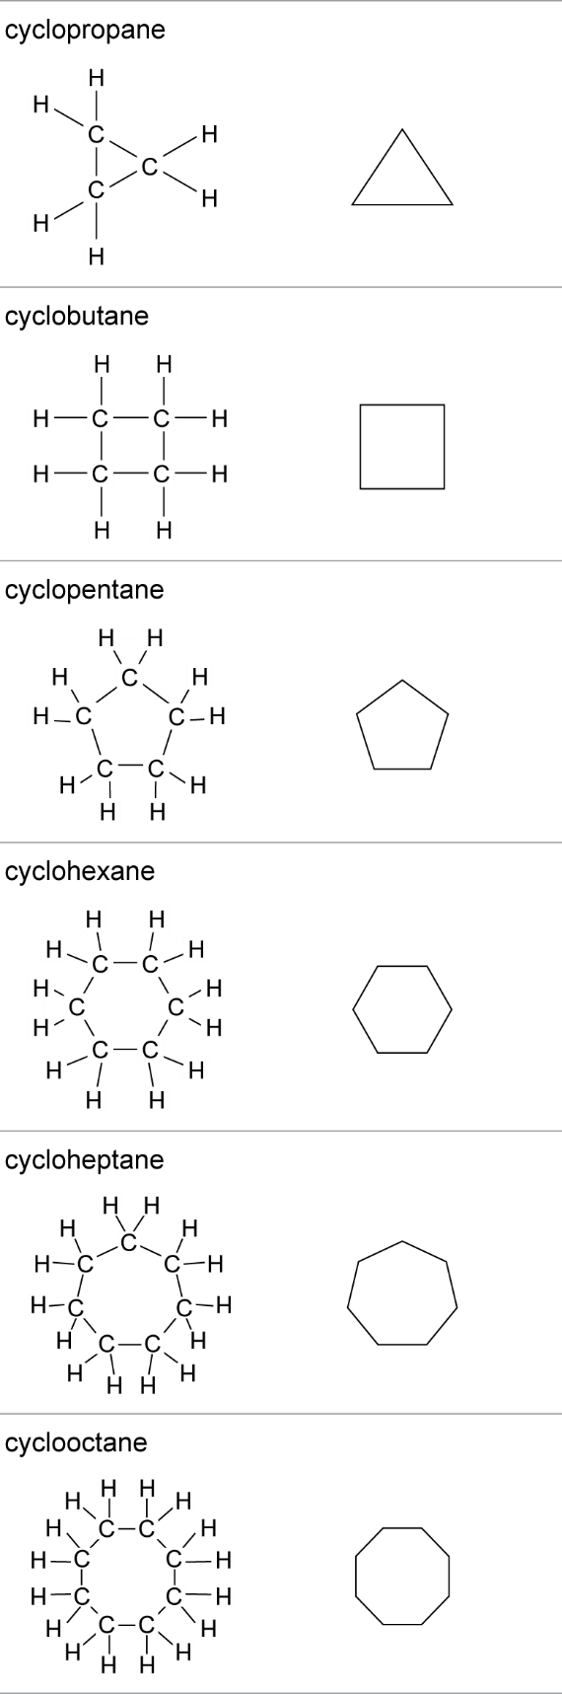
b.
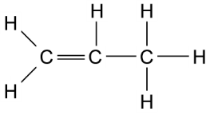
Structural isomer /chain isomer /ring chain isomer.
c. 60°, 90°, 108°, 120°, 129°, 135°
d. Carbon ring is strained in smaller cycloalkanes and more easily broken.
e. Cycloalkanes have stronger van der Waals intermolecular forces because ring shape allows molecules to get closer together.
10. D
11. D
12. A
13. D

Chapter 7: Energetics
  - Assignment 1
A1.
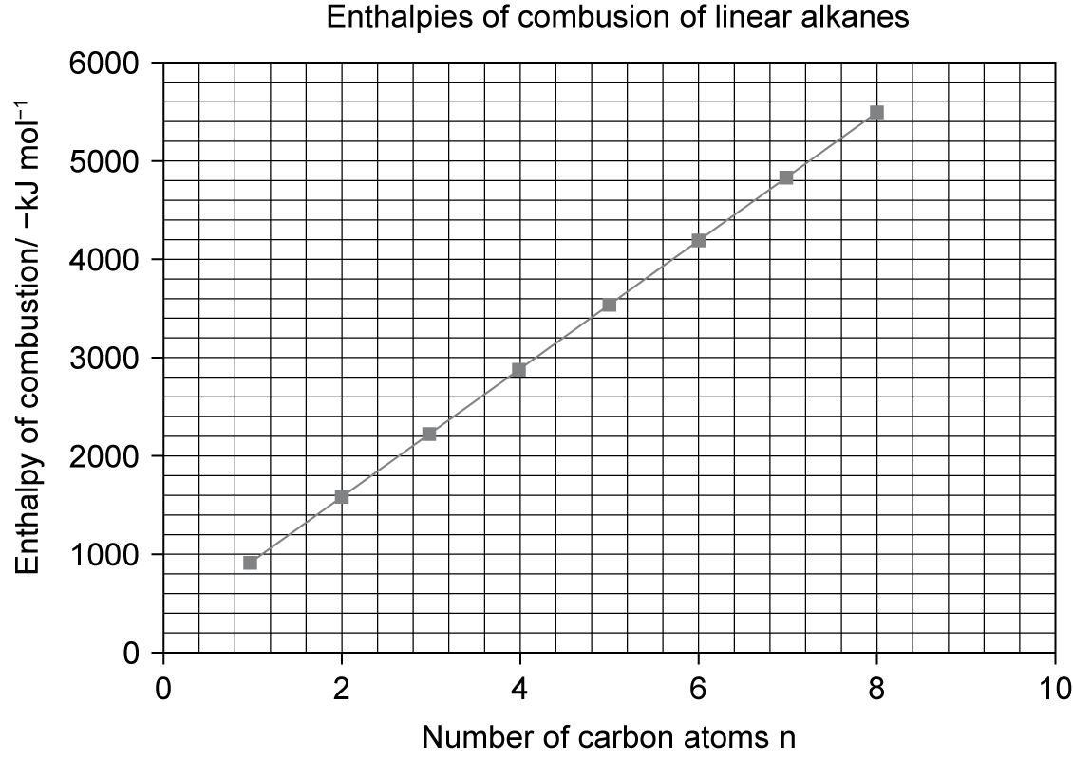
A2. Between 6100 and 6150 kJ mol⁻¹
A3. a. Difference are: 670, 659, 658, 632, 654, 654, 653
b. The difference between enthalpy values for each successive alkane is similar.
c. Each successive alkane has an extra CH₂ group. Breaking these bonds and using the atoms to make new bonds accounts for the regular increase in enthalpy of combustion.
  - Required Practical 2 (PART 1)
P1. Measuring 25 cm³ in a 50 cm³ measuring cylinder. Percentage error = 4%. Percentage error when using the 25 cm³ cylinder = 2%.
P2. The measured mass loss would be greater than that due to the liquid burning.
P3. Empty and dry the calorimeter. Use fresh water. Allow the calorimeter to cool if necessary.
  - Required Practical 2 (PART 2)
P1. Improved insulation, therefore less heat loss and more accurate values obtained.
P2. Copper is a good thermal conductor, therefore heat losses would be significant.
P3. The temperature of both solutions is monitored prior to mixing. When they are mixed, a timer is started and the temperature of the mixture recorded until several minutes after the reaction mixture has begun to cool. A graph of temperature against time is plotted and the straight line obtained when the mixture is cooling is extrapolated back to the time of mixing and the corrected temperature rise is estimated.
  - Assignment 2
A1. a. 40.7 kJ
b. 0.010 mol
c. 4074 kJ mol–1
A2. 104.3 kJ
A3. In the bomb calorimeter, the burning fuel in the calorimeter is surrounded by water and an air filled insulation jacket. Most of the energy from the burning fuel is transferred to the water and measured as a temperature rise. When the apparatus in Figure 5 is used to measure the energy transferred, much heat is lost in heating the surroundings.
  - Assignment 3
A1. a. 570 g
b. 58
c. 9.83 mol
d. 28 271 kJ dm–3
A2. a. 33 588 kJ dm–3
b. 23 471 kJ dm–3
c. 6427 kJ mol⁻¹
A3. Petrol (octane) can give the highest amount of energy. Hydrogen gas is the lowest, but hydrogen is gaseous and the other fuels are liquid.
A4. When petrol combusts most of the energy released is heat energy, which is lost to the surroundings.
  - Practice questions
1. q = m c ΔT
OR q =140 × 4.18 × 7.5
= 4389 J
Using 0.0110 mol, therefore ΔH = –399 (kJ mol⁻¹) OR –400
2. ΣB(reactants) – ΣB(products) = ΔH
Sum of bonds broken – Sum of bonds formed = ΔH
B(H–H) + ½B(O=O) – 2B(O–H) = –242
B(H–H) = –242 – ½(+496) + 2(+463)
B(H–H) = (+)436 (kJ mol^{–1})
3. a. Heat (energy) change at constant pressure
b. The enthalpy change / heat (energy) change (at constant pressure) in a reaction is independent of the route / path taken (and depends only on the initial and final states).
c. ΔH + 963 = –75 – 432 OR ΔH + 963 = – 507
ΔH = –75 – 432 – 963
ΔH = –1470 (kJ mol^{–1})
4. a. i. ΔH_{r} = ΣΔHf (products) − ΣΔHf (reactants)
OR a correct cycle of balanced equations with 1C, 3H₂ and 1O₂
ΔH_{r} = –201 + (–242) – (–394)
ΔH_{r} = –201 – 242 + 394
ΔH_{r} = –443 + 394
= –49 (kJ mol⁻¹)
ii. It is an element / elemental.
OR
By definition.
5. a. C(s) + 2F₂(g) CF₄(g)
b. It is an element / by definition.
c. Around carbon there are four bonding pairs of electrons (and no lone pairs); Therefore, these repel equally and spread as far apart as possible.
d. ΔH = ΣΔ_{f}H products – ΣΔ_{f}H reactants or a correct cycle
Hence = (2 × –680) + (6 × –269) – (x) = –2889; × = 2889 – 1360 – 1614 = –85 (kJ mol^{–1})
e. 436 + 158 – (562 × 2)
–530
So for 1 mole of HF = –265 (kJ mol^{–1})
6. a. The quantity of energy transferred in a chemical reaction
b. N₂(g) + ½O₂(g) → N₂O
c. i. Energy needed to break bonds to make 1 mol NF₃ = (0.5 × 945) + (1.5 × 159) = +711 kJ
Energy given out when bonds form to make1 mol NF₃ = −(3 × 278) = −834 kJ
Enthalpy of formation NF₃ = +711 −834 = −123 kJ mol⁻¹
ii. Mean bond enthalpies are calculated from bonds in a variety of environments.
d. i. Fluorine is an element.
ii. ΔH_{r} = ΣΔH_{f} (products) − ΣΔH_{f} (reactants) OR a cycle
ΔH_{r} = [−114 + (3 × −467)] − [(4 × −46) + 0]
= −1331 kJ
7. a. Mean bond enthalpy: the average enthalpy change when one mole of bonds in gaseous molecules is broken under standard conditions.
Standard enthalpy of formation: the enthalpy change when one mole of a substance is formed from its elements. All reactants and products are in their standard state at 100 kPa and 278 K.
b. Bonds broken: (4 × 388) + (1 × 163) + 4 × 463) + (2 × 146) = +3859 kJ
Bonds made: (1 × 944) + (8 × 463) = −4648 kJ
Enthalpy change = +3859 + (–4648)
= −789kJ
c. i. 0
ii. ΔH_{r} = ΣΔH_{f} (products) − ΣΔH_{f} (reactants) OR a cycle
ΔH_{r} = [(4 × −242)] − [(+75) + (2 × −133)]
= −777 kJ
d. Bond enthalpies are average values calculated from a range of molecules / enthalpies of formation are specific to a compound.
8. a. Standard enthalpy of formation: the enthalpy change when one mole of a substance is formed from its elements. All reactants and products are in their standard state at 100 kPa and 278K.
b. ΔH_{r} = ΣΔH_{c}(reactants) − ΣΔH_{c}(products)
ΔH_{r} = [(7 × −394) + (4 × −286)] – (−3909)
= +7 kJ mol⁻¹
c. q = m c ΔT
= 250 × 60 × 4.18
= 62 700 J
M_{r} methylbenzene = 92
$$\text{Δ}{\text{H}}_{\text{c}}\text{ = }\frac{\text{62.7}}{\text{2.5}}\text{ ×} \text{92}$$
= 2307 kJ mol⁻¹
d. q = m c ΔT
= 75 × 8.5 × 4.18
= 2664.75 J or 2.665 kJ
Mol of acid used = 0.05
Mol of sodium hydroxide used = 0.05
Mol of water and NaCl made = 0.05 each
$$\text{Standard enthalpy change = }\frac{\text{2.665}}{\text{0.05}}\text{ ×} \text{1}$$
= 53.3 kJ mol⁻¹
e. Less heat loss
9. a. Initial and final temperature water, initial and final mass spirit burner, volume ÷ mass water used.
b. Cu is a better conductor of heat.
c. To reduce heat loss.
d. q = m c ΔT
e. i. Heat loss.
ii. Precision errors on measuring cylinder, thermometer, balance.
iii. Procedural error.
10. a. i. CH₃OH +1½O₂ → CO₂ + 2H₂O
C₂H₅OH +3O₂ → 2CO₂ + 3H₂O
C₃H₇OH +4½O₂ → 3CO₂ + 4H₂O
C₄H₉OH +6O₂ → 4CO₂ + 5H₂O
C₅H₁₁OH +7½O₂ → 5CO₂ + 6H₂O
ii. C_{n}H_{2n+1}OH + $\frac{n}{2}$ + 2 O₂ → nCO₂ + $\frac{2n+2}{2}$ H₂O
iii. Number of carbon dioxide molecules equals number of carbon atoms in alcohol.
Number of water molecules produced equals number of carbon atoms in alcohol plus one.
iv. ΔH_{c} increases as number of carbon atoms in alcohol increases because energy given out as more CO₂ and H₂O are formed is greater than energy required to break one extra C–C bond and two extra C–H bonds.
11. A
12. B
13. D
14. B

Chapter 8: Kinetics
  - assignment 1
A1. The enthalpy of the products is lower than that of the reactants.
A2. The minimum energy needed by colliding molecules before they can react.
A3. The ‘bump’ is small.
A4. Nitroglycerine must be handled carefully because little energy is needed to make it explode. More energy is needed to make TNT explode so it is easier to handle.
A5. TNT
A6. It has a high activation energy; it produces large volumes of gases; it has a high rate of reaction.
A7. a. Since the reaction would be very slow, it would not explode.
b. The enthalpy profile would be the same.
  - Required Practical 3
P1. a. CaCO_{s}(s) + 2HCl(aq) → CaCl₂(aq) + CO₂(g) + H₂O(l)
b. Mass loss or collecting gas in syringe (not displacement of water because carbon dioxide is slightly soluble in water).
P2. a. Mg(s) + H₂SO₄(aq) → MgSO₄(aq) + H₂(g)
b.
$$\text{0.20 g Mg} \text{= }\frac{\text{0.20}}{\text{24}}\text{ mol Mg}$$
$$\text{From the equation, 1 mol Mg produces 1 mol H}\text{2}\text{, therefore }\frac{\text{0.20}}{\text{24}}\text{ mol Mg produces }\frac{\text{0.20}}{\text{24}}\text{ mol }{\text{H}}_{\text{2}}$$
$$\text{So, volume of }{\text{H}}_{\text{2}} \text{= }\frac{\text{0.20}}{\text{24}}\text{ ×} \text{24 000 }{\text{cm}}^{\text{3}} \text{=} \text{200 }{\text{cm}}^{\text{3}}$$
c. An inverted burette would be the mosy accurate, but does not come in large enough volume. Therefore, use a 250 cm³ measuring cylinder (any larger, such as 500 cm³, would increase the apparatus error).
P3. From 2SO₂ + O₂ ⇌ 2SO₃; 3 mol reactants produce 2 mol products, so the pressure will decrease as the reaction proceeds.
  - Assignment 2
A1. a.
$$\frac{\text{400 ×} \text{100}}{\text{1 000 000}} \text{=} \text{0.04\%}$$
b. 0.07
A2. 170.2%
A3. 343.6%
A4. More carbon dioxide diffuses into the plant cells to give a higher CO2(aq) concentration. More collisions with water molecules will have the necessary activation energy.
A5. Several factors can affect a change. Many have a high magnitude, in other words, there are plenty of them. However, often one is in very short supply, so its availability becomes the limiting factor.
A6. CH4(g) + 2O2(g) → 2H2O(g) + CO2(g)
A7.
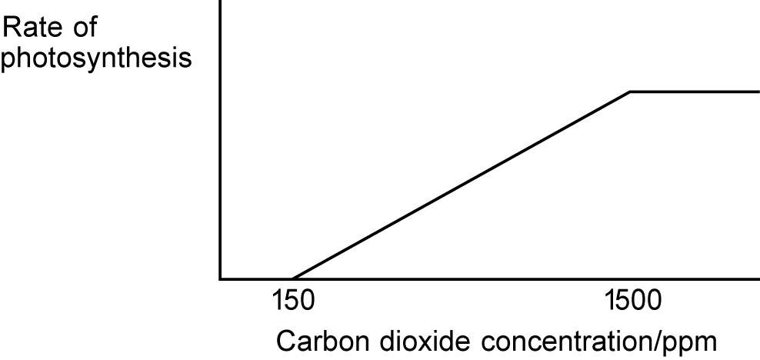
  - Assignment 3
A1. It provides a route with lower activation energy and, therefore, speeds up the reaction.

A2.
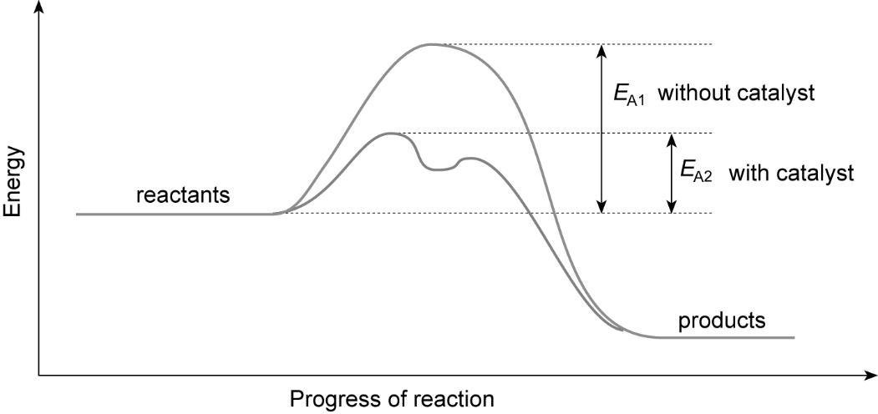
A3. Solid catalysts can have nanoparticles. The reactants need to be liquid or gaseous in order to collide with the catalyst.
A4. Reactions can happen quicker, decreasing energy use and increasing profits.
A5. Less energy is used. Reactions can be carried out at lower temperatures.
A6. The nanocatalyst (like all catalysts) forms a reactive intermediate and the activation energy for its formation is lower than that for the uncatalysed reaction. Also, because of its large surface area compared with conventional heterogenous catalysts, more molecues can be adsorbed onto its surface to form the reactive intermediate, so this also speeds up the reaction.
  - Practice questions
1. a. On the energy axis, E_{mp} at the maximum of the original peak; The peak of their new curve is displaced to the left and higher than the original.
  - The new curve starts at the origin and should begin to separate from the original almost immediately.
  - The new curve crosses the original curve once.
  - New curve goes towards the energy axis below the original curve but does not touch the original curve or the axis.
b. The rate of reaction decreases as the temperature decreases because a decrease in the number of molecules with E ≥ E_{a} OR fewer molecules have E ≥ Ea OR fewer molecules have sufficient energy to react.
2. a. Curve is steeper than original and starts at the origin; curve levels at the top line on the graph.
b. Curve is shallower than original and starts at the origin; curve levels at the first line on the graph.
c. Curve would be steeper than original; curve levels at the same original volume of O₂.
d. The concentration of H₂O₂ or reactant decreases OR The number of H₂O₂ or reactant molecules decreases.
The rate of reaction / decomposition / formation of oxygen / frequency of collisions / effective collisions in a given time decreases/is slower.
3. a. The activation energy is the minimum/least/lowest energy; Energy for a reaction to occur OR Energy for a successful collision.
b. Catalysts provide an alternative route/mechanism/path; Lowers the activation energy.
c. i. Stays the same.
ii. Increases.
iii. Increases.
iv. Stays the same.
4. a. i. The peak of the new curve is displaced to the right; The new curve starts at the origin; The
peak of the new curve is lower than the original; The new curve only crosses the original curve
once; An attempt has been made to draw the new curve correctly towards the energy axis but
not to touch the original curve; the new curve must not start to diverge from the original curve.
ii. Increase in the number/proportion of molecules with E ≥ E_{a} OR more molecules have E ≥ E_{a} OR more molecules have sufficient energy to react; More effective/productive/successful collisions.
b. i. Iron (Fe)
ii. Catalysts provide an alternative route/pathway/mechanism OR surface adsorption/reaction occurs that has a lower activation energy OR lowers the activation energy.
5. a. i. Increases rate of reaction.
ii. Increases the rate of reaction.
iii. Increases the rate of reaction.
b. i. The minimum energy needed by colliding molecules before they can react.
ii. Low collision rate.
c. Increased surface area.
6. a. i. Axes labelled: y = number of molecules/concentration; x = energy.
ii. The total number of molecules in the gas.
iii. Because gas molecules cannot have zero energy.
iv. The peak of the new curve is displaced to the right.
All of the following are required: The new curve starts at the origin; The peak of the new curve is lower than the original; and the new curve only crosses the original curve once; and an attempt has been made to draw the new curve correctly towards the energy axis but not to touch the original curve; the new curve must not start to diverge from the original curve.
b. Using a catalyst involves a different activation energy; increasing temperature or concentration do not. Catalyst provides an alternative pathway with a lower activation energy.
7. a. The minimum energy needed by colliding molecules before they can react.
b. A substance that increases the rate of a reaction without being used up.
c. Provides an alternative pathway with a lower activation energy.
d. i. Curve W should show the following: originates to show high concentration rapidly at first then slows; converges with horizontal section of given curve and joins with it.
ii. Curve Z should show the following: starts at the origin; increases rapidly at first then slows; has a steeper curve than that given; levels out to show same concentration of Z.
iii. Reactants are used up, their concentration decreases as the reaction proceeds.
8. a. 2CO + 2NO → 2CO₂ + N₂
b. To increase the surface area.
c. Catalysts are not used up in chemical reactions.
d. Provides an alternative route with a lower activation energy.
e.
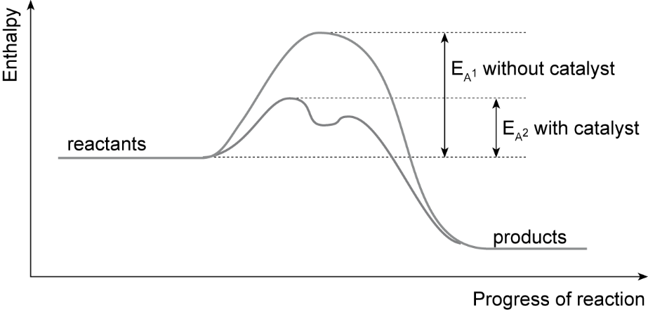

9. a. i. Water bath maintains a more constant temperature / avoids use of a flame.
ii. Instant / temperature can be plotted continuously.
b. Reactants will be mixed prematurely if same measuring cylinder is used.
c. Error on measuring cylinders / error on thermometer / human error in deciding when same amount of ppt is formed / cooling during experiment.
d. i. Make a dot in centre of each well of spotting tile/label tile / use same concentrations of reactants / place small volume or set number of drops of sodium thiosulfate on spotting tile / add smaller volume or number of drops of dilute hydrochloric acid to sodiumthiosulfate / measure time for dot to disappear / repeat using different concentrations or temperatures.
ii. Rapid cooling of reactants on spotting tile affects results.
10. a. Label four 100 cm³ volumetric flasks with concentrations; use a syringe to add following volumes of 1.0 mol dm^{–3} hydrochloric acid to each flask: 20 cm³, 40 cm³, 60 cm³, 80 cm³; add deionised or distilled water to each / use a dropper to make up to the 100 cm³ mark; stopper and invert to mix.
b. Points needed: place set length Mg ribbon in flask; measure set volume 1.0 mol dm^{–3} hydrochloric acid in a measuring cylinder; add to flask, connect syringe and start stopclock; record volume of gas given off at regular time intervals; rinse apparatus and repeat using different concentrations of acid.
11. A
12. C
13. A
14. D

Chapter 9: Equilibria
  - Assignment 1
A1. Yield increases.
A2. Yield decreases.
A3. Temperature increase moves the position of equilibrium in the endothermic direction. This is towards the reactants N₂ and H₂.
A4. Four moles of reactants produce two moles of products. A pressure increase moves the position of the equilibrium towards the products.
A5. Expensive and technically difficult to maintain.
A6. Lower temperature means a slower rate and longer time to reach equilibrium. 673 K is a compromise.
A7. It increases the rates of the forward and reverse reactions, so equilibrium is reached more quickly.
A8. Cooling: ammonia liquefies at –33 °C (240 K).
A9. Compromise conditions to produce moderate amounts of NH3 quickly and more economically.
  - assignment 2
A1. a. The position of equilibrium will move in the reverse direction.
b. The concentrations will increase.
A2. a. The position of equilibrium will move to the right.
b. It will increase.
c. The forward reaction is exothermic.
  - assignment 3
A1. Concentrated hydrochloric acid contains chloride ions. These displace water molecules from Cu(H₂O)₆²⁺ and the position of equilibrium moves in the forward direction. The solution turns green because a mixture of Cu(H₂O)₆²⁺ and CuCl₄²⁻ ions are present.
A2. Adding water shifts the position of equilibrium in the reverse direction and the solution becomes blue again.
A3. Homogeneous.
A4. Adding chloride ions or water molecules changes concentration and the equilibrium shifts to minimise the change.
A5. There is an insufficient concentration of chloride ions to shift the equilibrium almost completely to the right.
A6. a. Octahedral.
b. Tetrahedral.
  - assignment 4
A1. It moves in the reverse direction and K_{c} decreases.
A2. A lower temperature.
A3. A lower temperature gives a low reaction rate, so a compromise temperature is used.
A4. It moves in the forward direction.
A5. It increases, K_{c} does not change.
A6. a. No effect.
b. It increases the rate of reaction.
c. K_{c} does not change.
  - Practice questions
1. a. Concentrations (of reactants and products) remain or stay constant; Forward rate = Reverse rate.
b. Catalysts increase rate of both forward and reverse reactions; increase in rate is equal.
c. i. The yield increases. There are four molecules of gas on the left and two on the right. Equilibrium shifts to the side with less moles/molecules. The equilibrium shifts from left to right to oppose the increase in pressure.
ii. The yield decreases; The forward reaction is exothermic (gives out heat); The reverse reaction is endothermic (takes in heat). The equilibrium shifts from right to left to oppose the increase in temperature.
d. i. Should be comparative. Higher rate of reaction OR increase the rate of reaction OR gets to equilibrium quicker OR faster rate of attainment of equilibrium.
ii. Less electrical pumping cost OR Use lower pressure equipment / valves / gaskets / piping, etc. OR Uses less expensive equipment.
2. a. i. Concentration(s) of reactants and products remain(s) constant. Forward rate = Reverse rate.
ii. The forward reaction is endothermic OR The reverse reaction is exothermic.
iii. There is one mole of gas on the left and two moles on the right. The equilibrium shifts right to left to oppose the increase in pressure.
3. a. If any factor is changed which affects an equilibrium, the position of equilibrium will shift so as to oppose the change OR When a reaction in equilibrium is disturbed, the equilibrium shifts in a direction which tends to reduce the disturbance.
b. The forward reaction is endothermic OR The reverse reaction is exothermic. The equilibrium shifts to oppose the increase in temperature.
4. a. 0.30 (mol)
b. Curve starts at origin then flattens at 30 seconds at 0.20 mol.
c. i.
$$\text{Expression} \text{= }{\text{K}}_{\text{c}} \text{= }\frac{\text{[Z]}}{\left[\text{X}\right] \text{[Y]}}$$
$$\text{ii. Calculation = }{\text{K}}_{\text{c}}\text{ = }\frac{\text{0.35}}{\text{0.40 ×} \text{0.30}} \text{=} \text{2.92}$$
iii. Darkened / went more orange. The equilibrium moved to the right to oppose the increased concentration of Y.
iv. The orange colour would fade.
5. a. The forward and reverse reactions of reactants and products occur at the same rate and concentrations are constant.
b. Yield of Z increases. 3 mol reactants give 2 mol products; position of equilibrium moves to the right to counteract the change.
c.
$${\text{K}}_{\text{c}}\text{ = }\frac{{\text{[Z]}}^{\text{2}}}{\left[\text{X}\right]\text{ [Y}{\text{]}}^{\text{2}}}$$
d. i. Forward reaction is exothermic; increase in temperature moves position of equilibrium in endothermic direction to counteract change.
ii. Decreases.
6. a. The forward and reverse reactions of reactants and products occur at the same rate and concentrations are constant.
b. 4 mol reactants produces 2 mol products; increased pressure moves position of equilibrium in forward direction to counteract change.
c. Expensive / difficult to maintain.
d. i. Higher temperatures move position of equilibrium in endothermic direction (less NH₃).
ii. Rate of reaction increases; less time to reach equilibrium.
iii. More economically advantageous to make small amounts of ammonia quickly.
e. i.
$${\text{K}}_{\text{c}} \text{= }\frac{{\text{[N}{\text{H}}_{\text{3}}\text{]}}^{\text{2}}}{{\text{[}{\text{N}}_{\text{2}}\text{]}{\text{ [H}}_{\text{2}}\text{]}}^{\text{3}}}$$
ii. 600 K
Forward reaction is exothermic, lower temperature increases yield of NH₃; larger values of [NH₃] in K_{c} expression increases K_{c}.
7. a. The position of the equilibrium of a system changes to minimise the effect of any imposed change in conditions.
b. i. Lower yield of hydrogen; 2 mol reactants gives 4 mol products; position of equilibrium moves in reverse direction.
ii Higher yield of hydrogen; position of equilibrium moves in forward direction to counteract change.
iii. Higher yield of hydrogen; position of equilibrium shifts to counteract increased temperature.
c. i.
$${\text{K}}_{\text{c}}\text{= }\frac{{\left[\text{CO}\right]\text{[}{\text{H}}_{\text{2}}\text{]}}^{\text{3}}}{\left[\text{C}{\text{H}}_{\text{4}}\right]\text{[}{\text{H}}_{\text{2}}\text{O]}}$$
ii. All reactants are in the same phase.
8. a. i. Equilibrium constant.
ii. Concentration.
iii. Number of moles reacting in the balanced equation.
iv. K_{c} increases.
b. i. N₂(g) + 3H₂(g) ⇌ 2NH₃(g)
ii.
$${\text{K}}_{\text{c}} \text{= }\frac{{\text{[N}{\text{H}}_{\text{3}}\text{]}}^{\text{2}}}{{\text{[}{\text{N}}_{\text{2}}\text{]}{\text{ [H}}_{\text{2}}\text{]}}^{\text{3}}}$$
9. a. i.
$${\text{K}}_{\text{c}}\text{= }\frac{\left[\text{C}{\text{H}}_{\text{3}}\text{COO}{\text{C}}_{\text{2}}{\text{H}}_{\text{5}}\right]\text{[}{\text{H}}_{\text{2}}\text{O]}}{\left[{\text{C}}_{\text{2}}{\text{H}}_{\text{5}}\text{OH}\right]\text{[C}{\text{H}}_{\text{3}}\text{COOH]}}$$

ii.
$${\text{K}}_{\text{c}}\text{ = }\frac{\text{0.67 × 0.67}}{\text{0.33 × 0.33}} \text{=} \text{4.1}$$
9. b. 2 mol reactants give 2 mol products so units cancel out.
c. Forward reaction is exothermic so raising temperature decreases yield of CH₃COOC₂H₅ and H₂O; K_{c} has lower value.
d. Position of equilibrium moves to the right to decrease concentration of ethanol; concentration of CH₃COOC₂H₅ and H₂O increases; K_{c} increases.
10. a.
$$\text{moles of oxygen} \text{= }\frac{\text{7.04}}{\text{32}} \text{=} \text{0.22 mol}$$
number of moles NO = 2 × 0.22 = 0.44
b.
$$\text{number of moles N}{\text{O}}_{\text{2}}\text{ originally used} \text{= }\frac{\text{21.3}}{\text{46}} \text{=} \text{0.46}$$
number of moles NO₂ at equilibrium = 0.46 – 0.44 = 0.02
c.
$${\text{K}}_{\text{c}} \text{=} \frac{\text{[NO}{\text{]}}^{\text{2}}\text{[}{\text{O}}_{\text{2}}\text{]}}{{\text{[N}{\text{O}}_{\text{2}}\text{]}}^{\text{2}}} \text{=} \frac{\text{(0.44}{\text{)}}^{\text{2}}\text{(0.22)}}{{\text{(0.02)}}^{\text{2}}} \text{=} \text{106.5 }$$
d. Position of equilibrium varies with temperature for most reactions; concentrations of reactants and products change, changing value of K_{c}.
11. D
12. A
13. A
14. B

Chapter 10: Redox reactions
  - Assignment 1
A1. +3
A2. a. Fe₂O₃(s) + 3CO(g) → 2Fe(l) + 3CO₂(g)
b. Iron: +3 to 0; carbon; +2 to +4
c. Fe³⁺ + 3e⁻ → Fe
A3. Iron loses electrons, oxidation state changes from 0 to +3, which is oxidation.
A4. a. Al³⁺ + 3e⁻ → Al
b. 2O²⁻ → O₂ + 4e⁻
c. Reduction occurs at the cathode and oxidation at the anode.
A5. a. +3
b. W³⁺ + 3e⁻ → W
A6. a. +2, any suitable examples such as CuO, CuSO₄.5H₂O, CuCl₂
b. Cuprite +1, chalcocite +1, malachite +2, azurite +2
c. Green/blue since malacite and azurite have these colours.
d. Cuprite 888 g, chalcocite 799 g, malachite 575 g, azurite 587 g.
e. The fact that the ratios are fixed suggests they are compounds and not mixtures, evidence of substantiated research, i.e. checking from at least two sources.
  - Assignment 2
A1. a. 2Au(s) + 3Cl₂(g) → 2AuCl₃(s)
b. Oxidation state for Au: 0 to +3, so oxidised; oxidation state for Cl: 0 to –1 so reduced.
c. Au → Au³⁺ + 3e⁻ and Cl₂ + 2e⁻ → 2Cl⁻
A2 a. +3
b. Au³⁺ + 4Cl⁻ ⇌ AuCl₄⁻
c. No oxidation states change and this is not a redox reaction.
d. Products.
e. Moves in the forward direction to minimise the change.
A3. –1. Metals usually lose electrons in redox reactions and have positive oxidation states. Here Au has gained an electron.
  - Assignment 3
A1. 6.25 cm3
A2. 6.25 × 10–4
A3. 5Fe2+(aq) + MnO4– (aq) + 8H+ → 5Fe3+(aq) + Mn2+ (aq) + 4H2O(l)
A4. 5
A5. 3.125 × 10–4 mol
A6. 0.00125 mol or 1.25 × 10–3
A7. 0.07 g
A8. 0.014 g or 14 mg
A9. Yes
A10. Burette = 1.6%, volumetric flask = 0.05%, pipette = 0.24%. Overall precision error = 1.89%.

  - Practice questions
1. a i. 3CuS(s) + 8HNO₃(aq) 3CuSO₄(aq) + 8NO(g) + 4H₂O(l)
ii. +5; +2
iii. 4H⁺ + NO₃– + 3e– → 2H₂O + NO
iv. S²⁻ + 4H₂O → SO₄²⁻ + 8e⁻ + 8H⁺
2. a. 2Ca₅F(PO₄)₃ + 9SiO₂ + 15C → 9CaSiO₃ + CaF₂ +15CO + 6P
b. P₄ = 0; H₃PO₄ = +5
3. a. i. 0; +5
ii. I₂ + 10HNO₃ → 2HIO₃ + 10NO₂ + 4H₂O
b. IO₃⁻ + 6H⁺+ 5I– → 3I₂ + 3H₂O
Oxidising agent: NaIO₃ OR IO₃– OR iodate ions OR iodate(V) ions, etc.
4. a. i. MnO₂ +4
ii MnO₂ + 4H⁺+ 2e – → Mn²⁺ + 2H₂O
iii Iodide ions are oxidised because they have lost electrons.
b. Cl₂ = 0; HClO = +1
5. a. An electron acceptor.
b. Copper has lost two electrons/has a +2 charge/oxidation state is +2.
c.

 | Oxidation state
Carbon in CO₃^{2–} | +4
Phosphorus in PCl₄⁺ | +5
Nitrogen in Mg₃N₂ | –3

d. i. Cu → Cu²⁺ + 2e⁻
ii. 2NO₃⁻ + 8H⁺ + 6e⁻ → 2NO + 4H₂O
iii. 3Cu + 2NO₃⁻ + 8H⁺ → 3Cu²⁺ + 2NO + 4H₂O
6. a. +4; +6
b. Br₂ + 2e⁻ → 2Br⁻
c. SO₂ + 2H₂O → SO₄²⁻ + 4H⁺ + 2e⁻
d. SO₂ + 2H₂O + Br₂ → SO₄²⁻ + 4H⁺ + 2Br⁻
7. a. Gains electrons and is itself reduced.
b. i. Ag⁺ = oxidising agent; S = reducing agent.
ii. SO₂ + 2H₂O → SO₄²⁻ + 4H⁺ + 2e⁻
c. i. Fe²⁺ → Fe³⁺ + e⁻
ii. +5
iii. ClO₃⁻ + 6H⁺ + 6e⁻ → Cl⁻ + 3H₂
iv. 6Fe²⁺ + ClO₃⁻ + 6H⁺ → 6Fe³⁺ + Cl⁻ + 3H₂O
8. a. i. 0
ii. +3
iii. +5
iv. +5
v. +3
vi. +2
vii. +4
viii. +7
b. i. NO₃⁻ + 2H⁺ + e⁻ → NO₂ + H₂O
ii. Cu + 2NO₃⁻ + 4H⁺ → 2NO₂ + 2H₂O + Cu²⁺
9. a. i. Fe → Fe²⁺ + 2e⁻
ii. 0, +2
iii. Oxidation
b. O₂ + 2H₂O + 4e⁻ → 4OH⁻
c. 2Fe + O₂ + 2H₂O → 4OH⁻ + Fe²⁺
d. Fe²⁺(aq) + OH⁻(aq) → Fe(OH)₂(s)
e. Fe²⁺ → Fe³⁺ + e⁻
10. a. i. H₂ → 2H⁺ + 2e⁻
ii. O₂ + 4e⁻ → 2O²⁻
iii. 2H₂ + O₂ → 2H₂O
iv. To transfer 4 electrons, 2 hydrogens and 1 oxygen need to react; hydrogen and oxygen are gases so equal volumes contain same number of molecules.
b. i. CH₃OH + H₂O → CO₂ + 6H⁺ + 6e⁻
4H⁺ + O₂ + 4e⁻ → 2H₂O
ii. 2CH₃OH + 2H₂O + 3O₂ → 2CO₂ + 6H₂O
11. C
12. D
13. A
14. B

Chapter 11: Group 2, the alkaline earth metals
  - Assignment 1
A1. pH electrode and meter.
A2. pH values less than six.
A3. H⁺(aq) + OH–(aq) → H₂O(l)
A4. Because of the greater surface area the rate of reaction will be faster.
A5. a. CaCO₃(s) + 2H⁺(aq) → Ca²⁺(aq) + H₂(l) + CO₂(g)
b. Solubility of Group 2 hydroxides increases down the group, so barium hydroxide will produce a higher concentration of hydroxide ions than calcium hydroxide (for example) and have a higher pH.
c. They are less readily obtainable and more expensive.
A6. a. Ionic bonding between calcium ions and hydroxide ions (there is a covalent bond between O and H in a hydroxide ion).
b. Ionic lattice (giant structure).
A7. a. Magnesium ions are smaller than barium ions and are packed more closely to the hydroxide ions in the ionic lattice, so the attraction is stronger.
b. When a lattice is broken up energy is transferred from the surroundings, so the temperature of the surroundings decreases. When hydrated ions form, energy is released and transferred to the surroundings, so the temperature of the surroundings increases.
  - assignment 2
A1. Element Z = 118 is in Group 0(18), so element 119 can be expected to be in Group 1 and element 120 in Group 2.
A2. 120 of each.
A3. Plutonium has 94 protons and iron has 26 protons. Combining these makes 120 protons.
A4. Nuclear reactions involve the particles in the nucleus; ordinary chemical reacitons involve electrons.
A5. First ionisation energies decrease.
A6. Between 502 and 548 kJ mol⁻¹.
A7. Curium with chromium ion; californium with titanium ions.
  - assignment 3
A1. a. Pb2+(aq) + SO42−(aq) → PbSO4(s)
b. Cu2+(aq) + CO32−(aq) → CuCO3(s)
c. Ag+(aq) + Cl−(aq) → AgCl(s)
d. No precipitate formed.
e. Pb2+(aq) + 2Cl−(aq) → PbCl2(s)
f. No precipitate formed.
g. Ca2+(aq) + CO32−(aq) → CaCO3(s)
h. Ba2+(aq) + SO42−(aq) → BaSO4(s)
A2. a. The presence of sulfate ions.
b. The presence of chloride ions.
c. Ba2+(aq) + SO42−(aq) → BaSO4(s) and Ag+(aq) + Cl−(aq) → AgCl(s)
A3. a. 0.0065 mol
b. 0.0065 mol
c. 0.065 mol
A4. Solutions of Group 2 nitrates can be used. Addition of a few drops of sodium hydroxide will produce a precipitate if the Group 2 hydroxide is insoluble. Barium, strontium and calcium hydroxide: no precipitate; magnesium and beryllium hydroxides: precipitate.
  - Practice questions
1 a. Ba + 2H₂O → Ba(OH)₂ + H₂
b. Ba²⁺ + SO₄²⁻ → BaSO₄; White solid/precipitate
c. Barium meal OR used in X-rays OR to block X-rays OR X-ray contrast medium OR CT scans; barium sulfate is insoluble (and therefore not toxic).
2. a. i. Increases
ii. Decreases
iii. Increases
b. Calcium has a higher melting point than strontium because delocalised electron(s) closer to cations / positive ions / nucleus OR cations / positive ions / atoms are smaller OR cation / positive ion / atom or it has fewer (electron) shells / levels. Relative strength of metallic bonding has stronger attraction between the cations / positive ions / nucleus and the localised electron(s) OR stronger metallic bonding.
c. i. Sulfuric acid / it contains sulfate ions / SO₄²⁻ OR Sulfuric acid would form a (white) precipitate
ii. Ba²⁺ + SO₄²⁻ → BaSO₄
3. a. i. ΔH = ΣΔH_{f} (products) − ΣΔH_{f} (reactants)
OR a correct cycle of balanced equations
= – 1669 – 3(– 590)
= –1669 + 1770
= +101 (kJ mol⁻¹)
ii. To increase collision frequency; To increase the surface contact.
iii. Any one from: Aluminium is extracted by electrolysis OR aluminium extraction uses (large amounts of) electricity; Reaction / process / I /the mixture requires heat; It is endothermic.
b. Calcium has a higher melting point than strontium; correct reference to size of cations / proximity of electrons; For Ca, delocalised electrons closer to cations / positive ions / atoms / nucleus OR cations / positive ions / atoms are smaller OR cation / positive ion / atom or it has fewer (electron) shells / levels; Ca has stronger attraction between the cations / positive ions / atoms / nucleus and the delocalised electrons OR stronger metallic bonding.
c. i. 2Mg + O₂ → 2MgO
ii. Mg + 2H₂O → Mg(OH)₂ + H₂
iii. Magnesium hydroxide is used as an antacid / to relieve indigestion (heartburn) / neutralise (stomach) acidity / laxative.
4. a. Mg(g) → Mg⁺ + e⁻
b. First IE decreases because outer electrons are further from nucleus / nuclear charge is less / more shielding from inner shells.
c. Mg(s) + H₂O(l) → Mg(OH)₂(aq) + H₂(g)
d. Slower
e. Increases
f. Ca(OH)₂(s) + 2HCl(aq) → CaCl₂(aq) + 2H₂O(l)
5. a. i. Magnesium hydroxide is sparingly soluble. Only a small amount of the tablet will dissolve.
ii. Neutralisation
iii. H⁺ + OH⁻ → H₂O
b. i. Colourless solution forms.
ii. Magnesium sulfate is very soluble.
c. Barium sulfate is insoluble / does not dissolve in body fluids.
6. a. i. Addition of barium chloride solution.
ii. White precipitate forms.
iii. Ba²⁺(aq) + SO₄²⁻(aq) BaSO₄(s)
b. i. Solubility decreases down the group.
ii. Solubility increases down the group.
c. i. Calcium oxide / calcium hydroxide to increase soil pH.
ii. Magnesium hydroxide; indigestion/laxative.
iii. Titanium carbide forms when carbon is used / difficult to remove.
7. a. Extra shell of electrons added.
b. i. Ba(g) → Ba⁺(g) + e⁻
ii. Further from nucleus / lower nuclear charge / more shells of electrons to shield charge.
c. i. Ca(s) + 2H₂O(l) → Ca(OH)₂(aq) + H₂(g)
ii. Reactivity increases.
iii. Outer electrons are easier to remove / First and second IE decrease down Group 2
8. a. Metallic bonding.
b. i. Higher nuclear charge attracts outer electrons more strongly.
ii. Overall decrease.
iii. Attraction between positive metal ions and delocalised electrons decreases down group because of increasing number of electron shells / more shielding of nuclear charge.
c. Both melting points and first IE depend on nuclear charge / number of electron shells.
9. a. Decreases down the group.
b. i. Addition of barium chloride solution.
ii. Colourless solution forms.
iii. Ba²⁺(aq) + SO₄²⁻(aq) → BaSO₄(s)
iv. Magnesium sulfate is very soluble.
10. a. 2.00 × 10⁻⁴, 1.53 × 10⁻², 3.37 × 10⁻², 1.50 × 10⁻¹ (all mol dm⁻³)
b. 4.11 g
c. i. Fill burette with HCl, use portions of saturated Ca(OH)₂(aq), add few drops methyl orange indicator, titrate hydrochloric acid against calcium hydroxide solution, calculate concentration of calcium hydroxide solution in mol dm⁻³.
Find mass of 100 cm³ saturated calcium hydroxide solution (weigh empty container / weigh container plus 100 cm³ solution). Calculate solubility in mol/100 g saturated solution.
ii. Calcium hydroxide reacts with carbon dioxide in the air to form calcium carbonate precipitate.
11. A
12. D
13. B
14. A

Chapter 12: Group 7(17), the halogens
  - Assignment 1
A1. Cl₂(aq) + 2Br⁻ (aq) → 2Cl⁻(aq) + Br₂(aq)
A2. A. 2Br⁻ (aq) → Br₂(aq) + 2e⁻
b. Cl₂(aq) + 2e⁻ (aq) → 2Cl⁻(aq)
A3. Bromine atoms have more electrons than chlorine and fluorine and strong van der Waals forces. More energy is needed to break these and bromine boiling point is higher than chlorine’s or fluorine’s.
A4. Sulfur is oxidised, oxidation state changes form +4 to +6; bromine is reduced, oxidation state changes from 0 to −1.
A5. a. 2HBr(aq) + Cl₂(aq) → Br₂(l) + 2HCl(aq)
b. Bromine is oxidised, −1 to 0; chlorine is reduced, 0 to −1
A6. a. Fumigants, flame proofing agents, water purification, dyes, medicines, photography, pesticides.
b. Corrosive, toxic, reacts with metals and be be transported in glass containers
  - Required practical 4
P1. Silver nitrate solution decomposes in light.
P2. At lower concentrations of hydroxide ions, the solution is irritant, but at higher concentrations, it is corrosive.
P3. Qualitative tests identify substances present, and not the amount.
P4.
Method | Information provided
test tube reactions | anions and cations, functional groups in organic compounds (and others)
flame tests (and emission spectra) | identification of metal ions
mass spectroscopy | determination of atomic number (isotopes) and identification of organic compounds
IR spectroscopy | identification of bond types, structures and functional groups in molecules

  - assignment 2
A1. a. 0.0001%
b. 0.003%
c. 0.043%
A2. a. Tetrahedral
b. 109°
A3. a. Advantage: leaves no chemical additive in the water; Disadvantage: water can become reinfected.
b. Advantage: chlorine remains in the water supply; Disadvantage: chlorine is hazardous to handle, may cause minor health problems.
A4. Addition of acidifed silver nitrate produces a white precipitate which darkens on exposure to light and dissolves in dilute ammonia solution.
A5. Fluorine gas is very reactive and hazardous to handle.
A6. H₂O(l), H⁺(aq), NO₃⁻(aq), AgCl(s), Ag⁺(aq), F⁻(aq)
A7. For: evidence of stronger tooth enamel, low natural fluoride concentration in water supply, etc.; Against: conflicting evidence of role of fluorides in tooth decay, personal choice, etc.
  - assignment 3
A1. Ammonia has three bonding pairs of electrons and a lone pair. The lone pair of electrons has a greater repulsion than the bonding pairs of electrons.
A2. HOCl(aq) + NH₃(aq) → NH₂Cl(aq) + H₂O(l);
HOCl(aq) + NH₂Cl(aq) → NHCl₂(aq) + H₂O(l);
HOCl(aq) + NHCl₂(aq) → NCl₃(aq) + H₂O(l)
A3. A high pH has a high concentration of OH⁻ ions which react with the H⁺ ions from the dissociation of chloric(I) acid and move the position of equilibrium for the equation: HOCl(aq) ⇋ H⁺(aq) + ClO⁻(aq) in the forward direction. The concentration of chloric(I) acid reduces.
A4. An acid.
A5. Dichloramine and trichloramine do not form.
A6. The formation of chloramines uses up the free available chlorine. Extra chlorine is added to replace it.
  - Practice questions
1. a. i. Iodine OR I₂ OR I₃⁻
Cl₂ + 2I⁻ → 2Cl⁻ + I₂ OR ½ Cl₂ + I⁻ → Cl⁻ + ½ I₂
redox or reduction–oxidation or displacement
ii. (the white precipitate is) silver chloride
Ag⁺ + Cl⁻ → AgCl
(white) precipitate / it dissolves OR colourless solution
b. i. H₂SO₄ + 2Cl⁻ → 2HCl + SO₄ ²⁻ OR H₂SO₄ + Cl⁻ → HCl + HSO₄⁻
OR H⁺ + Cl⁻ → HCl
hydrogen chloride OR HCl OR hydrochloric acid
ii. 2I⁻ → I₂ + 2e⁻ OR 8I⁻ → 4I₂ + 8e⁻
H₂SO₄ + 8H⁺ + 8e⁻ → H₂S + 4H₂O
OR SO4²⁻ + 10H⁺ + 8e⁻ → H₂S + 4H₂O
oxidising agent / oxidises the iodide (ions) OR electron acceptor
sulfur OR S OR S₂ OR S₈
iii. The NaOH / OH⁻ / (sodium) hydroxide reacts with / neutralises the H⁺ / acid / HBr (lowering its concentration)
OR a correct neutralisation equation for H⁺ or HBr with NaOH or with hydroxide ion
The (position of) equilibrium moves / shifts (from L to R)
• to replace the H⁺ / acid / HBr that has been removed / lost
• OR to increase the H⁺ / acid / HBr concentration
• OR to make more H⁺ / acid / HBr / product(s)
• OR to oppose the loss of H⁺ / loss of product(s)
• OR to oppose the decrease in concentration of product(s).
The (health) benefit outweighs the risk OR a clear statement that once it has done its job, little of it remains OR used in (very) dilute concentrations / small amounts / low doses.
2. a. Cl₂ + 2Br⁻ → 2Cl⁻ + Br₂
solution goes orange / yellow (from colourless)
b. Cl₂ + 2NaOH → NaClO + NaCl + H₂O
(NaOCl)
bleach or kills bacteria / bactericide / microorganisms / microbes
sodium chlorate(I) ONLY
3. a. i. ½Cl₂ + I⁻ → ½ I₂ + Cl⁻ OR Cl₂ + 2I⁻ → I₂ + 2Cl⁻
ii. (Solution turns from colourless to) brown / red-brown solution
b. 2Cl₂ + 2H₂O → 4HCl + O₂
c. The relative size (of the molecules/atoms):
Chlorine is smaller than bromine OR has fewer electrons/electron shells
OR It is smaller / It has a smaller atomic radius / it is a smaller molecule
/ or has smaller Mr
(or converse for bromine).
How size of the intermolecular force affects energy needed:
The forces between chlorine/Cl₂ molecules are weaker (than the forces between bromine/Br₂ molecules leading to less energy needed to separate the molecules)
(or converse for bromine)
OR chlorine/Cl₂ has weaker / less / fewer forces between molecules
OR chlorine/Cl2 has weaker / less / fewer intermolecular forces
(or converse for bromine).
4. a. i. Readily accept electrons.
ii. Decreases down the group.
b. i. Brown solution forms.
ii. Cl₂ (aq) + 2KBr(aq) → 2KCl(aq) + Br₂(aq)
iii. Each chlorine accepts one electron to form Cl⁻ ion.
c. i. They can transfer electrons.
ii. Reducing power increases down the group.
iii. X is sodium iodide, Y is iodine.
iv. +6 (in H₂SO₄) to +4 (in SO₂).
5. a. i. Increasing size of halogen atoms down the group means larger van der Waals forces; more
energy is needed to break them.
ii. Molecular crystal structure.
I₂ molecules held in crystal lattice by van der Waals forces / intermolecular forces.
iii. Ability to attract electrons decreases down group as atoms get larger and nuclear charge decreases / electrons are further from nucleus.
b. i. Brown solution forms / cream precipitate forms / brown fumes given off.
ii. Cl₂(aq) + 2Br⁻(aq) → Br₂(aq) + 2Cl⁻(aq)
iii. Br⁻(aq) + AgNO₃(aq) → AgBr(s) + NO₃⁻(aq)
iv. KBr gives off brown bromine fumes / KI gives off purple iodine fumes and a rotten egg smell.
6. a. Extra electron shell.
b. i. Bromine atoms are larger, large van der Waals forces/intermolecular forces / more energy needed to overcome them.
ii. I₂ molecules held in crystal lattice by van der Waals forces/intermolecular forces.
c. I. Chloride ions form white precipitate, bromide ions form cream precipitate.
ii. Silver chloride dissolves in dilute ammonia to give a colourless solution, silver bromide sparingly soluble in dilute ammonia, but dissolves in concentrated ammonia solution.
7. a.
Species | Oxidation state of chlorine
Cl₂ | 0
HOCl | +1
HCl | −1

b. Disproportionate (one chlorine is oxidised, the other reduced).
c. i. Water is not contaminated.
ii. Disinfecting properties remain in the water.
iii. Health effects / chlorine is a toxic gas.
d. i. Sodium chlorate(I)
ii. Bleach
8. a. 2Br⁻(aq) + Cl₂(aq) →Br₂(aq) + 2Cl⁻(aq)
b. Bromine is oxidised and chlorine reduced.
c. Displacement
d. i. Bromine is reduced; sulfur is oxidised.
ii. Br₂ + 2e⁻ → 2Br⁻
SO₂ + 2H₂O → SO₄²⁻ + 4H⁺ + 2e⁻
e. Red-brown bromine forms
f. i. Silver nitrate solution followed by concentrated ammonia solution.
ii. Cream precipitate forms that is soluble in concentrated ammonia.
9. a. Smaller volumes of reactants needed / many tests can be carried out together.
b. A solid product formed from two solutions.
c. X bromide, Y iodide, Z chloride
d. 2I⁻(aq) + Cl₂(aq) → I₂(aq) + 2Cl⁻(aq)
e. Cl⁻(aq) + AgNO₃(aq) → AgCl(s) + NO₃⁻(aq)
f. Add dilute ammonia solution followed by concentrated ammonia solution to the precipitate.
AgCl dissolves in dilute ammonia solution, AgBr dissolves in concentrated ammonia solution, AgI does not dissolve.
g. Tests are qualitative.
10. a. 2
b. 0.0015 mol
c. 0.00075 mol
d. 0.0015 mol
e. 1.5 mol
11. A
12. A
13. A
14. A

Chapter 13: Halogenoalkanes
  - assignment 1
A1. Halogen atoms are bonded covalently. Ag⁺ only forms a precipitate with halide ions.
A2. It is a solvent and is miscible with water.
A3. Nucleophilic substitution.
A4. Silver nitrate solution.
A5. R–X + OH⁻ → R–OH + X⁻
A6. White: chloro-; cream: bromo-; yellow: iodo-.
A7. Ag⁺(aq) + Cl–(aq) → AgCl(s); Ag⁺(aq) + Br–(aq) → AgBr(s); Ag⁺(aq) + I–(aq) → AgI(s)
A8. The bond energy of the carbon–halogen bond decreases down Group 7(17). The C–I bond is most easily broken and forms the precipitate first.
A9. The weakest bonds are broken first and the precipitates form first.
  - assignment 2
A1. a. C₆H₆
b. C₆H₅CH₃
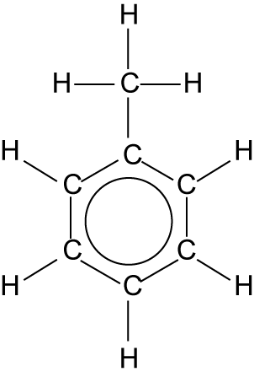
A2. a. Chlorine gas and UV radiation.
b. Free radical mechanism.
A3. a. Step 2
b. Sodium cyanide dissolved in ethanol.
c. Nucleophilic substitution; a lone pair of electrons on the C of CN is attracted to the small positive charge on the C bonded to the halogen. Carbon–halogen bond breaks heterolytically and halogen is replaced by CN.
A4. a. Methylbenzene
b. Compound formed in step 3.
c. Compound formed in step 2.
  - assignment 3
A1. a. Cl₂ → Cl• + Cl•
b. Each chlorine receives one electron from the bonding pair(c).
c. It is the first reaction in a chain reaction – free radical reaction.
A2. a. i. CH₄ + Cl• → CH₃• + HCl
ii. CH₃• + Cl₂ → CH₃Cl + Cl•
b. A radical is present in the reactants and products.
c. Chlorine radical attracts electron density from C–H bond, C–H splits homolytically giving methyl radical and HCl.
Cl₂ splits homolytically, Cl• attracted to CH₃• and CH₃Cl and Cl• formed.
A3. a. CH₃Cl(g) + Cl₂(g) → CH₂Cl₂(g) + HCl(g)
CH₂Cl₂(g) + Cl₂(g) → CHCl₃(g) + HCl(g)
CHCl₃(g) + Cl₂(g) → CCl₄(g) + HCl(g)
b. Chloromethane, dichloromethane, trichloromethane, tetrachloromethane
A4. CH₃• + Cl• → CH₃Cl or similar
  - assignment 4
A1. There will be a greater proportion of UVB wavelengths.
A2. a. UVA: Sun tan which comes and goes quickly, penetrates skin to cause ageing, may enhance skin cancer.
b. UVB: Lasting suntan, leathery skin forms to protect from further damage, sun burn, skin cancer, eye problems (such as cataracts).
A3. Thickness of the layer, intensity of the sun, cloud cover, ozone depletion.
A4. a. UVB
b. UVA
c. UVA and UVB
A5. Zinc oxide reflects UV and octyl methoxycinnamate absorbed UV and emits it as IR radiation.
A6. Molecules in sunscreen contain many different elements bonded together and absorbances overlap to form a wide band.
  - Practice questions
1. a. 1,1,1,2-tetrachloro-2,2-difluoroethane OR 1,2,2,2-tetrachloro-1,1-difluoroethane
b. i. 2O₃ → 3O₂
ii. O + NO₂ → NO + O₂
2. a.
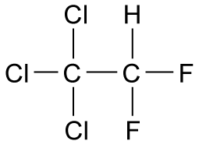
b. i. C–Cl bond
Chlorine atom or chlorine – radical
ii. 2O₃ → 3O₂

3. a. i.
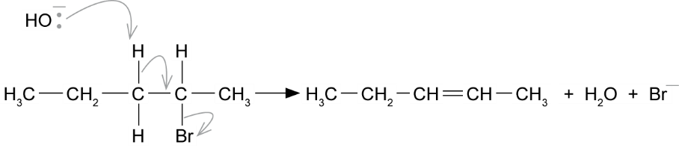
    - Arrow from lone pair on oxygen of OH− to correct H.
    - Arrow from C–H adjacent to C–Br towards appropriate C–C.
    - Should be from original molecule.
ii. Pent-1-ene, CH₃CH₂CH₂CH=CH₂
b.
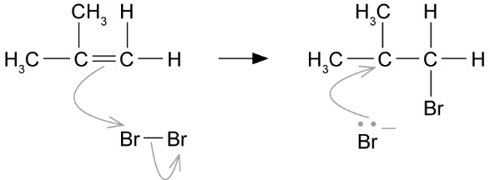
    - Arrow from double bond to Br of Br–
    - Breaking Br–Br
    - Tertiary carbocation with Br on correct
    - Arrow from lone pair on negatively charged bromide ion towards positively charged carbon atom.
4. a. i. UV light
ii. CCl4 + CCl3• + •Cl
b. Cl• + O₃ → ClO• + •Cl
ClO• + O₃ → Cl• + 2O₂

5. a. Bromine is more electronegative than carbon.
b. i. Ammonia
ii. A lone pair of electrons.
iii. Double headed curly arrow from lone pair of electrons on NH₃ to positive C; Curly arrow from C–Br bond to slightly negative Br.
c. i. Nucleophilic substitution.
ii. Bromine is more electronegative than carbon / small negative charge on Br and positive charge on C.
d. i. Propene
ii. Elimination
6. a. 2-bromobutane
b. Arrow from lone pair of electrons on OH to slightly positive C; Arrow from C–Br to negative Br.
c. i. Same molecular formula, but atom bonded together in different order.
ii.
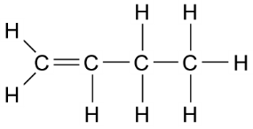
d. i. Butan-2-ol
ii. Nucleophilic substitution.
7. a. i. CCl₂F₂
ii. CClF₃
b. i. CCl₂F₂ → CCl₂F• + Cl•
ii. UV radiation
iii. Cl• + O₃ → ClO• + Cl•
ClO• + O₃ → 3O₂ + Cl•
c. C–F bond is a strong bond/has high bond energy; needs a lot of energy to break it; CFCs are very stable.
8. a. i. Unreactive; stable; gas at room temperature.
ii. Thinning of the ozone layer in the stratosphere / ozone hole.
b. i. CHF₃
ii. Decompose in the lower atmosphere / similar properties to CFCs but do not break down ozone.
iii. It’s because carbon–fluorine bonds are very strong (much stronger than carbon–chlorine).
9. a. Lone pair of electrons.
b. C–Cl bond in chloroethane is polar and C has negative charge; Lone electron pair / negative charge on O in water attracted to positive C; C–Cl break to give hydrogen chloride and ethanol.
c. Bond energy of C–F bond is too high to break in lower atmosphere, UV radiation does not have sufficient energy to break bond in stratosphere.
10. C
11. D
12. A
13. D

Chapter 14: Alkenes
  - assignment 1
A1. The order of unsaturation from most to least is sunflower oil, olive oil, palm oil and coconut oil.
A2. Yellow to colourless.
A3. a. Dipole induced in bromine molecule.
b. Double bonds are areas of negative charge.
c. Positive end of bromine molecule is attracted to the negative charge of the double bond and a C–Br bond forms. The adjacent carbon now has a small positive charge and attracts the bromide ion.
A4. a. 0.25 cm³
b. 4.0 × 10^{–5} mol
c. 4.0 × 10^{–5} mol
d. 0.16 mol
A5. 0.25 × 0.92 = 0.23 g sunfliower oil reacted with 7.00 cm³ 0.02 mol dm^{–3} bromine water.
$$\text{7.00 }{\text{cm}}^{\text{3}} \text{0.02 mol }{\text{dm}}^{\text{-3}} \text{bromine water contains }\frac{\text{(7} \text{×} \text{0.02} \text{×} \text{160)}}{\text{1000}} \text{=} \text{0.0224 g }{\text{Br}}_{\text{2}}$$
Therefore, 0.23 g sunfliower oil reacted with 0.0224 g Br₂ and the mass of bromine that would react with 100 g sunflower oil (its bromine number) is:
$\frac{\text{(0.0224} \text{×} \text{100)}}{\text{0.23}} \text{=} \text{9.7 g. So, bromine number of sunflower oil is 9.7}$.
A6. Repeat results and average titre calculated, volume of oil measured using a 1 cm³ pipette.

  - assignment 2
A1. a.
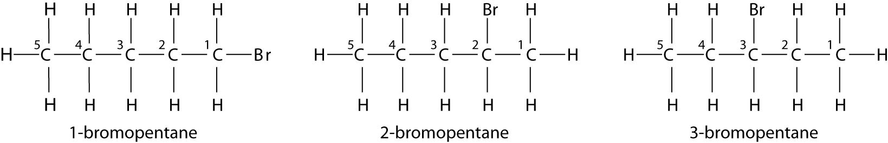
b. Functional group isomerism.
A2. a. Electrophilc addition.
b. The hydrogen in hydrogen bromide.
c. Hydrogen bromide is a polar molecule and bromine is more electronegative than hydrogen; hydrogen has a small positive charge.
A3. a. Carbocations have a positive charge on the caron atom.
b. CH₃CH₂CH₂CH₂CH₂Br and CH₃CH₂CH₂CHBrCH₃
c. 2-bromopentane because the intermediate carbocation is a secondary carbocation which is more stable than the primary carbocation which is the alternative.
d. CH₃CHBrCH₂CH₂CH₃ and CH₃CH₂CHBrCH₂CH₃
e. Neither, because both form intermediate secondary carbocations; probably a 50/50 mixture.
  - assignment 3
A1. 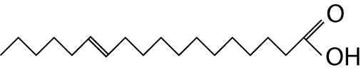
A2. Double bond is 6-carbon atoms from the omega carbon atom (at end of chain).
A3. a.
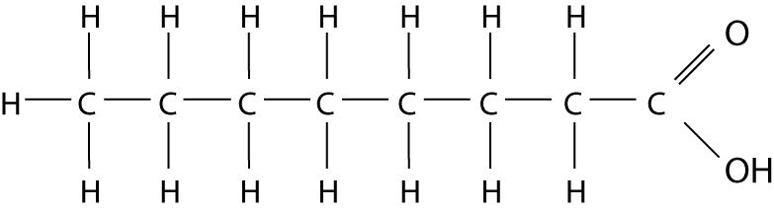
b. Bromine water + octanoic acid = no change; bromine water + flax oil = yellow to colourless.
c. Electrophilic addition.
d. Dipole is induced in Br₂ by the C=C bond – high electron density. Br⁺ acts as electrophile. High electron density of C=C attracts Br⁺ and forms a bond with one of the C atoms. Br– attracted to the carbocation formed, and forms second bond.
A4. Z-isomers are retained in the spread. These are linked with the reduced risk of heart disease.
A5. a. The unsaturated chain in the fatty acid becomes saturated.
b. Changes from a V-shape to a straight shape.
c. No, content of unsaturated fats in margarine can be less.
  - Practice questions
1. a. Electrophilic addition.
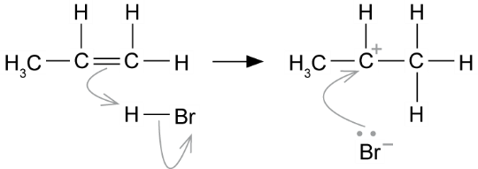
Show an arrow from the double bond towards the H atom of the H–Br molecule; the breaking of the H–Br bond; the structure of the secondary carbocation; an arrow from the lone pair of electrons on the negatively charged bromide ion towards the correct (positively charged) carbon atom.
b. Nucleophilic substitution.
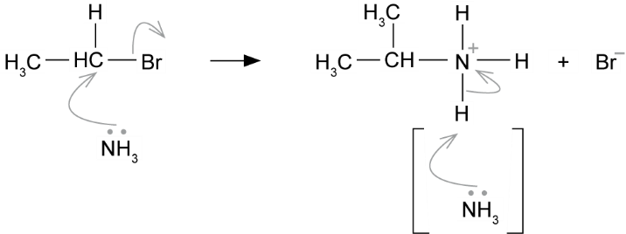
Show an arrow from the lone pair of electrons on the nitrogen atom of an ammonia molecule to the correct C atom; the movement of a pair of electrons from the C–Br bond to the Br atom; the structure of the alkylammonium ion, which could be a condensed formula. Show a positive charge on/or close to, the N atom; an arrow from the N–H bond to the N atom.
c. i. Addition polymerisation.
ii. Poly(propene)
d.
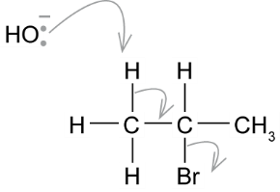
Show an arrow from the lone pair on the oxygen of a negatively charged hydroxide ion to a correct H atom; an arrow from a correct C–H bond adjacent to the C–Br bond to the appropriate C–C bond; should be from the original molecule.
2. a. i. Double bonds are electron-rich OR electron pair donors OR centres of electron density; Bromine becomes polarised OR forms an induced dipole OR becomes δ+/δ–.
ii. Electrophilic addition.
iii. Structure for 1,2,4,5 tetrabromopentane, such as BrCH₂CHBrCH₂CHBrCH₂Br OR
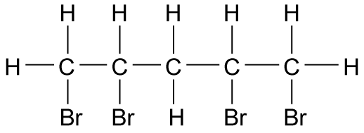
b. i. Structure of CH₃C⁺ HCH₃
ii. Secondary carbocation OR secondary carbonium ions.
3. a. i. 3-bromo-3-methylpentane
ii. Electrophilic addition (reaction).
iii. Displayed formula of 2-bromo-3-methylpentane
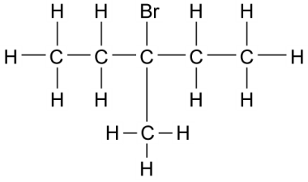
Position(al) (isomerism)
iv. Structure of (E)-3-methylpent-2-ene
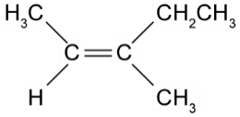
4. a. Fill the jet space; Remove the funnel.
b. Drop sizes vary.
c. Use a larger single volume of oil / Dissolve all the oil in some of the organic solvent / Transfer to a conical flask and make up to 250 cm ³ with solvent / Titrate (25 cm³) samples from the flask.
d. Mass of oil = 0.92 × (0.05 × 5) = 0.23 g
$$\text{Mol of oil} \text{= }\frac{\text{0.23}}{\text{885}} \text{=} \text{2.6 × }{\text{10}}^{\text{–}\text{4}}$$
Mol bromine = 0.020 × 0.0394 = 7.9 × 10⁻⁴
Ratio oil : bromine
2.6 × 10⁻⁴ : 7.9 × 10⁻⁴
1 : 3
Hence three C=C bonds.
5. a. Electrophilic addition.
b. Propene is unsymmetrical alkene; secondary carbocation formed is more stable than primary carbocation.
c. Nucleophilic substitution.
d. Electrophile is attracted to area of negative charge; nucleophile is attracted to area of positive charge OR electrophiles have positive charge; nucleophiles have areas of negative charge/lone pairs.
6. a.
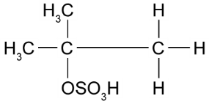

b. Electrophilic addition.
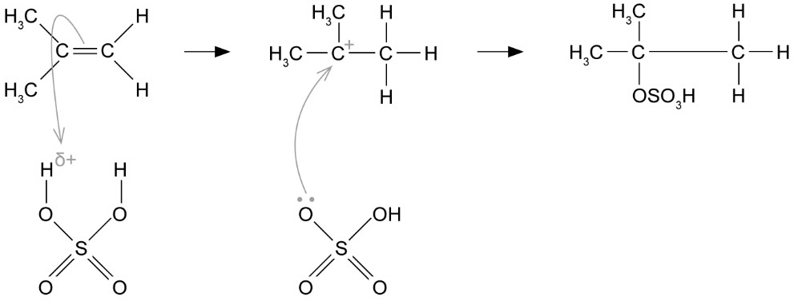
c.
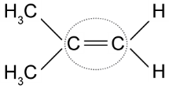
d.
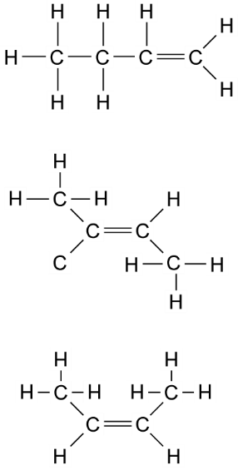
7. a. i.
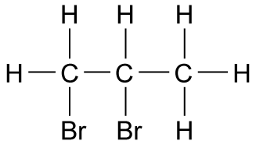
ii.
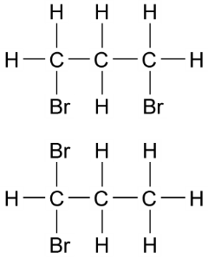
iii. Positional
b. i. Induced dipole in bromine molecule; positive end of bromine molecule is attracted to the double bond in propene / area of high electron density.
ii. Positive area of bromine molecule attracted to double bond and C–Br bond forms; bromide ion remains; attracted to positive charge on remaining C, second C–Br forms.
8. a. i. CH₂
ii. But-1-ene – unsymmetrical; methylpropene – unsymmetrical
b. i. Electrophilic addition.
HBr is polar; negative charge of double bond attracted to positive hydrogen of HBr and C–H bond forms and bromide ion; bromide ion attracted to positive charge on C, C–Br bond forms.
ii.
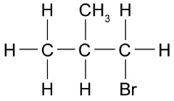
Involves formation of primary carbocation; less stable than secondary carbocation.
c. i. 2-bromobutane
ii. 1-bromobutane; 2-bromobutane involves the formation of secondary carbocation, 1-bromobutane involves the formation of a primary carbocation; secondary carbocations are more stable than primary carbocations.
9. a. i. Electrophilic addition.
ii. Displayed formula and curly arrows to show:
induced dipole in iodine molecule; electron density of C=C attracted to positive end of iodine molecule, C–I bond forms and iodide ion; iodide ion attracted to positive carbon atom.
iii. Bubble ethene gas through iodine solution.
b. Bond enthalpies are C–Br > C–I; greater attraction between carbon and bromine and reaction is faster.
10. B
11. B
12. A
13. C

Chapter 15: Alcohols
  - Assignment 1
A1. Both have the same molecular formula. Butan-1-ol has straight carbon chains, which can lie close together. Butan-2-ol has branched carbon chains. Butan-1-ol has stronger van der Waals forces and more energy is needed to overcome them before the alcohol can boil.
A2. Both have the same molecular formula. 2-Methylpropan-2-ol is a tertiary alcohol, and butan-2-ol is a secondary alcohol. Intermolecular forces decrease with more branching of the carbon chain, so 2-methylpropan-2-ol has a lower boiling point than butan-2-ol.
A3. The diagram could show: δ⁺ and δ– charges on the OH in the alcohol and the O and H atoms in the water molecules; a hydrogen bond between the positive H of either the alcohol group or the water molecule and the lone pair of electrons on the oxygen atom.
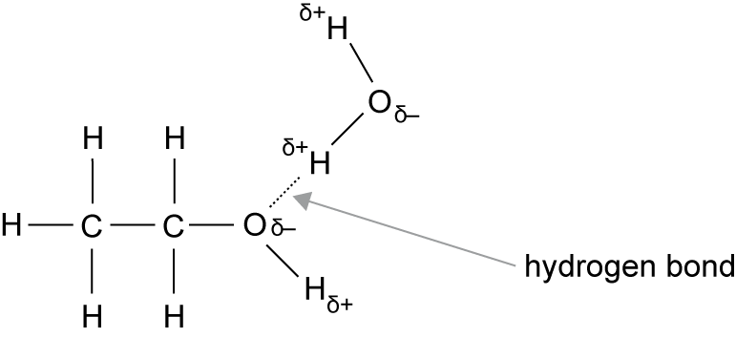
A4. Increasing strength of the van der Waals forces between the carbon chains lower the solubility in water as the chain increases in length. These intermolecular forces become stronger than the hydrogen bonding between the alcohol and the water. The long-chained alcohols are attracted more strongly to each other.
A5. All alcohols have hydrogen bonding between the lone pair on the O atoms and the H atoms in alcohols. Hydrogen bonding is the strongest type of intermolecular force. There is no hydrogen bonding in alkanes, so their boiling points are lower.
  - Required Practical 5
P1. Easier to use, less contamination, less chance of vapours escaping into the atmosphere.
P2. So that the water rises up through the condenser and stays in it longer.
P3. To prevent build-up of pressure.
P4. To condense any vapour in the apparatus and prevent it escaping into the atmosphere.
  - Assignment 2
A1. The carbon atom with the OH group has two other carbons attached to it.
A2. a. Electrophilic addition.
b.
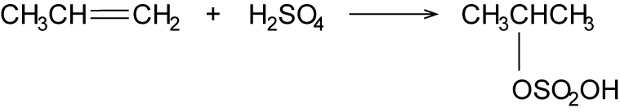
c. The ethyl hydrogen sulfate group attached to the carbon atom with one hydrogen atom as this is a secondary carbocation.
A3. Overall, water is added to propene.
A4. a.
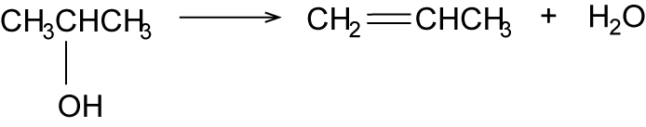
b. Because water is eliminated.
A5. a. Oxidation.
b. Propanone.
c. An aldehyde and then carboxylic acid would be formed. The colour change would be the same.

  - Assignment 3
A1. Skeletal formulae.
A2. C₆H₁₁OH and C₆H₁₀
A3. Because a molecule of water is eliminated from each alcohol molecule.
A4. It acts as a catalyst.
A5. Water, unreacted alcohol, phosphoric acid, products from side reactions.
A6. Water.
A7. a. To dissolve any water soluble impurities.
b. To react with and remove any phosphoric acid.
c. To dry the product.
  - Practice questionS
1. a. Compounds 1 and 3 (butanal and butanone) have the same M_{r} (to five d.p.) because either: they contain the same number of atoms of the same element; are both C₄H₈O; have the same molecular formula; contain the same number of C,H and O atoms.
Compound 2 (pentane) has a different M_{r} (to five d.p.) because either: it has different numbers of atoms of different elements; is C₅H₁₂ (contains C and H); has different molecular formula; does not contain oxygen (atom).
b. With Tollen’s reagent: silver mirror OR black solid/precipitate (NOT silver precipitate) stays colourless OR no change/reaction OR no silver mirror. OR with Fehling’s solution: red solid/precipitate stays blue OR no change OR no red solid OR no red precipitate.
2. a. i. Hexan-1-ol
ii. Homologous
iii. Displayed formula for butan-2-ol:
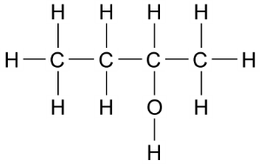
iv. CH₃CH₂CH₂CH₂OH + [O] → CH₃CH₂CH₂CHO + H₂O
v. Displayed formula for butanone:
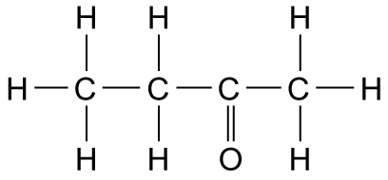
b. q = mcΔT OR calculation 175 × 4.18 × 8 = 5852 J (5.85 kJ)
0.005 mol, therefore ΔH = –1170 kJ mol⁻¹
OR ΔH = –1170.4 kJ mol⁻¹
OR ΔH = –1200 kJ mol⁻¹
c. i. The enthalpy change (or heat change at constant pressure) when 1 mol of a compound is burned completely in oxygen OR burned in excess oxygen with all reactants and products in standard states OR all reactants and products in normal states under standard conditions.
ii. ΔH = ΣΔH_{f} (products) – ΣΔH_{f} (reactants)
OR a correct cycle of balanced equations
= 4(–394) + 5(–286) – (–327)
= – 2679 kJ mol⁻¹
3. a. i. Temperature –37–40 °C, yeast/enzymes in yeast, water/glucose in solution.
ii. Fermentation.
iii. C₆H₁₂O₆ → 2C₂H₅OH + 2CO₂
b. i. C₂H₅OH + 2O₂ → 3H₂O + 2CO₂
ii No sulfur pollutant / less greenhouse gases produced / renewable.
c. i. One water molecule is lost from one alcohol molecule.
ii. Ionic sulfuric.
iii C₂H₅OH → C₂H₄ + H₂O
4. a. Functional group is in a different position.
b. Pentan-1-ol (compound A), pentan-2-ol (compound B)
c. i. Oxidation.
ii. Acidified potassium dichromate.
iii. Leave reactants in water bath at higher temperature.
iv.
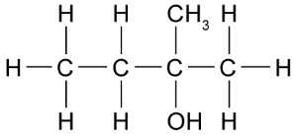
v.
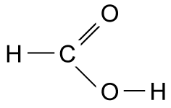

d. i. Tollen’s or Fehling’s.
ii.
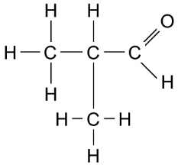
5. a. i.
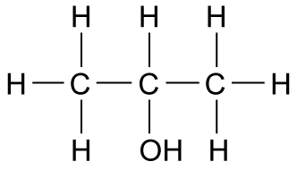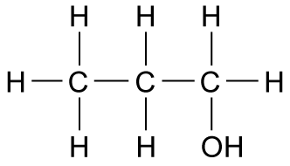

ii. Positional.
b. i.
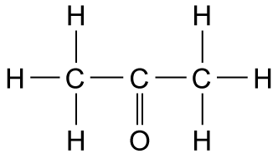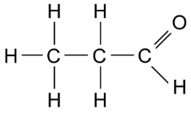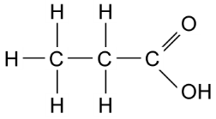

ii. CH₃CH₂CH₂OH + [O] → CH₃CH₂CHO + H₂O
CH₃CH₂CH₂OH + 2[O] → CH₃CH₂COOH + H₂O
CH₃CH(OH)CH₃ + [O] → CH₃COCH₃ + H₂O

c.
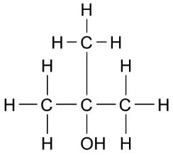
6. a. i. Phosphoric(V) acid.
ii. Low temperatures give higher yields of ethanol, but also slow rate of reaction, compromise temperature to produce little often.
iii. Two moles products gives one mole of reactants, increasing pressure shifts position of equilibrium in direction to counteract the change, so increase yield ethanol.
iv. No effect.
v. Increases rate of reaction.
vi. Removing ethanol and recycling unreacted reactants.
b. Advantages: renewable reactants, low temperature and atmospheric pressure; Disadvantages: labour intensive, batch process, uses land needed for food production, slow reaction, needs fractional distillation to purify product.
7. a. C₄H₁₀O
b. i. and ii.
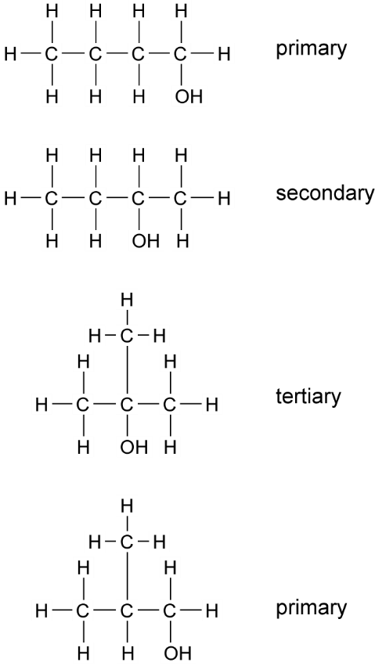

c. i. Aldehyde.
ii.
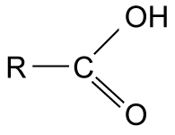
Carboxylic acid.

8. a. Fractional distillation.
b. i. To collect a product within a boiling range.
ii. To measure the temperature of the vapour being collected.
iii. To change the fraction from a gas to a liquid.
iv. Smooth boiling.
v. To prevent build-up of pressure.
c. Place reaction mixture in the flask, add a few anti-bumping granules and assemble apparatus; Heat until reaction mixture starts to boil, reduce heat to constant boiling and collect fraction between 20–22 °C.
9. a. Place mixture in flask, add a few anti-bumping granules and assemble fractional distillation apparatus; Heat until mixture starts to boil and collect fraction between 81–84 °C.
b. No naked flames, use anti-bumping granules for smooth boiling, etc.
c. Initial volume of mixture; volume of propan-2-ol collected.
d. Propan-2-ol molecules do not lie as close together and induced dipole–dipole forces are lower. Less energy is needed to overcome them and boiling point is lower.
10. C
11. A
12. D
13. A

Chapter 16: Analytical techniques
  - Required Practical 6
P1. The tests are qualitative.
P2. Add potassium dichromate(VI) solution (primary alcohol gives an aldehyde, secondary gives a ketone) and use either Fehling’s solution or Tollen’s reagent to distinguish between the aldehyde and ketone products.
P3. Alcohols are flammable.
  - assignment 1
A1. Chlorine is smaller than iodine, so there is less shielding of the nuclear charge and hydrogen is attracted more strongly.
A2. 3000 to 3300
A3. a. Between 2500 and 4000, and between 1500 and 500.
b. Between 1500 and 2500.
A4. Stronger bonds absorb infrared radiation with higher wavenumbers.
  - assignment 2
A1. a. Ethanol, O–H about 3300 cm^{–1}, C–H about 3000 cm^{–1}, C–O bond about 1000 cm^{–1}
b. C=O about 1700 cm^{–1}
c. Yes
A2. a. O–H (acid) at 2950 cm^{–1}, O–H (alcohol) at 3250 cm^{–1}, C=O at 1700 cm^{–1}
b. Chemical bonds absorb certain frequencies of IR radiation to vibrate more.
c. Compare the main absorptions and the finger print region.
A3. a. [C₇H₆O₃]⁺
b. 138
c. 138.0315
d. Other molecules may have a molecular mass of 138, so a low-resolution mass spectrum does not confirm the presence of 2-hydroxybenzoic acid.
  - assignment 3
A1. a. O–H or C–H
b. C=O
c. C–O
A2. The absorptions at 2915 and 1739 cm⁻¹
A3. a. Fingerprint region.
b. To identify a compound by comparing it with the spectrum of a known compound.
A4. No, because there is not strong absorption at 1240 cm⁻¹ and the finger print regions do not match.
  - Practice questions
1. a. CH₂O
b. No peak/absorption/C=O in the range 1680 to 1750 cm^{–1} (suggesting no evidence of C=O)
2. a. i. C
ii. A
iii. D
iv. B
b. Br₂ OR bromine (water) OR bromine (in CCl₄ / organic solvent); cyclohexane OR the alkane remains the same OR no reaction OR reference to colour going to cyclohexane layer; cyclohexene OR the alkene goes colourless; Alternatives: potassium manganate(VII)
c. Acidified potassium or sodium dichromate OR H₂SO₄ / K₂Cr₂O₇ OR H⁺ / K₂Cr₂O₇ OR correct combination of formula and name; oxidation OR oxidised OR redox; secondary / 2° (alcohol).
3. a. i.
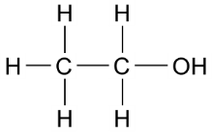
ii.
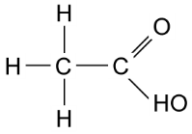
b. i. O–H (alcohols)
ii. C–H
c. C=O bonds
d. A
e. i. Heating mantle, flask and condenser. Place reaction mixture in the flask and add a few anti-bumping granules, assemble reflux apparatus, heating until boiling and adjust thermostat on heating mantle.
ii. Oxidation
4. a.
Compound | Formula of molecular ion | Mass of molecular ion
ethanol | [C₂H₅OH]⁺ | 46
ethanal | [CH₃CHO]⁺ | 44
ethanoic acid | [CH₃COOH]⁺ | 60

b. Molecular ion peaks show molecular mass of compound.
c. 46.0417
5. a. Water, methane
b. Increases it.
c. C=O
d. i. Electrons are knocked off molecules / positive ions form.
ii. [CO₂]⁺
iii. 44
6. a. i.
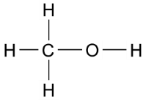
ii.
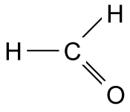
iii.
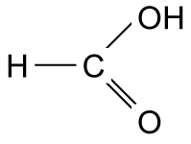
b. i. Methanol
ii. O–H absorption 3230-3550 cm⁻¹; C–O absorption 1000-1300 cm⁻¹
c. i. [CH₃OH]⁺
ii. [HCHO]⁺
iii. [HCOOH]⁺
d. Methanol: 32.0261; Methanol: 30.0105; Methanoic acid: 46.0054
7. a. A qualitative test identifies species present; a quantitative test measures amounts present.
b. To prevent added reactants from inferring with the test.
c. W: cyclohexene; X: butan-2-ol; Y: propanoic acid; Z: butan-1-ol
d. Acidified potassium dichromate(VI) oxidises primary alcohols to aldehydes and secondary alcohols to ketones. Colour change from orange to green. Fehling’s solution oxidises aldehydes to carboxylic acids. Colour change – brick-red precipitate forms. Fehling’s does not oxidise ketones.
e. Advantage: can be heated in a water bath. Disadvantage: uses more reagents, only one test per test tube.
f. No naked flames, more even temperature obtained.
8. a. Propan-2-ol: secondary alcohol; ethanol: primary alcohol
b. Addition of acidified potassium dichromate(VI) solution and place in a water bath at 60 °C for a few minutes. Place a few cm³ Fehling’s solutions in a test tube, add a few drops of each sample; place in a hot (60 °C) water bath for a few minutes (alternative: Tollen’s test). Acidified potassium dichromate(VI) oxidises ethanol to ethanal and propan-2-ol to propanone. Fehling’s solutions oxidise ethanal to ethanoic acid; do not oxidise propanone.
c. Molecular ions on spectra will have masses of 60 (propan-2-ol) and 46 (ethanol).
d. Both will have absorption for O–H bond; both will have absorption for C–O bond; both have C–C bonds, C–H bonds, C–O bonds, O–H bonds.
9. B
10. C
11. C
12. D

