KS4 PSHCE LESSON PLAN.

** INTERNET ACCESS REQUIRED BY STUDENTS THIS LESSON! **
DATE: LESSON FOCUS: Disability in the UK Today
Number of male students: | Number of SEN students: | Last lesson’s focus:
Number of female students: | Number of G & T students: | Next lesson’s focus:
Class/year group: | Misc:

LESSON OBJECTIVES.

- (1) I can learn more about what the term ‘disability’ means in the modern world.
- (2) I can explore how disability should be viewed in the UK today.

STARTER.
- Share LOs with class.
- Refer class to LO1 for this starter activity.
- Ask pairs to have a 3-minute discussion on how confident they are about what ‘disability’ actually means in the modern world. For example, is dyslexia a disability? Is pregnancy? Is hay fever? What about drug dependency? What about dementia? A broken leg?
- Ask spokespersons to give feedback. Class will find out more about definition in main activity.
- Ask a volunteer to read out the ‘Nujeen’ book excerpt from Photocopiable Resource 1.
- Invite volunteers to guess how it might have felt for Nujeen - who loves reading and has cerebral palsy - to only read about characters who don’t use a wheelchair. Suggested vocabulary to trigger discussion: role model, positive portrayal, invisible minority, self-confidence, unheard voice etc.
MAIN.
- Using Photocopiable Resource 2 (What does disability mean in the UK today?), ask students to find out more about what ‘disability’ means. Ask them to re-write/cut and paste the sentences into the correct order.
- Correct order is (5, 3, 6, 1, 4, 2):
According to the Equality Act 2010, a disability is something (mental and/or physical) that has a ‘substantial’ and ‘long-term’ negative effect on performing normal daily activities. An example of a substantial impairment is when an activity such as getting out of bed takes much longer than it would for the average citizen. A long-term impairment is one lasting for a year or more. Obviously, some conditions become worse as the years pass. These are called progressive conditions and can be classed as disabilities if they cause substantial and long-term negative effects. Certain progressive conditions (including cancer and HIV infection) are classed as a disability as soon as the initial diagnosis is received. Some conditions are not classed as disabilities under the Equality Act 2010. Examples are hay fever, addiction to alcohol and the tendency to physically/sexually abuse others.
- Refer class to LO2.
- Tell students that they are going do independent research (using the internet) on how disability should be viewed in the UK today. Refer them to Photocopiable Resource 3 (How Disability should be Viewed in the UK Today). This worksheet features success criteria instructions and recommended websites. Remember to arrange for student access to the recommended websites via your IT team!
- Highlight to class that students will be reading each other’s work at the end of the lesson.
- Examples of good answers are provided on Photocopiable Resource 4 (Examples of Answers).
PLENARY
** A short plenary will allow students adequate time to do their internet research. **
- Ask students to leave their work on the desk and to walk around the room reading other pupils’ work.
- Each student should put a tick in the top right corner of any work they see that teaches them something new (or that inspires them to see things from a different viewpoint).

SEN SUPPORT.
- For the main activity (in which students put words into the correct order), cut out the six parts of the paragraph in advance. Students can then physically manipulate the paragraph rather than retaining word order in their mind.
G & T SUPPORT.
- For the main activity (in which students do internet research), ask G & T students to use an appropriate website that is not recommended on Photocopiable Resource 3 as part of their research.
HOMEWORK/STRETCH TASK.
- Print out the face of a positive role model who has a disability and is from/living in the UK. Add their name and age. Also state three facts about what makes her/him a positive role model to others.

Photocopiable Resource 1 (Excerpt from ‘Nujeen’, pp. 89 - 90: Starter).
In case you think I only know TV, I also liked reading books. Of course I had no way to get them myself, so I had to borrow them from Nasrine or sometimes steal them from her shelf when she was out. Just before we moved to Manbij she got Gone with the Wind from Jamila’s grown-up stepson (I forgot to mention that Jamila’s husband has two wives which I was a bit shocked about when I found out, even though my grandfather has four as is allowed in our culture).

That became my favourite book. Margaret Mitchell is just a genius because through the whole novel you are thinking something will happen between Scarlett O’Hara and Ashley who she is pursuing, then suddenly the scoundrel Rhett Butler shows up and turns out to be the main character and the whole story is actually about Rhett and his love for her, so I’m like what! I love the twist, someone is the bad guy then turns out to be the main character the story revolves around. Also, like us in Syria, Scarlett is trying to survive in the middle of a civil war and keep the home she loves.

The good thing about the books was you could read them by torch or candlelight, and it didn’t matter when there was no electricity. The bad thing was there never seemed to be any characters in wheelchairs. Well, only the rich friend Clara in Heidi, and Clara ended up walking anyway.

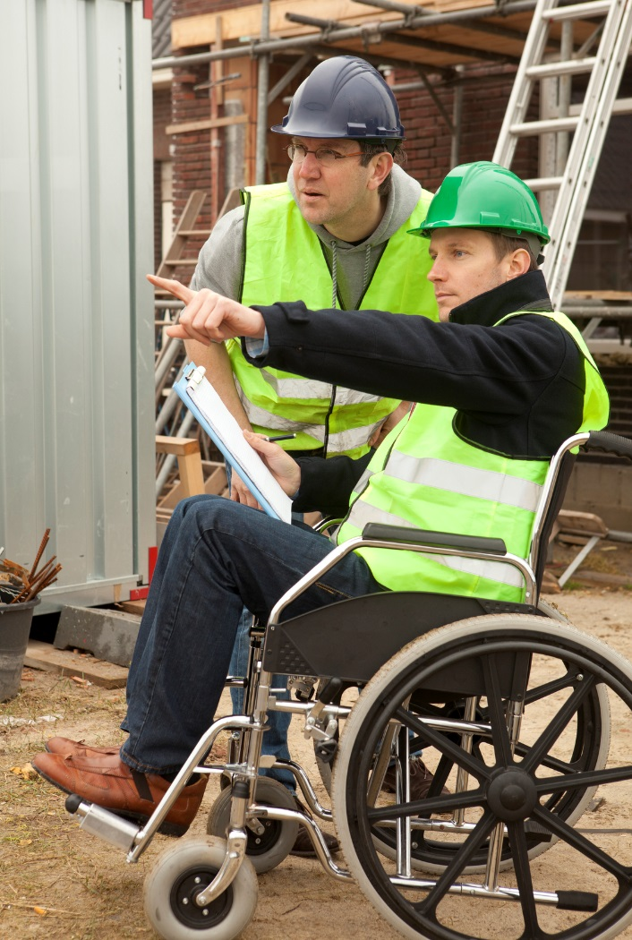

Photocopiable Resource 2 (What does ‘Disability’ mean in the UK Today? Main).
WHAT COUNTS AS A DISABILITY AND WHAT DOESN’T?
Put the following into the correct order, so that you create a paragraph that makes sense:
1. disabilities if they cause substantial and long-term negative effects. Certain progressive conditions (including cancer and HIV infection) are classed as a disability
2. Act 2010. Examples are hay fever, addiction to alcohol and the tendency to physically/sexually abuse others.
3. performing normal daily activities. An example of a substantial impairment is when an activity such as getting out of bed takes much longer than it would for the average citizen. A long-term impairment is one lasting for a year
4. as soon as the initial diagnosis is received. Some conditions are not classed as disabilities under the Equality
5. According to the Equality Act 2010, a disability is something (mental and/or physical) that has a ‘substantial’ and ‘long-term’ negative effect on
6. or more. Obviously, some conditions become worse as the years pass. These are called progressive conditions and can be classed as
………………………………………………………………………………………………………………………………………………………………………………………………………………………………………………………………………………………………………………………………………………………………………………………………………………………………………………………………………………………………………………………………………………………………………………………………………………………………………………………………………………………………………………………………………………………………………………………………………………………………………………………………………………………………………………………………………………………………………………………………………………………………………………………………………………………………………………………………………………………………………………………………………………………………………………………………………………………………………………………………………………………………………………………………………………………………………………………………………………………………………………………………………………………………………………………………………………………………………………………………………………………………………………………………………………………………………………………………………………………………………………………………………………………………………………………………………………………………………………………………………………………………………………………………………………………………………………………………………………………………………………………………………………………………………………………………………………………………………………………………………………………………………………………………………………………………………………………………………………………………………………………………………………………………………………………………………………………………………………………………………………………………………………………………………………………………………………………………………………………………………………………………………………………………………………………………………………………………………………………………………………………………………………………………………………………………………………………………………………………………………………………………………………………………………………………………………………………………
Photocopiable Resource 3 (How Disability should be Viewed in the UK Today: Main).
How should disability be viewed in the UK today? Before filling in this worksheet you must:
- explore the three recommended websites in the box below
- check your understanding of ‘disability’ (look at your work from the start of this lesson)
www.gov.uk/government/publications/inclusive-communication/inclusive-language-words-to-use-and-avoid-when-writing-about-disability
www.oliverhellowell.com (a photographer who happens to have Down’s Syndrome)
www.scope.org.uk/About-Us/End-the-Awkward/Why-is-Scope-running-this-campaign

1. The Paralympics is often the first thing we think of in terms of UK role models with a disability. Why do we need to find out more about role models with a disability in non-sport situations? ______________________________________________________________________________________________________________________________________________________________________________________________________________________________________________________
2. The simplistic view of disability is a person in a wheelchair. Give an example of a disability that doesn’t necessarily involve a wheelchair. __________________________________________________________________________________
3. Are some disabilities more immediately obvious than others when we meet someone for the first time? Explain your answer. ______________________________________________________________________________________________________________________________________________________________________________________________________________________________________________________
4. Why does the government encourage us to talk about disability by saying (for example) ‘a person with cerebral palsy’ rather than ‘a cerebral palsy sufferer’? ______________________________________________________________________________________________________________________________________________________________________________________________________________________________________________________
5. Is it appropriate to think of all people with a disability as ‘the disabled’, or is there a more useful way to view individuals who each have a distinct disability? Explain your answer. ________________________________________________________________________________________________________________________________________________________________________________________________________________________________________________________________________________________________________________________________________
6. Why must society get the balance right between treating people who happen to have a disability as equals and acknowledging that disability-related discrimination still exists (not to mention the feeling of awkwardness that some non-disabled people have around people with a disability). ________________________________________________________________________________________________________________________________________________________________________________________________________________________________________________________________________________________________________________________________________
Photocopiable Resource 4 (Examples of Answers: Main).
For staff use, to help prompt good-quality answers:
1. The Paralympics is often the first thing we think of in terms of UK role models with a disability. Why do we need to find out more about role models with a disability in non-sport situations? Just like people who are non-disabled, people with a disability aren’t all good at/interested in sport! Paralympians are dedicated, brave, inspiring individuals. Similarly, many such individuals with a disability are surgeons, scientists, models, engineers, comedians, teachers, lawyers, politicians etc.
2. The simplistic view of disability is a person in a wheelchair. Give an example of a disability that doesn’t necessarily involve a wheelchair. Long-term depression.
3. Are some disabilities more immediately obvious than others when we meet someone for the first time? Explain your answer. Yes. For example, a physical disability such as only having one hand might be immediately noticeable. On the other hand, you might not realise that someone is deaf when you first meet them.
4. Why does the government encourage us to talk about disability by saying (for example) ‘a person with cerebral palsy’ rather than ‘a cerebral palsy sufferer’? Someone with cerebral palsy might feel that cerebral palsy is not the most relevant part of her/his identity. For example s/he might identify more with having a PhD, being Sikh or running a company. Also, when we describe someone as a victim/sufferer, there is a danger or pitying them and viewing them as someone with very little independence.
5. Is it appropriate to think of all people with a disability as ‘the disabled’, or is there a more useful way to view individuals who each have a distinct disability? Explain your answer. People without disabilities are all individuals with different needs and opinions. This, of course, is also the case for people who have a disability. This is why the umbrella term ‘the disabled’ can lead to stereotyping and to dangerous assumptions that all persons with a disability are ‘the same’. In reality, Zak (who has OCD) might have nothing in common with Amina (who has a liver condition).
6. Why must society get the balance right between treating people who happen to have a disability in the same way that we treat others and acknowledging that disability-related discrimination still exists (not to mention the feeling of awkwardness that some non-disabled people have around people with a disability). It goes without saying that everyone in society should be entitled to equal treatment in terms of access to education, healthcare and employment etc. However, people who are disabled and people who are not can treat each other as equals without pretending that awkwardness and discrimination don’t exist. People with a disability are still often patronised, overlooked or ignored in society. They are under-represented in well-paid jobs, and in advertising/TV/film. In addition, a significant amount of hate crime towards citizens with a disability exists. This must be challenged.

