KS4 PSHCE LESSON PLAN.
DATE: LESSON FOCUS: Protected Characteristics
Number of male students: | Number of SEN students: | Last lesson’s focus:
Number of female students: | Number of G & T students: | Next lesson’s focus:
Class/year group: | Misc:

LESSON OBJECTIVES.

- (1) I can find out what protected characteristics are.
- (2) I can understand why protected characteristics are relevant to the Equality Act 2010.

STARTER.
- Share LOs with class.
- Refer class to LO1 for this starter activity.
- Ask students to read the excerpt from ‘Nujeen’ (Photocopiable Resource 1).
- Ask pairs to have a quick discussion about what Nujeen is aiming to do in this excerpt. Answer: Nujeen seems keen to become increasingly independent. This is after her sister notices that other young adults with disabilities are able to do many things for themselves.
- Explain that it is part of British law that citizens with a disability are entitled to the same rights as those without one. Add that this is because disability is on a special government list of ‘protected characteristics’.
- Ask students to match the nine protected characteristics on Photocopiable Resource 2 with the nine people in the right-hand column. NB ‘Transsexual’ is an increasingly outdated term for ‘transgender’. A transgender woman is someone who was assigned ‘male’ at birth and now lives as and identifies as a woman. Transgender men are assigned ‘female’ at birth and now live as men.
- Answers: 1 = C, 2 = F, 3 = B, 4 = H, 5 = D, 6 = A, 7 = G, 8 = E and 9 = I.
MAIN.
- Refer class to LO2 for this main activity.
- Ask small groups to discuss (a) whether they have heard of the Equality Act 2010 and (b) whether they know what it is.
- Explain that the Equality Act 2010 protects people from discrimination in wider society, e.g. on an apprenticeship or in the workplace. Also explain that the Equality Act 2010 replaces lots of separate pieces of legislation from the 20th century (including the Disability Discrimination Act and the Sex Discrimination Act).
- Tell students that you/a student will read out ten statements about the Equality Act 2010 and that they have to decide whether each one is true or false. For each statement, they should stand up if they believe it is true and sit down if they think it is false.
- Statements:
1. The Equality Act 2010 recognises that discrimination comes in different forms (including harassment and indirect discrimination). TRUE. Example of indirect discrimination: The manager insists that everyone attends the weekly team meeting on the 25th floor. All twenty staff can get to the top floor apart from Davie, because there’s no lift access for his wheelchair to that floor. Plenty of other meeting rooms are available, but the manager says she prefers the view on that floor.
2. The Equality Act 2010 acknowledges that certain organisations can employ people of one gender only. TRUE. Example: A charity supporting women who have been abused by men might choose to only employ female staff.
3. If you think you have been discriminated against then it will always cost you money to get advice or make a complaint. FALSE. Example: ACAS or the Citizens’ Advice Bureau offer free support.
4. In an interview, you should not ask someone about their relationship status and/or whether they plan to have children. TRUE.
5. It is against the law to stipulate in a job advert that applicants must have a degree. FALSE.
6. The Equality Act 2010 is linked to eleven protected characteristics. FALSE (nine).
7. Under the Equality Act 2010, ‘disability’ refers to mental health as well as physical health. TRUE.
8. The government provides guidance for employers about how to avoid discriminating against employees. TRUE.
9. The Equality Act 2010 only applies in the workplace. Renting, transport, shopping and education are not covered. FALSE
10. The Equality Act 2010 protects you if you are treated badly after making a complaint about discrimination (whether the alleged discrimination is against you or against someone else). TRUE.
- Ask students to write down three things that they learnt (or considered for the first time) as a result of the true/false activity. Invite volunteers to share their answers.
PLENARY.
- Give students Photocopiable Resource 3 (Fill in the Gaps). Explain that this worksheet summarises the main points from today’s lesson. Ask students to fill in the missing words, using the vocabulary provided.
- Answers: A = disability, B = differ, C = zero, D = equality, E = basis, F = simplified, G = protected, H = nine, I = individuals and J = teenagers.
- Invite volunteers to comment upon how they are considering changing their thought processes/actions now that they know more about the nine protected characteristics.
SEN SUPPORT.
- For main activity, tell SEN students in advance that there are six ‘trues’ and four ‘falses’. According to their ability, challenge students to get a certain amount of answers right.
G & T SUPPORT.
- For starter activity, invite G & T students to define ‘transgender’ (or ‘transsexual’) for the class – rather than immediately giving the class the definition.
HOMEWORK/STRETCH TASK.
- Choose one of the characters from the starter activity. Describe three other ways in which a protected characteristic s/he has might be used as the basis for discrimination. Examples: Connie has been arrested by the police (despite having never broken the law) three times this month, simply because her local police officers don’t trust teenagers; Connie has been told after a sports injury that she’s not entitled to an A and E appointment because the NHS is prioritising older patients; Connie’s driving instructor refuses to allow clients to drive on a roundabout until they’re 21.

Photocopiable Resource 1 (Excerpt from ‘Nujeen’, pp. 245 -246: Starter).

Nasrine came to my school one day and she pointed out that some of my classmates are much more disabled than me yet much more independent. They can move around on their own, get their own drinks and meals, not waiting for a sister. So now I am trying to be more independent. For the first time I get dressed myself and brush my own hair, though Nasrine still has to get up early to get me ready in the mornings. I still dream that one day Nasrine will get married and have kids, and I go to college and she help me with physics.

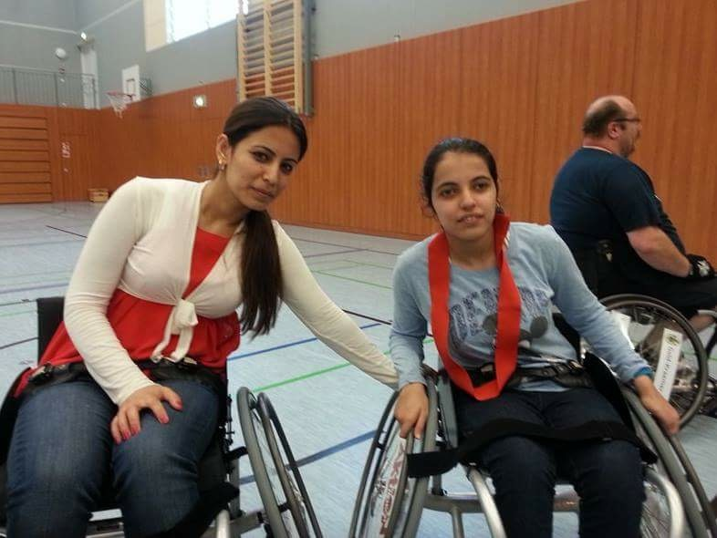
Photocopiable Resource 2 (What are Protected Characteristics? Starter).
Match each of the nine protected characteristics below to the right person:
A. Mariam’s GP surgery has refused to have Mariam as a patient because the nurses aren’t comfortable with the fact that she’s bisexual.
- DISABILITY

B. Connie’s boss didn’t tell her about a promotion because he doesn’t promote anyone under 25.
2. BEING/BECOMING A TRANSSEXUAL PERSON

C. Junior’s employer just sacked him when Junior explained that he has long-term depression.
3. AGE

D. Jon and his boyfriend have been turned away from a hotel because they’re not married.
4. SEX (gender)

E. Earl’s social worker told him that he can’t qualify for council accommodation because the local mayor thinks that “white people cause trouble in council properties”.
5. BEING IN A CIVIL PARTNERSHIP OR BEING MARRIED

F. Nazmeen’s gym cancelled her membership when they realised that she was a transgender woman.
6. SEXUALITY

G. Sacha’s university have refused her reasonable request to miss a lecture to attend her baby’s 20-week scan.
7. BEING ON MATERNITY LEAVE OR BEING PREGNANT

8. RACE INCLUDING COLOUR, NATIONALITY, ETHNIC GROUP OR NATIONAL ORIGIN

H. Kelli’s male colleague earns 15% more than her for doing exactly the same job.

I. Dan’s just saw a leaked email from his manager saying that only the Christians on his team will escape redundancy next month.
9. RELIGION/BELIEF OR LACK OF RELIGION/BELIEF

Photocopiable Resource 3 (Fill in the Gaps: Plenary).
HOW ARE PROTECTED CHARACTERISTICS LINKED TO THE EQUALITY ACT 2010?
Fill in the gaps below, using the missing words provided:
basis differ disability equality individuals nine protected simplified teenagers zero

There are many people in the world who, like Nujeen, have a (A) ____________. There are also many global citizens who are pregnant, who are married/in a civil partnership, who are in their teens, and/or who are atheists. Obviously the list continues indefinitely in terms of how we humans (B) ___________ from one another other (gender, sexuality, nationality, skin colour etc)!
In order to strive for a (C) ‘________ tolerance’ approach to discrimination in this country, the UK government uses nine protected characteristics alongside the Equality Act 2010. The idea of these is that everyone living in the UK feels confident that (D) _____________ is a priority.
The nine protected characteristics are (1) sex/gender, (2) age, (3) being/becoming transgender, (4) race (ethnicity etc), (5) marriage/civil partnership, (6) pregnancy/being on maternity leave, (7) sexuality, (8) not having a religion/religious beliefs and (9) disability. It is against the law to be discriminated against on the (E) ___________of any of these characteristics.
The Equality Act 2010 (F) _____________________ discrimination from a legal point of view. This is because it replaced lots of older separate pieces of legislation (for example about equal pay). The Equality Act 2010 allows anyone who is experiencing discrimination (e.g. because s/he is a transgender person or a person with a disability) to be taken seriously and to be (G) ____________. The Equality Act 2010 is well known in the workplace. It also applies when citizens are buying housing, using the transport system and accessing the NHS.
Without the Equality Act 2010 and clear guidance on the (H) _______ protected characteristics, UK society would potentially be very unfair. For example, in the past some British women were sacked at work simply because they were pregnant. It is also well known that gay marriage was not allowed here until fairly recently. There is no doubt that certain (I) ___________________ and groups still experience discrimination (both directly and indirectly) in the UK. However, it is hoped that educating (J) ___________________ about protected characteristics will help to build a more tolerant and fair society in the future.

