KS4 PSHCE LESSON PLAN.
DATE: LESSON FOCUS: How can I be a Productive Member of a Diverse Society?
Number of male students: | Number of SEN students: | Last lesson’s focus:
Number of female students: | Number of G & T students: | Next lesson’s focus:
Class/year group: | Misc:

LESSON OBJECTIVES.

- (1) I can find appreciate what the term ‘diverse society’ means.
- (2) I can explore what makes a citizen a productive member of a diverse society.

STARTER.
- Share LOs with class.
- Refer class to LO1 for this starter activity.
- Ask students to read book excerpt (Photocopiable Resource 1). Excerpt refers to Nujeen’s trip with her sister Nasrine to meet the American Ambassador to the UN.
- Highlight to class that it is clear from the excerpt that many people who flee their own country are keen to be a productive member of diverse society.
- Give small groups two minutes to provide definitions of the words ‘diverse’ and ‘society. Invite spokespersons to share the groups’ ideas.
- Give the class the correct definitions and praise groups whose definitions most closely match.
- Diverse: where things or people differ greatly from each other and/or when there are lots of different people or things in one place or group. Society: a large group of people who live together, sharing tasks/responsibilities and making joint decisions.
- Give students Photocopiable Resource 2 (What is a diverse society?).
- Give students ten minutes to draw an image (using the worksheet) that represents the phrase ‘diverse society’. To trigger creativity, encourage students to focus on what makes us all different from one another. Ideas include sexuality, physical ability, age, gender, nationality, skin colour, religious/political views, food preferences, type of education/career, languages spoken etc.
- Show three or four good examples to rest of class.
MAIN.
- Refer class to LO2 for this main activity.
- Explain to class that the ability to flee your own country and start a new life abroad requires many skills (innovation, courage, persistence, resourcefulness etc); skills which enable you to make positive contributions to wider society. Also highlight the fact that it is vital to demonstrate flexibility, compassion, tolerance and cooperation when welcoming refugees and asylum seekers into your own country. Point out that these skills too are very useful in a much wider sense in society.
- Ask students to fill in the crossword on Photocopiable Resource 3, explaining that all of the answers are useful character traits when acting as a productive member of a diverse society. NB 2-page resource.
- Share answers with class – see Photocopiable Resource 4.
PLENARY.
- Circle time activity: ask students to sit on their chairs in one big circle.
- Reinforce circle time rules, i.e. all students must face the person speaking and all students must be respectful of other people’s comments.
- Ask the following questions:
- The skills that you came across in the crossword are needed by citizens who want to be productive members of a diverse society. Name one of those skills and give evidence of when you personally have demonstrated it.
- Which of the skills do you think it is most important to have in order for a diverse society to operate well? (Suggested answers: Dynamism is essential because dynamic citizens motivate others to challenge prejudice and thus to change society for the better, e.g. through social media campaigns; People with integrity stand up for vulnerable groups when discrimination takes place; Creativity allows for interesting ‘hybrids’ to emerge when different cultures meet, e.g. in fusion cooking).
- Think back to the excerpt from the starter activity. Which useful skills do Nujeen, Hamber and Bourak seem to have? What can we learn from them?
- Give an example of a situation in the UK (a diverse country) where citizens have not been respectful of differences between one another.
- Give an example of a situation in another country where citizens have been intolerant of diversity.
SEN SUPPORT.
- For starter activity, suggest what students should draw (shop displaying food from different countries, Paralympic athlete wearing a gold medal, group of children wearing clothing/jewellery from different religions etc).
G & T SUPPORT.
- For crossword activity (main), ask G & T pairs to discuss which of these character traits are the most challenging to develop. For example, is it harder to be resilient than to be generous? Does it take years of life experience to become efficient or assertive, or can these skills be learnt at a young age?
HOMEWORK/STRETCH TASK.
- Choose a skill from the crossword worksheet. Write a paragraph about why that skill is essential in the UK today.

Photocopiable Resource 1 (Excerpt from ‘Nujeen’, p260: Starter).
Speaking of curiosities, in June 2016 I was invited with a
In June 2016 I was invited with a group of refugees to go to Berlin to meet a lady called Samantha Power, the American Ambassador to the United Nations. I went on the train with Nasrine and we laughed at how it’s become just normal for us to take trains. I was excited to see this famous city where until the year Nasrine was born there was a wall dividing it and where Hitler and Eva Braun killed themselves in the bunker. We can lose this part in yellow Matt.

There were about a dozen refugees and everyone told their stories, which were heartbreaking, and I wished I didn’t have to listen. But they also showed how they were trying to make a positive contribution to life in their new country.

There was a doctor called Hamber who had been a political prisoner in Damascus and was trying to get accredited to practise medicine in Germany. In the meantime he has been volunteering as an interpreter for refugees undergoing medical examinations in Berlin.

There was also a young man called Bourak from Aleppo like us. He had been at the university like Nasrine, studying computer science, and of course, like her, his studies had been brought to an end. He was learning German and was desperate to go back to university and has designed an app called
BureauCrazy to help asylum seekers navigate the application process and make the forms available in multiple languages.

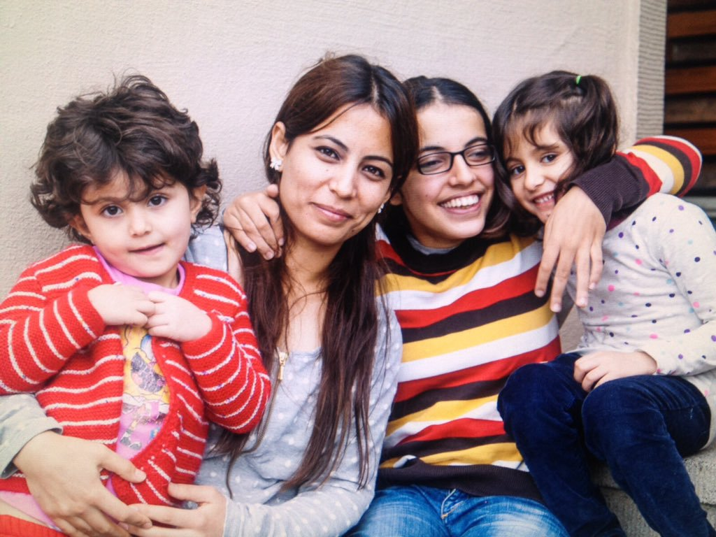
Photocopiable Resource 2 (What is a Diverse Society? Starter).
TIME TO BE CREATIVE!
Create an image that represents the phrase ‘diverse society’:

DIVERSE SOCIETY

Photocopiable Resource 3 (Crossword: Main).
WHAT MAKES A CITIZEN A PRODUCTIVE MEMBER OF A DIVERSE SOCIETY? Using the clues, fill in the crossword:
 |  |  |  |  |  |  |  |  |  |  |  |  | 1 |  |  | 2
 |  |  |  |  | 3
 |  |  |  |  |  |  |  |  |  |  |  |  |  |  |  |  |  | 4
 |  |  |  |  |  |  |  |  |  |  | 5
 |  | 6 |  |  |  |  |  |  |  |  |  |  |  |  |  |  |  |  |  |  | 7
 |  |  |  |  |  |  |  |  |  | 8
 | 9 |  |  |  |  |  |  |  | 10 |  |  |  |  | 11
12
 |  |  |  |  |  |  |  |  |  |  |  |  | 13
 |  |  |  | 14
 |  |  |  |  |  |  |  |  |  |  | 15
 |  |  |  |  |  | 16
 |  |  |  |  |  |  |  |  |  |  | 17
18
 |  |  |  |  |  |  |  | 19
ACROSS
1 Understanding for someone else’s suffering (8).
3 Being brave (7).
6 Working well with others (11).
8 Admiration for someone's ideas or personality (7).
11 Using new ideas or systems (10).
12 Willingness to help others on a regular basis e.g. by giving time or money (10).
14 Being able to 'spring back' to a good physical/mental position (10).

CONTINUED: Photocopiable Resource 3 (Crossword: Main).
ACROSS.
15 The ability to make your own decisions without consulting others (8).
17 Being able to change as a situation changes (11).
18 Sticking to your strong moral principles (9).
19 A power that attracts other people to your ideas and actions (8).
DOWN
2 The ability to continue trying to achieve something, even when you did not previously succeed (11).
3 Feeling sadness for others when they experience difficulties (10).
4 The ability to produce unusual ideas (10).
5 Being able to accept other people's views, even if you disagree with them (9).
7 Creating ideas and pictures in your mind (11).
9 Having clever ideas in testing situations (15).
10 Having lots of energy and enthusiasm (8).
13 Putting forward ideas in a polite but firm way (13).
16 Acting quickly in an organised way (10).
?
?

?
?
?
Photocopiable Resource 4 (Crossword Answers: Main).
ANSWERS FOR CROSSWORD.
 |  |  |  |  |  |  |  |  |  |  |  |  | S | Y | M | P | A | T | H | Y
 |  |  |  |  | C | O | U | R | A | G | E |  |  |  |  | E
 |  |  |  |  | O |  |  |  |  |  |  |  |  |  |  | R |  | C
 |  |  |  |  | M |  |  |  |  |  | T |  |  |  |  | S |  | R
 |  | C | O | O | P | E | R | A | T | I | O | N |  |  |  | I |  | E |  |  | I
 |  |  |  |  | A |  |  |  |  |  | L |  |  |  |  | S |  | A |  |  | M
 |  |  |  |  | S |  |  |  |  | R | E | S | P | E | C | T |  | T |  |  | A
 |  |  |  |  | S |  |  |  |  |  | R |  |  |  |  | E |  | I |  |  | G
 | R |  |  |  | I |  |  |  | D |  | A |  |  | I | N | N | O | V | A | T | I | O | N
G | E | N | E | R | O | S | I | T | Y |  | N |  |  |  |  | C |  | I |  |  | N
 | S |  |  |  | N |  |  |  | N |  | C |  | A |  |  | E |  | T |  |  | A
 | O |  |  |  |  |  |  |  | A |  | E |  | S |  |  |  |  | Y |  |  | T
 | U |  |  |  |  |  |  |  | M |  |  |  | S |  |  |  |  |  |  |  | I
 | R |  |  | R | E | S | I | L | I | E | N | C | E |  |  |  |  |  |  |  | O
 | C |  |  |  |  |  |  |  | S |  |  |  | R |  |  |  |  |  |  |  | N
 | E |  |  |  |  |  |  |  | M |  | A | U | T | O | N | O | M | Y
 | F |  |  |  |  | E |  |  |  |  |  |  | I
 | U |  |  |  |  | F |  |  |  |  |  |  | V
 | L |  |  |  |  | F |  |  |  |  | F | L | E | X | I | B | I | L | I | T | Y
I | N | T | E | G | R | I | T | Y |  |  |  |  | N
 | E |  |  |  |  | C |  |  |  |  |  |  | E
 | S |  |  |  |  | I |  | C | H | A | R | I | S | M | A
 | S |  |  |  |  | E |  |  |  |  |  |  | S
 |  |  |  |  |  | N
 |  |  |  |  |  | C
 |  |  |  |  |  | Y

