KS4 PSHCE LESSON PLAN.
DATE: LESSON FOCUS: What is the Relevance of our Human Rights?
Number of male students: | Number of SEN students: | Last lesson’s focus:
Number of female students: | Number of G & T students: | Next lesson’s focus:
Class/year group: | Misc:

LESSON OBJECTIVES.

- (1) I can find out what my human rights are.
- (2) I can appreciate the relevance of my human rights.

STARTER.
- Share LOs with class.
- Refer class to LO1 for this starter activity.
- Ask students to read Photocopiable Resource 1 (excerpt from ‘Nujeen’).
- Put class into pairs. Ask pairs to discuss which basic violations of rights they can spot in the excerpt. NB at this stage do not ask about human rights specifically.
- Suggested answers include: right to life, right to freedom, right to dignity, right to choose partner and right to avoid persecution.
- Show students Photocopiable Resource 2 (What are our Human Rights?). Explain that ‘The Universal Declaration of Human Rights’ was created in 1948 and that it sets out universal rights to which every global citizen is entitled.
- Ask students to guess which five human rights are missing and to fill in (in pencil) the relevant words/phrases.
- Answers (to be written in pen!): (5) torture, (11) innocent until proven guilty, (15) nationality, (16) married & (26) education.
MAIN.
- Refer class to LO2 for this main activity.
- Give each student Photocopiable Resource 3 (What is the Relevance of our Human Rights?).
- Ask students to answer the questions on the worksheet, providing as much detail as they can.
- Examples of good answers are provided on Photocopiable Resource 4. These examples can be used now within the lesson in a brief peer feedback activity and/or for marking purposes by the teacher later.

PLENARY.
- Ask a volunteer to read out the ‘Nujeen’ excerpt that was explored in the starter activity.
- Put class into groups of 5/6. Ask each group to choose a sentence (or a few sentences) from the excerpt that highlights a violation of human rights.
- A spokesperson from each group should read out their chosen sentence, explaining how it represents a violation of human rights.
- Example of a good answer: One of our basic human rights is the right to life. We therefore chose the sentence about the 13-year-old boy who was killed whilst trying to protect his sister. It is such a chilling example of how human rights can be abused.
SEN SUPPORT.
- For starter activity, HLTA/teacher to give clues for five missing rights using examples from the news (e.g. Pakistani teenager Malala Yousafzai was shot by the Taliban when she spoke up about girls’ right to a what?).
G & T SUPPORT.
- For the homework activity below, also describe which one of the rights is the most difficult to enforce in practice in the 21st century. Justify your answer.
HOMEWORK/STRETCH TASK.
- Name a right that you believe should be added to a 21st century update to the Universal Declaration of Human Rights. Explain why you have chosen this new right.

Photocopiable Resource 1 (Excerpt from ‘Nujeen’, p103: Starter).

One day Nasrine and Bland were in a car driving round the roundabout when they noticed there was a head on a spike. It started happening more and more. Another day gunmen came to the house of Aunt Shamsa and Uncle Bozan, whose son had been kidnapped, and fired in the air then banged on the door – maybe because they had two nice cars outside. No one was home, but as soon as my aunt and uncle came back and heard what had happened they decided to leave and move to Kobane.
Later they called us with a terrible story. Aunt Shamsa told us that their neighbour who was also a Kurd had a beautiful daughter, and one day when her father was not at home militants from Daesh came wanting to take her away. Her thirteen-year-old brother tried to stop them, but they killed him. A day later they returned and said, ‘She must marry our Emir. Make her ready tomorrow, and we will collect her.’ Her terrified parents had no choice. The men came back and took her, and after a week she was allowed home for a day. Her mother asked her, ‘Who is your husband, is he a good man?’ The girl started crying. ‘You think you let me marry one man?’ she said. ‘Every night I have ten men.’
The next day our family left.

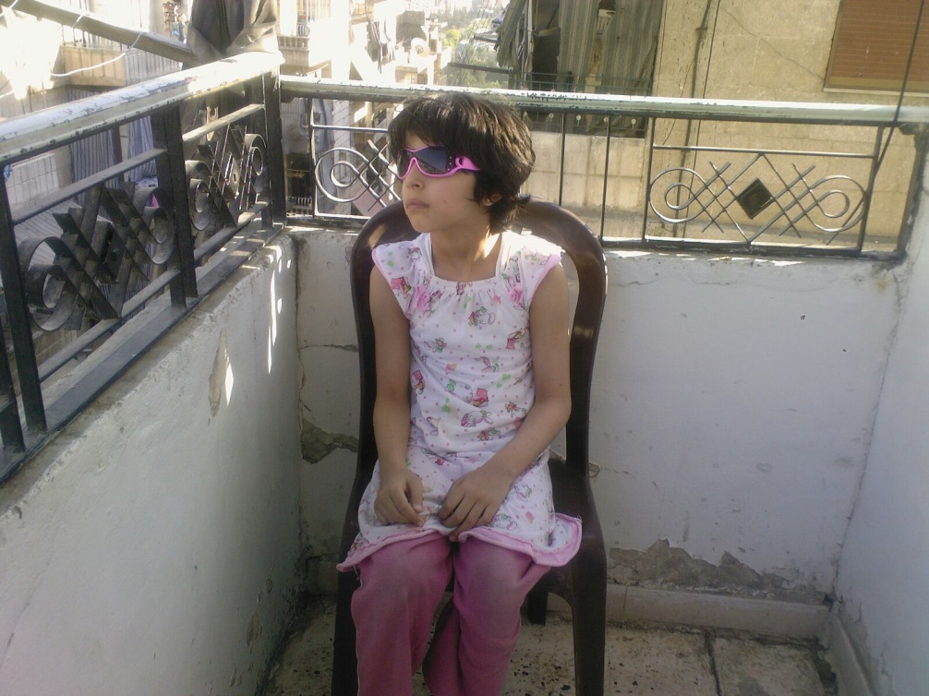
Photocopiable Resource 2 (What are our Human Rights? Starter).
Can you guess which five rights are missing? Fill in the missing words/phrases.
What are our Human Rights?
1. General rule: we all have an equal right to human rights. | 16.The right to get __________________*. *Civil partnerships aren’t mentioned as they weren’t available at the time.
2. General rule: we should never discriminate against another human. | 17. The right to own property.
3. The right to life and to personal safety. | 18. The right to freedom of conscience, thought and religion.
4. The right to freedom from slavery. | 19. The right to freedom of opinion and expression (and the right to seek/share new information).
5. The right to freedom from _______________. | 20. The right to freedom of association (who we know and who we communicate with) and of assembly (meeting other people).
6. The right to equal treatment within the justice system. | 21. The right to take part in and to choose our government.
7. The right to equal protection within the justice system. | 22. The right to social security (access to medical care and to childcare etc).
8. The right to appeal (within the legal system) when we are not treated fairly. | 23. The right to equal pay for equal work and to form/join trade unions.
- The right to freedom from arbitrary arrest. | 24. The right to paid holidays and reasonable working hours.
10. The right to a fair trial. | 25. The right to adequate living standards (food, housing etc).
- The right to be presumed ________________ ________________________________________ | 26. The right to an ____________________.
12. The right to privacy (at home, when communicating with friends, in your family life etc). | 27. The right to copyright our own creations.
13. The right to move freely within your own country and to visit other countries. | 28. General rule: our human rights must apply in our own country and in other countries.
14. The right to claim political asylum in other countries. | 29. General rule: everyone in society has the responsibility to protect each other’s human rights.
15. The right to a _______________________. | 30. General rule: you cannot use your human rights to repress someone else’s human rights.
҉ ҉ ҉ ҉ ҉ ҉ ҉ ҉

Photocopiable Resource 3 (What is the Relevance of our Human Rights? Main).
Answer the questions below, giving as much detail as you can.
- Name three activities that you have taken part in this week that are linked to human rights. ____________________________________________________________________________________________________________________________________________________________________________________________________________________________________________________________________________________________________________________________________________________________________________________________________________________________________________________________________________________________________________
- Some people argue that human rights are no longer relevant in the UK because the UK is a democratic country. Give an example of an argument that opposes this viewpoint. ______________________________________________________________________________________________________________________________________________________________________________________________________________________________________________________
3. How can people in this country complain if they feel that their human rights have been violated? ______________________________________________________________________________________________________________________________________________________________________________________________________________________________________________________
4. Why is it vital that children across the globe are educated about their human rights? ______________________________________________________________________________________________________________________________________________________________________________________________________________________________________________________
5. Which of the human rights interested you the most? Why did you find this one interesting? ______________________________________________________________________________________________________________________________________________________________________________________________________________________________________________________
6. Give an example of a recent news story that is linked to a violation of human rights. ____________________________________________________________________________________________________________________________________________________________________________________________________________________________________________________________________________________________________________________________________________________________________________________________________________________________________________________________________________________________________________

Photocopiable Resource 4 (Examples of Good Answers: Main).
Examples of good answers are shown below. Other answers are also applicable.
1. Name three activities that you have taken part in this week that are linked to human rights. Firstly, I went to Liverpool at the weekend (right to move freely in my own country). Secondly, I visited my cousin’s new flat (right to own property). Thirdly, I came to school today (right to an education).
2. Some people argue that human rights are no longer relevant in the UK because the UK is a democratic country. Give an example of an argument that opposes this viewpoint. Although the modern-day UK has a good human rights record, human rights are still relevant here. This is because they act as our safety net for the future, for example if the government tries to take away our right to vote. It is also our moral responsibility to challenge human rights violations abroad.
3. How can people in this country complain if they feel that their human rights have been violated? It depends on the complaint. We can approach the police if we feel that we have been the victim of hate crime. If we think we have been discriminated against at work, we can take legal action through the court system. We can contact our MP if we feel that our neighbourhood is unsafe, etc.
4. Why is it vital that children across the globe are educated about their human rights? If young people are not made aware of their rights, they might think it is acceptable to be harmed/discriminated against - or indeed they might grow up to harm others. In addition, children/teenagers living in countries with a poor human rights record need to be aware that they’re entitled to a better life. This knowledge helps them to make informed decisions as they grow up.
5. Which of the human rights interested you the most? Why did you find this one interesting? The ‘right to claim political asylum in other countries’. I did not know that this right existed. Obviously, I’m aware that there are lots of asylum seekers living in many different countries. However, I had never considered that vulnerable people have a legal entitlement to live elsewhere if they are in danger.
- Give an example of a recent news story that is linked to a violation of human rights. Last week, I saw a BBC documentary claiming that black teenage males are treated unfairly by the police and by judges. It showed footage of young black teenagers being stopped and searched with no apparent justification. If powerful people in society really are biased against certain citizens, this has huge implications on the right to freedom from arbitrary arrest. It also affects our right to equal treatment within the justice system!

