KS4 PSHCE LESSON PLAN.
DATE: LESSON FOCUS: Refugees and Asylum Seekers
Number of male students: | Number of SEN students: | Last lesson’s focus:
Number of female students: | Number of G & T students: | Next lesson’s focus:
Class/year group: | Misc:

LESSON OBJECTIVES.

- (1) I can understand what refugees and asylum seekers are.
- (2) I can appreciate why some vulnerable people choose to leave their own countries.

STARTER.
- Share LOs with class.
- Refer class to LO1 for this starter activity.
- Choose volunteer to read book excerpt (Photocopiable Resource 1) to rest of class. Explain that the refugee camp in question was called Pikpa, on the Greek island of Lesbos. Nujeen spent a week of her memorable journey there.
- Explain that as there is lots of confusion regarding the terms ‘refugee’ and asylum seeker’, the class is going to undertake an activity to gain a better understanding of them.
- Ask pairs to fill in the missing words on Photocopiable Resource 2. Share answers.
- Answers: 1 = migrants, 2 = country, 3 = Convention, 4 = sexuality, 5 = genuine, 6 =refugee, 7 = persecution, 8 = conditions, 9 = wage and 10 = permanent.
MAIN.
- Refer class to LO2 for this main activity.
- Put students into groups of 4/5 for competition: which team can think of the most reasons why a citizen might choose to stay in their own country of birth? Ideas to get students started, if necessary: you speak the language fluently, you feel attached to special festivals (e.g. Christmas), you understand all the main systems in your country (how to use the currency, what your options are after leaving school, how to access emergency healthcare) etc.
- Ask spokesperson from each group to feed back ideas to class. Class votes on which idea is most interesting.
- Give students pyramid (Photocopiable Resource 3). Read through instructions with them. Aim of activity is to decide how important different factors are in deciding whether to remain in or leave your country of origin.
- Once pyramids have been completed, invite whole-class oral feedback on following questions:
1. Which factors are the most relevant in deciding whether to remain in or leave your home country? (Suggested answers: whether your human rights are being met, e.g. right to safety, right to freedom of religion, right to be educated, right to life, right to select government and right to dignity).
2. Which factors are the least relevant? (Suggested answers: issues that don’t have a direct link to your safety or your access to democracy, e.g. which shoes are in fashion in your country, what time local shops stay open till and how often there’s light rain in summer).
3. Which factors not mentioned on the worksheet also need taking into account when deciding whether to leave your country of origin? (Suggested answer: Human rights are very important to asylum seekers and refugees. However, economic migrants usually focus upon whether moving abroad will provide access to a better wage, to a better education system and/or to better career opportunities for their children).
4. Why are many refugees and asylum seekers willing to leave their own country on a permanent basis? (Suggested answer: even when they weigh up all the benefits of remaining in their own country where they speak the language fluently and are familiar with the culture – and where they might have a big family, lots of friends, many qualifications, an excellent career etc - they are willing to sacrifice all of this in order to be safe and to have freedom).
PLENARY.
- Explain that students will now reflect upon what they learnt in the starter and main activities.
- Ask students to complete the matching activity (Photocopiable Resource 4). Aim of activity is to match eight boxes in first column with eight boxes in second column. The resulting eight sentences summarise key learning points from lesson.
- Answers: 1 = E, 2 = H, 3 = B, 4 = G, 5 = A, 6 = D, 7 = C, and 8 = F.
- Ask a volunteer to give evidence that s/he met LO1. Repeat process with another volunteer for LO2.
SEN SUPPORT.
- For main activity, oral feedback can be given in small group led by HLTA. Prompt questions (in blue) can be used to trigger discussion.
G & T SUPPORT.
- For starter activity, students should be challenged to fill in missing words without reference to the ten provided. Obviously synonyms are acceptable in some cases.
HOMEWORK/STRETCH TASK.
- Use the internet to find out where your nearest support centre is for local refugees/asylum seekers. What is its name? List at least three services that it offers.

Photocopiable Resource 1 (Excerpt from ‘Nujeen’, pp. 155-156: Starter).

Next to us was another Syrian family with a young girl whose eyes were very red and infected. They told us their dinghy had capsized because the engine failed and they were eleven hours in the water before being rescued. Another family told us that so much water had come into their dinghy they had thrown everything out, even the bag with their gold jewellery and money, so they had been left with nothing.
We were given mats to sleep on but some people were sleeping on cardboard. The camp was near the airport and there was a barrage of noise from the planes coming low over-head and from all the children. It reminded me of Manbij and the bombing and I covered my ears. I hated it there. The place was too hot in the day and full of mosquitoes at night. Nahda’s children kept whining and my sisters kept moaning about the lack of hygiene – there was rubbish everywhere and other refugees referred to it as the Jungle. There were separate toilets for men and women, but not bathrooms. Only a curtain separated men from women and it smelt so disgusting no one could endure it for more than ﬁve minutes. I noticed a lot of the women were veiled and complaining that it was not possible for them to do the ablutions we do before prayers. Some of the men bathed in the sea. Nasrine and Nahda wanted to wash our clothes but there was a long queue to use the sink.

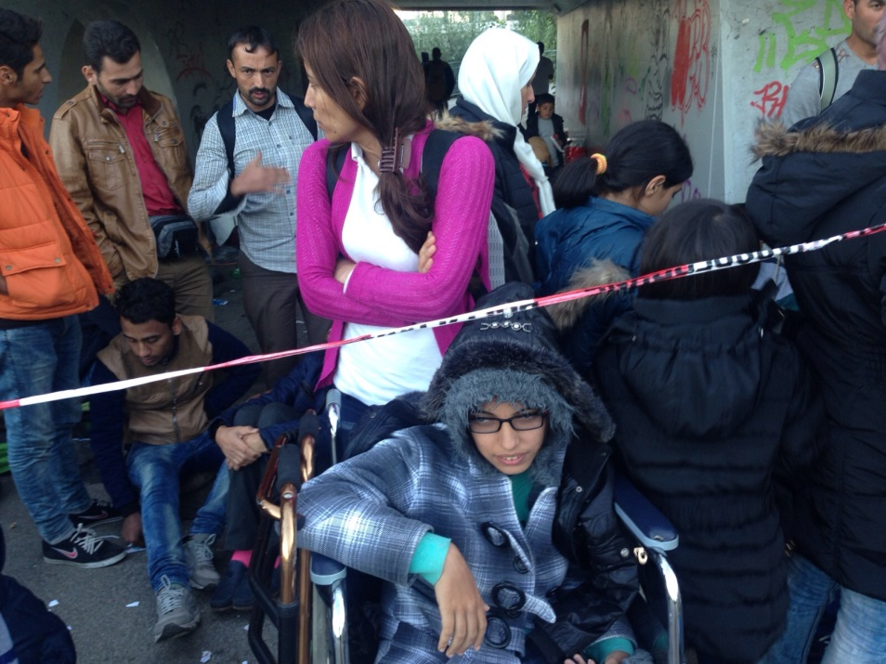
Photocopiable Resource 2 (Missing Words Activity: Starter).
WHAT ARE REFUGEES AND WHAT ARE ASYLUM SEEKERS?
Fill in the missing words below:
The terms ‘refugee’ and ‘asylum seeker’ are often used interchangeably. This can lead to a lot of confusion, especially given that members of the public and news commentators also often talk about economic (1) _____________________.
In the UK, an asylum seeker is someone from another (2) ___________ who comes here and applies for asylum (safety/protection given by a government) under the 1951 Refugee (3) __________________ on the Status of Refugees. In other words, a genuine asylum seeker is someone who is very afraid – justifiably so - that they will face/continue to face persecution in their own country. This persecution might be based upon religion, (4) ______________, political beliefs or another characteristic. Such persecution can take various forms including serious discrimination in the workplace, denied access to education and medical treatment, censorship, verbal and physical abuse, sexual harassment, torture, and murder. An asylum seeker remains an asylum seeker whilst our government looks into their case to assess whether it is (5) _____________.
An asylum seeker becomes a (6) ________________ if the government approves his/her application to be protected in a new country. For example, a gay man who has been seriously assaulted by police officers in his own country – on the sole basis of his sexuality – might become a refugee in the UK so that the British government can protect him from homophobic crime.
Sometimes the media also use the term ‘refugee’ to describe people who are fleeing a natural disaster (e.g. and earthquake) or a civil war. These people are not necessarily afraid of (7) _________________. Rather, they fear for their lives.
An economic migrant is someone who left their own country to seek better (8) ____________________ in another country. For example, an economic migrant’s own country might have a poor education system. It might also have a low average (9) ____________ and provide very few rights/benefits for workers. It can therefore be very appealing to move to a country in which you can earn a good wage and give your children access to a good education system and a high standard of healthcare. Some economic migrants enter the UK illegally and some do not. Some stay for a short-term period whereas others move on a (10)__________ basis because they believe that the advantages of living outside of their own country outweigh the disadvantages. There is no assumption that an economic migrant faces danger if they return to their own country. Many economic migrants currently living in the UK feel very unsettled about their future, following the summer 2016 EU referendum.
MISSING WORDS: conditions Convention country genuine migrants permanent persecution refugee sexuality wage

Photocopiable Resource 3 (Pyramid: Main).
WHY DO SOME PEOPLE CHOOSE TO LEAVE THEIR OWN COUNTRY?
Below, twelve young adults explain how they feel about their own country. Decide how important these factors are when someone’s deciding whether to stay living in the country where they were born. Do this by putting numbers 1- 12 into the pyramid. For example, if you think statement 1 is very important when deciding where to live, write ‘1’ in the top of the pyramid.
- The stadium for my favourite football team is only half an hour away from my house.
- I like living here because I would find it intimidating to live somewhere where I had to learn another language. It would also be hard to adjust to a different culture.
- I live in constant fear of being arrested due to my religion. It’s terrifying.
- My grandparents are buried here and I often visit their grave.
- I am in a long-term gay relationship. My partner and I would risk life-long imprisonment if our relationship got discovered.
- I like the weather here because it’s what I’m used to. I burn easily in the sun.
- You can buy so many different types of food in this country. The variety’s amazing.
- There is no democracy here. Our so-called elections are faked by dictators.
- My teachers have known me since I was four and so I feel confident around them.
- My parents were murdered last night because they were journalists who told the truth about our corrupt royal family.
- I really like the fact that you can get next-day clothes delivery here when you buy online.
- Women and men have equal rights in this country.

Which factors are the most important when deciding whether to stay in your home country?
?
?
Photocopiable Resource 4 (Matching Activity: Plenary).
WHAT HAVE I LEARNT THIS LESSON?
Make eight full sentences, using lines/colours, by matching the numbers to the appropriate letters:
1. Nujeen spent some of her long journey from… | A. …safety in another country.
2. In the book excerpt, Nujeen describes the camp as… | B. …an unhygienic refugee camp shows how desperate she was to flee her own country.
3. Nujeen’s willingness to spend time in such… | C. …employment and financial prospects.
4. Some of the fellow Syrians that Nujeen met… | D. …have been approved. (Sometimes the term is also used to describe groups escaping from civil wars or natural disasters).
5. Asylum seeker are people who are desperate to obtain… | E. …Syria in a refugee camp in Lesbos.
6. Refugees are people whose asylum claims… | F. …sometimes get confused about the difference between asylum seekers, refugees and economic migrants.
7. Economic migrants are keen to improve their… | G. …lost all of their belongings during their escape in a dinghy.
8. Media commentators and members of the public… | H. …being full or rubbish and smelling awful.
1 = ______
2 = ______
3 = ______
4 = ______
5 = ______
6 = ______
7 = ______
8 = ______
8

ANSWERS

